ASHARA SAJJADIYYAH

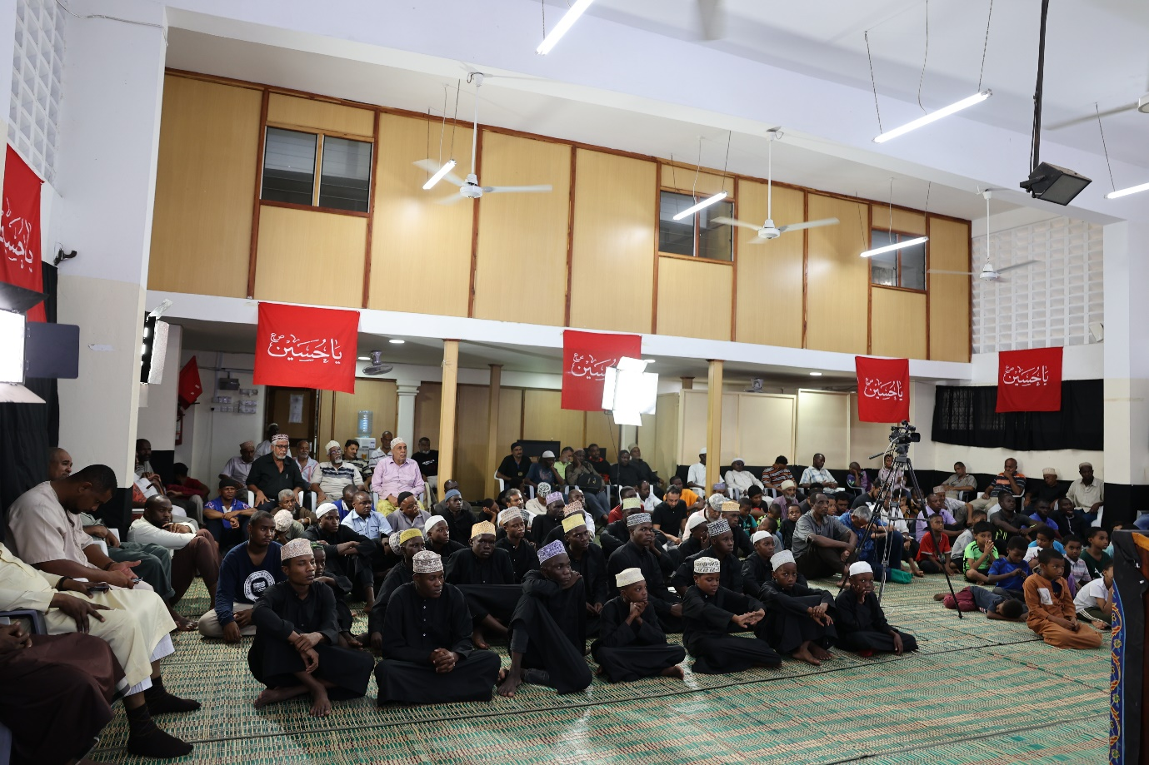

August 2023

Muharram 1445 AH





A concise summary of the reason for Imam Husayn’s sacrifice in Karbala is found in his own will in which he writes ‘I have taken this stand not out of arrogance or pride, neither out of mischief or injustice. I have risen to seek reformation in the community of my grandfather. I would like to bid good and forbid evil and follow the tradition of my grandfather and my father Ali ibn Abi Talib.’

After the events at Karbala, the Imam’s divine work was continued by his son Imam Ali Zainul Abeidin – As-Sajjad (A), who succeeded him as Allah’s representative on this Earth. It was therefore befitting that the Bilal Muslim Mission of Kenya, with generous financial support organized ten days of majaalis to commemorate Imam Sajjad (A) and his martyrdom.

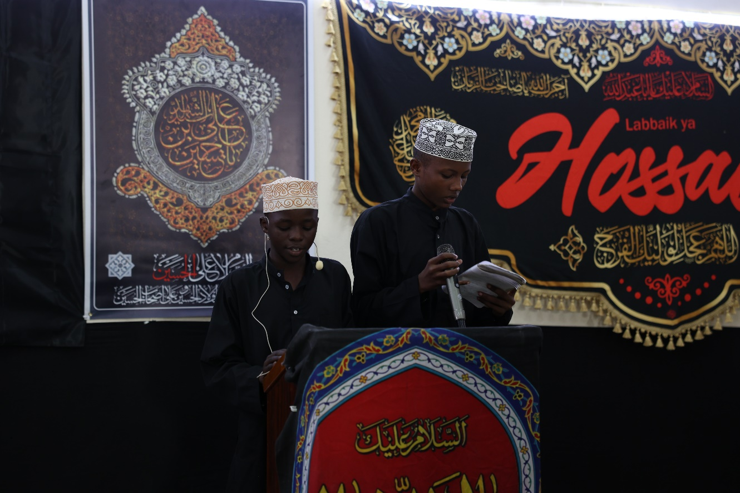

Central theme

Imam Sajjad(A) was a youth who was the inheritor of the Holy Prophet and his noble purified lineage; very appropriately chosen therefore, the theme for this year’s Sajjadiyyah majaalis was **Imam Sajjad (A.S) na uongozi wa vijana.** Uongozi refers to management or leadership**.** The Imam carried immense leadership responsibilities in his early twenties. The lectures this year included inspirational messages for attendees, especially those between the ages of buloogh and forty to look up to the Imam as their role model in various aspects of their lives.

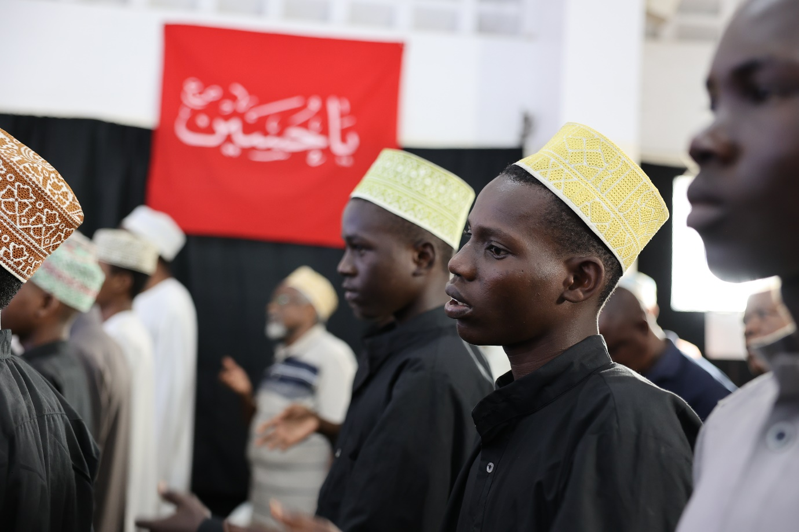

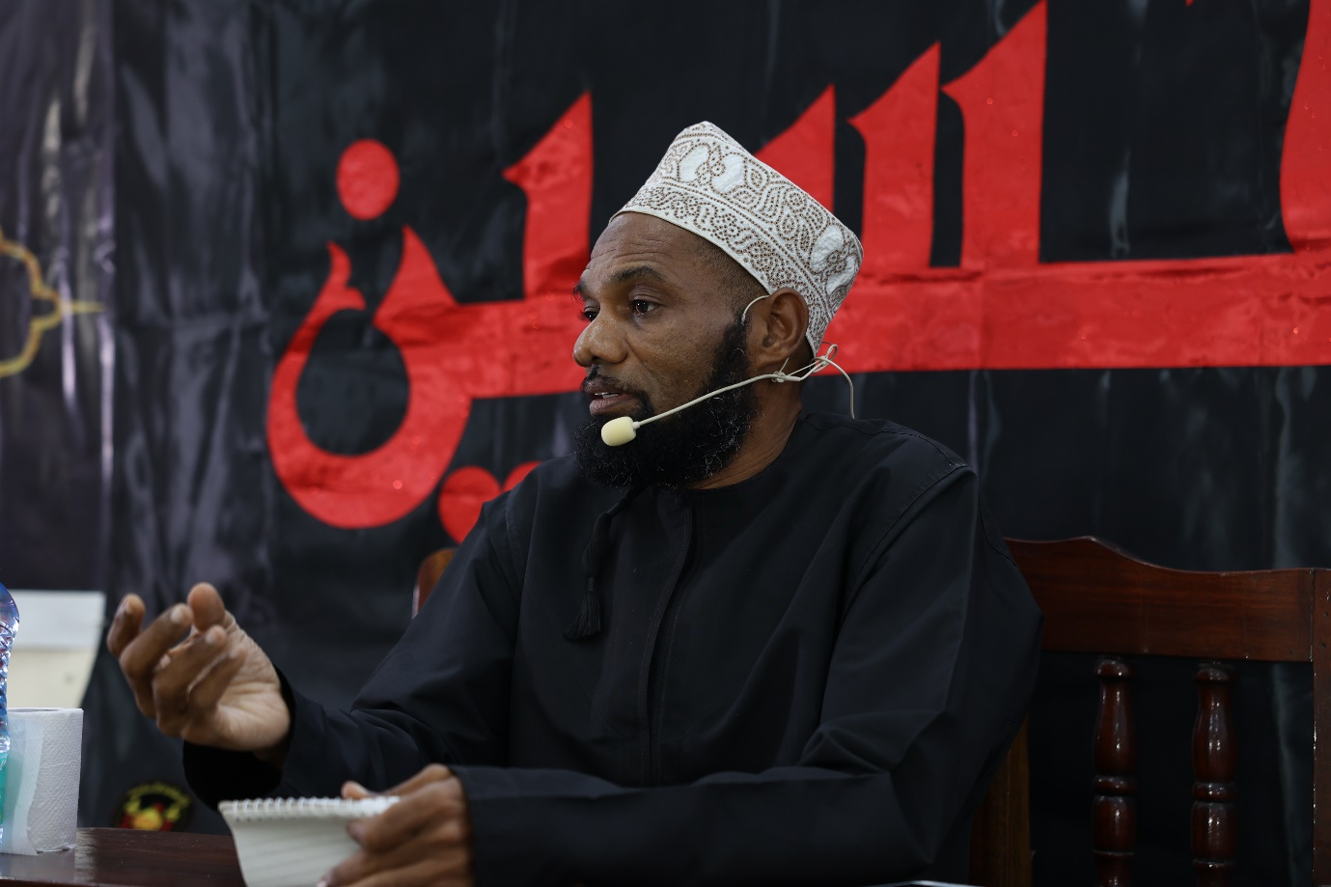

Other details

The majaalis were held at the Bilal Hall in Mombasa between the 9th and the 18th of August. The programs lasted approximately one hour commencing about 5pm with eloquent Quran recitation. Touching arabic and swahili poetry followed. The lectures emphasized the important role played by Imam Sajjad(A) in safeguarding the true Islam and his relevance today and were embellished and authenticated with the treasured verses of the Holy Quran. The programs ended with latmiyat, ziyarat and serving of take-away tabarrukat.

Sheikh Athman Akbar managed the Quran, poetry and Latmiyat recitation. Sheikh Ali Njoloi and Sayyid Twahir Muhammad gave the lectures until the 17th and Sheikh Juma Shughuli delivered the final lecture of the ashara.

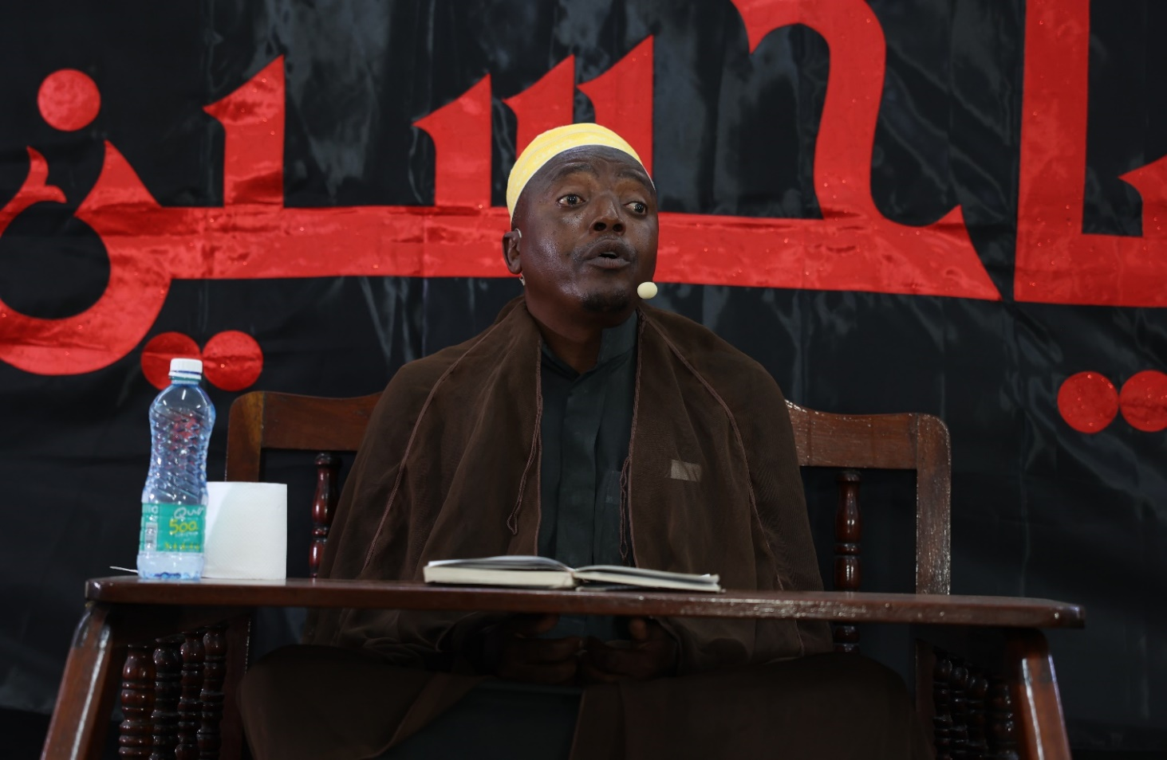

Inclusivity and global reach

The attendance was noteworthy. Mourners and supporters hailed from varied ethnic and social backgrounds. Ladies also attended the sessions. All the lectures were live streamed on our digital platforms.

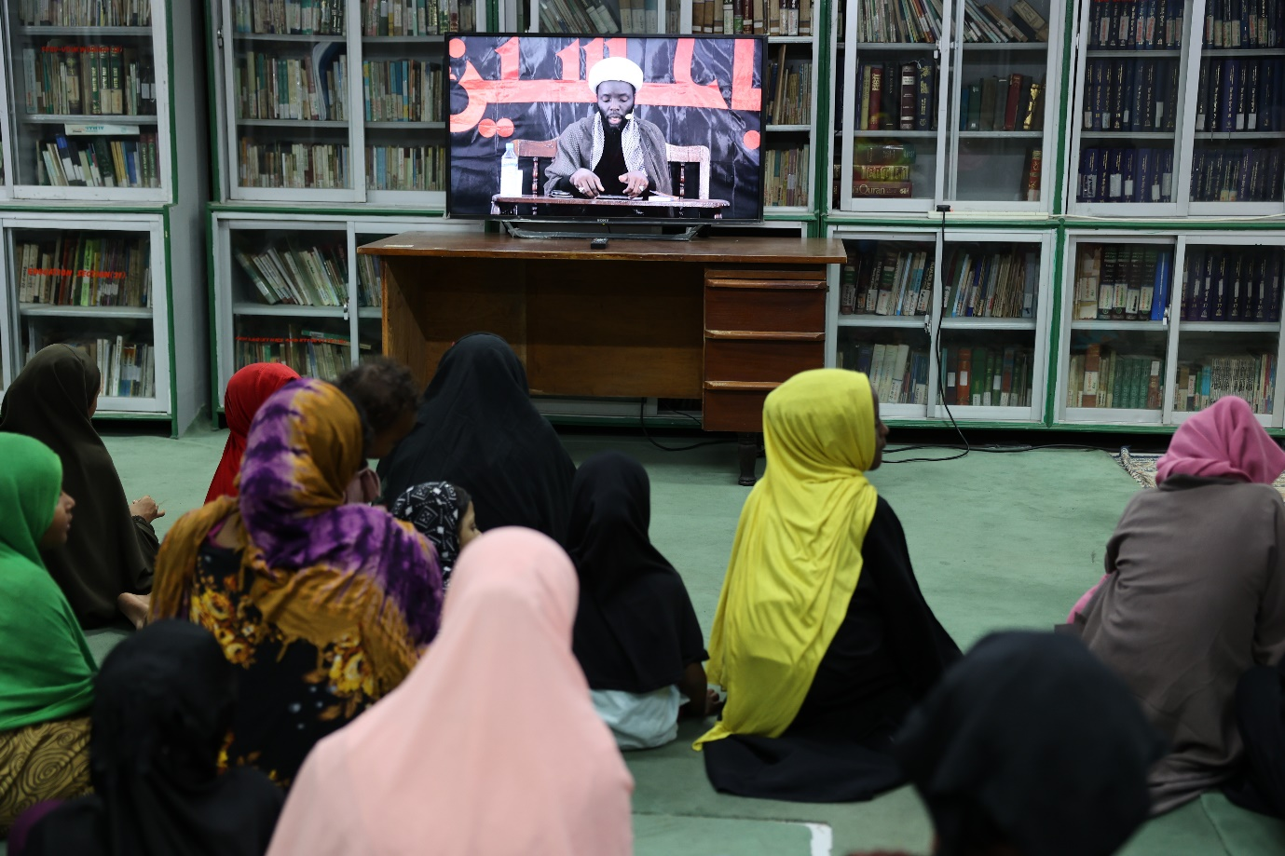

Appreciation

The Bilal Muslim Mission of Kenya appreciates the generous financial support we received which enabled us to honour, in a dignified manner, the memory of Imam Sajjad (A) and the noble party of Allah (SWT) that accompanied him.