ASHARA ZAINABIYYAH

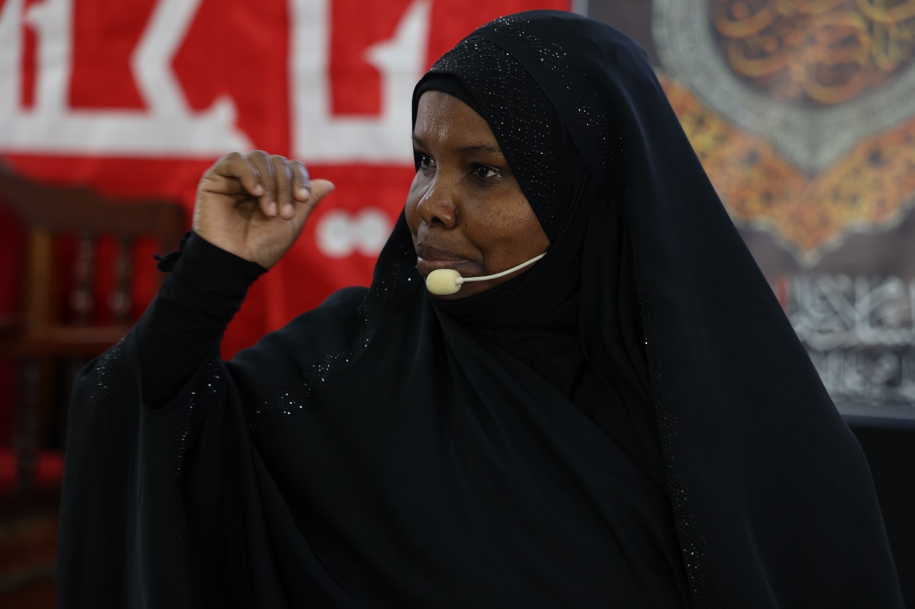

August – September 2023

Safar 1445 AH





Eloquent Vibrant Zainab

Brave Defiant Zainab

Silenced tyrants, Zainab!

Zainab saw nothing but beauty

She saw Islam as her line of duty

She gave her all, wholehearted and truly

Remaining firm in the face of cruelty.

Zainab witnessed death and fire

Zainab stood firm and did what was required

Zainab crumbled a whole empire

Her resistant words made oppressors retire.

*Adapted Excerpt from a poem by*

Hajj Mohammad Taleb

Lady Zainab was a towering figure who supported the Imam of her time, Imam Ali Zainul Abeidin (A) in extremely trying circumstances. She was the founder of the greatest of universities, the Majaalis of Imam Hussain. Zainab (A.S) was instrumental in ensuring that Imam Hussain’s sacrifice was not in vain and that the message of his revolution was spread far and wide. As in previous years, the season of mourning and reform ended in tribute to Shareekatul hussain and her caravan of brave ones.

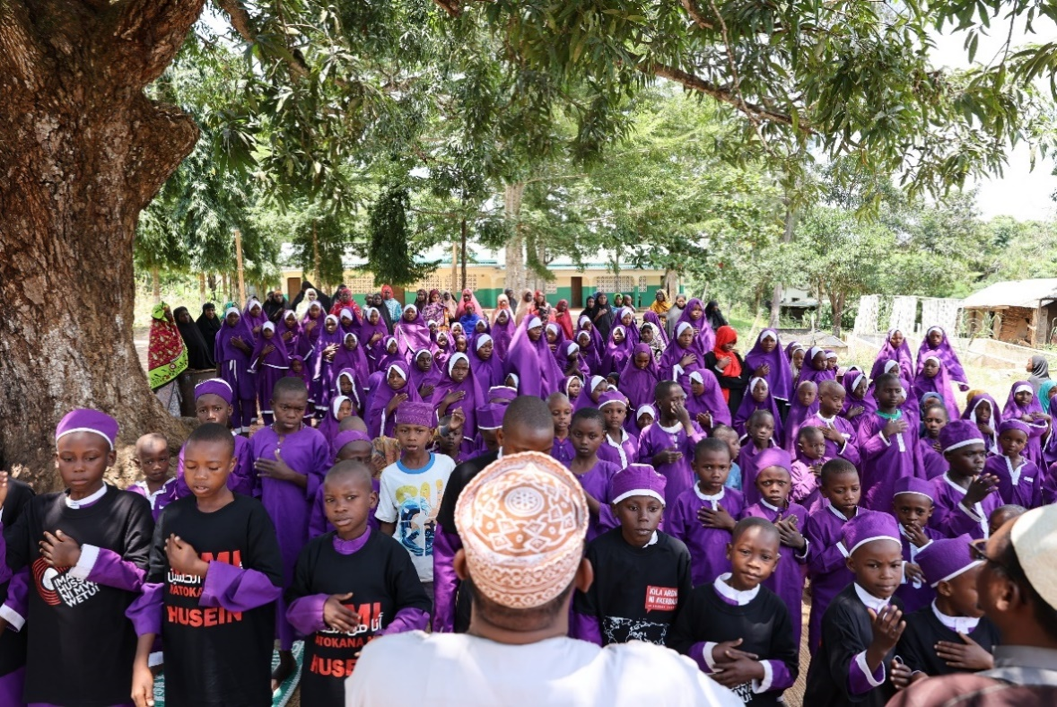

**Majaalis held at Bilal-supported centres in and around the coastal region**

Ashara Zainabiyya was commemorated at all our centres in and around the coastal region and gatherings to revive Imam Hussain’s message were held in varied settings. Arbaeen day was given special significance.

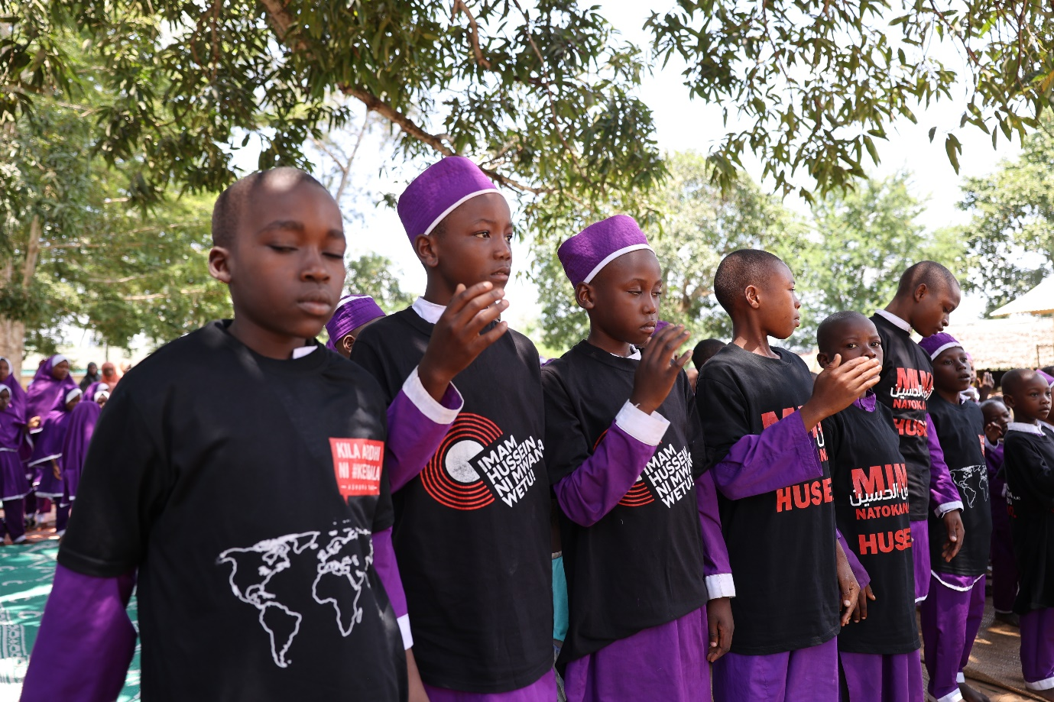

# **Majaalis held at Bilal Hall in Mombasa – central theme**

The theme chosen this year for all the Majaalis was **Bibi Zainab (A.S) ni chuo cha kina mama**, which means that Lady Zainab is a university for women to learn from. Just like her mother, she truly is the ideal for women in all their roles. This year we endeavored to communicate the embodiment of moral virtues that was Zainab. This remarkable Lady showed how one may partake in social activities while preserving their dignity and nobility as a muslim. Her involvement in politics is evidence that women cannot remain passive observers in an Islamic society. In fact, she is a role model and inspiration for all muslims striving towards Allah (S). Lady Zainab is also revered in other faiths.

# **Ladies Majaalis at Bilal Hall Mombasa**

Ladies majaalis were held for eight days in the mornings from approximately 11am to 12pm. The first majlis was held on Tuesday the 29th of August. As always, the majaalis commenced with eloquent recitation of the Holy Quran followed by soul-stirring poetry. Sister Ummu Muhammad addressed the ladies for the first five mornings and Sister Latifah Muhammad continued the discourse from the 3rd to the 5th of September. Madrasatuz-Zahra managed the poetry and Latmiya recitals.

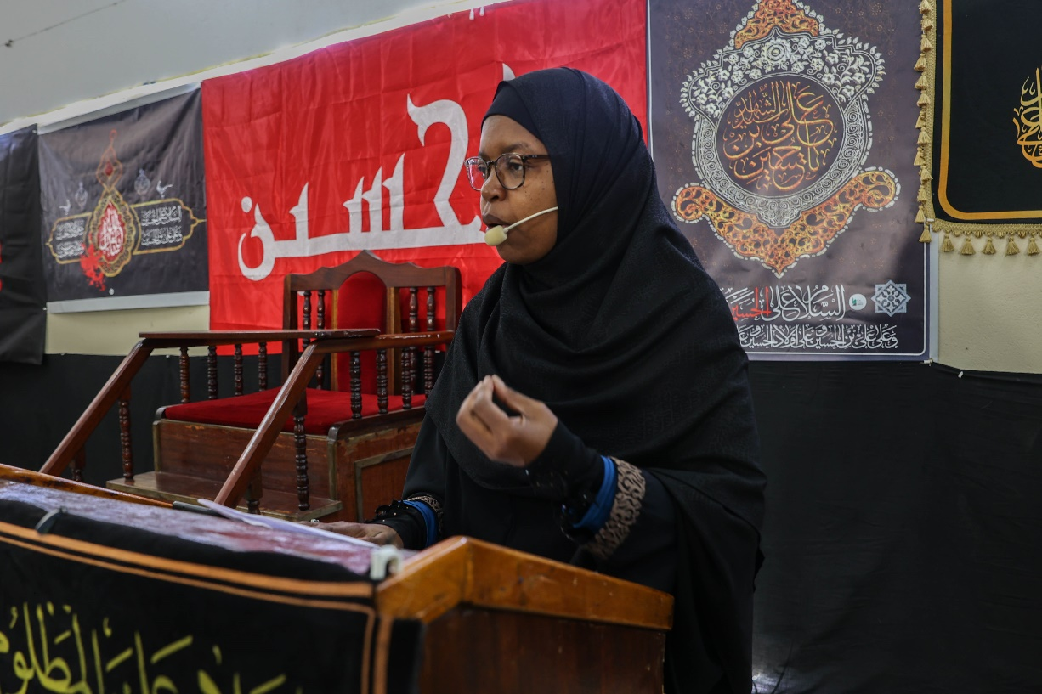

# **Gents Majaalis at Bilal Hall Mombasa**

The Bilal Hall was enlivened by Majaalis for the gents in the afternoons at 5 pm from the 28th of August to the 5th of September. Poetry and Latmiya recitals were exceptionally managed by Madrassa Zainul Abeidin. Sheikh Ali Bahero addressed the attendees for the first four sessions and Sheikh Musa Shali gave the following four lectures. On the ninth evening Sheikh Hussein Hinzano spoke to the gathering.

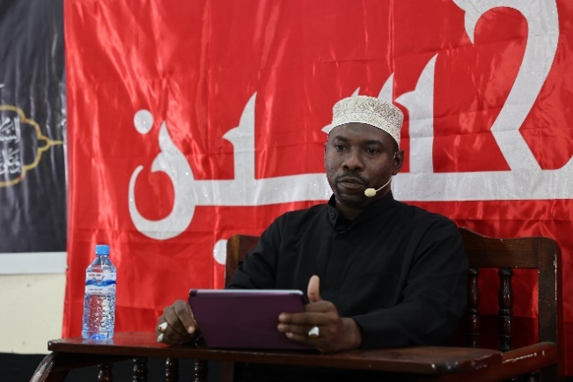 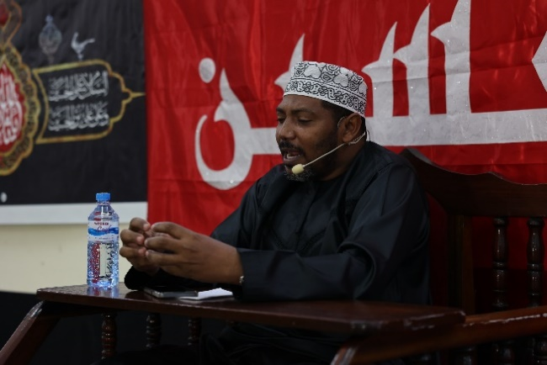

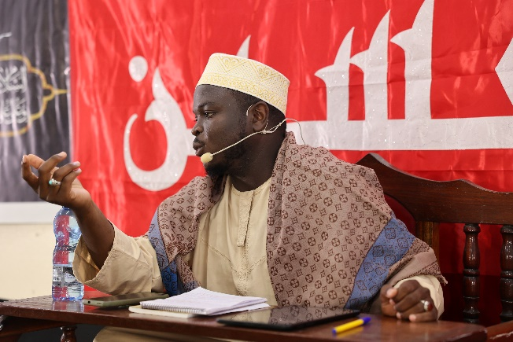

# **Arbaeen Day Majlis at Bilal Hall Mombasa**

This was a combined afternoon majlis on the 7th of September for ladies and gents. Sheikh Hassan Hinzano spoke about the signs of a believer, one of them being the recitation of Ziyarate Arbaeen on this significant day. He drew attention to the gathering of people in Kerbala for Arbaeen as being the largest gathering in the world for any single cause. This year, Iraqi authorities have recorded over 22 million visitors to Kerbala. The lecture ended with Arabic maqtal recitation and touching Swahili poetry. Sounds of ‘Waa Hussaina Waa Ghareeba Waa Shaheeda’ filled the hall during the Latmiya and the program ended with recitation of Ziyarate Arbaeen. Watch how lovers of the Ahlulbayt gave their respects by clicking the link below:

[Arbaeen Day Majlis](https://www.google.com/search?q=siku+ya+arbaen+&sca_esv=563740992&sxsrf=AB5stBj8B8r_cZx8QJcvD_5PEDlGPoWTTg%3A1694251483)

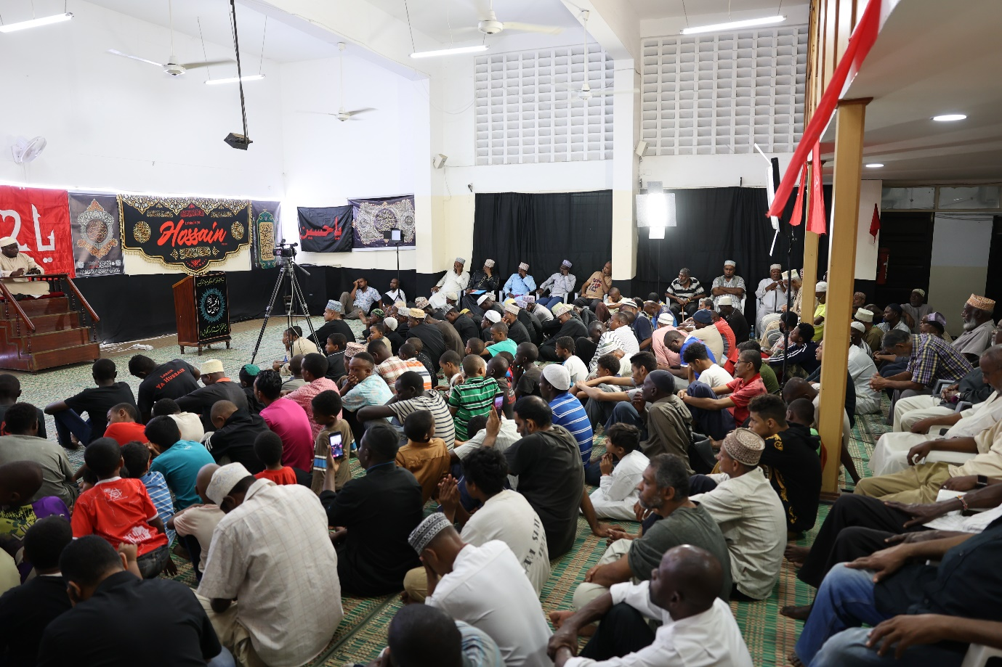

**Global reach**

All majaalis conducted at the Bilal Hall in Mombasa were live streamed on our digital media platforms and available for participation and viewing to a global audience.

# **Appreciation**

Bilal Muslim Mission of Kenya appreciates the generous financial support given to us which enabled us to honour Lady Zaynab and the remaining members of the noble party of Allah who gave unspeakable sacrifices to safeguard the religion of Islam. We also thank all those who contributed in various other ways to make it possible for us to establish the Ashara Zainabiyya Majaalis this year.