**EID AL ADHA CELEBRATIONS**

**2023**

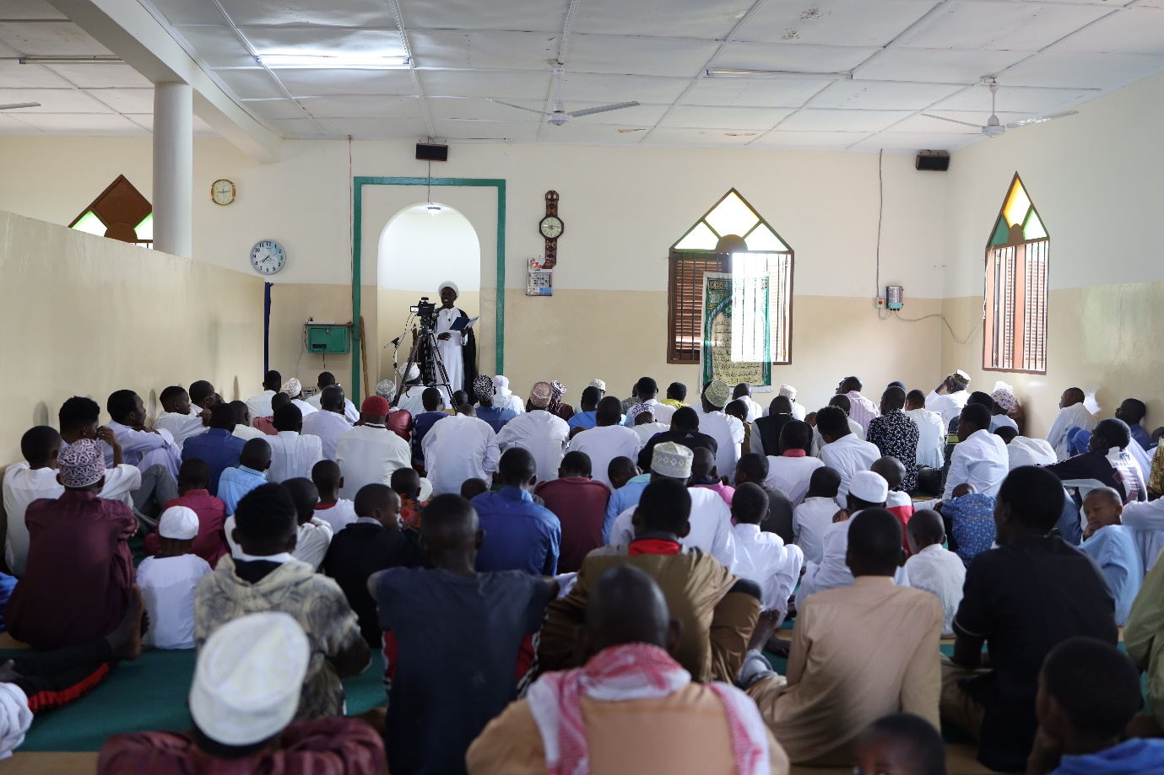

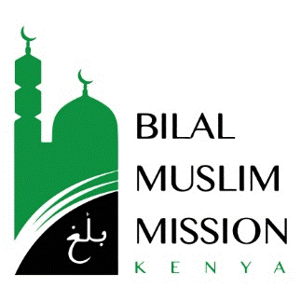



The month of Dhul Hijjah, in which the sacred pilgrimage of Hajj takes place is an overlooked gem of the Islamic calender. It is one of the four sacred months in Islam. Additionally, the first ten days have been specifically highlighted as significant for worship and devotion. The holy prophet Muhammad Mustafa, may the peace and blessings of Allah be upon him, has said that there are no other days in which good deeds are more beloved to Allah, may his glory be glorified, than those done in the first ten days of Dhul Hijjah.

According to some narrations, when the Qur’an states in suratul fajr, وَٱلْفَجْرِوَلَيَالٍ عَشْرٍۢ ‘by the dawn and the ten nights’, it is the first ten nights of dhul hijjah that Allah the majestic swears an oath by. The ninth day is known as Arafah. It is a sanctified day for which special acts of worship have been ordained.

The special season culminates in Eid al Adha, the day on which the Lord bestows his favours on his devotees. This day is marked with fervour throughout the muslim community worldwide. The Bilal Muslim Mission of Kenya is no exception. This year, as in previous years, the festival of sacrifice was celebrated at all the Bilal supported centres country-wide as well as at the forty independent centres to whom we extend assistance.

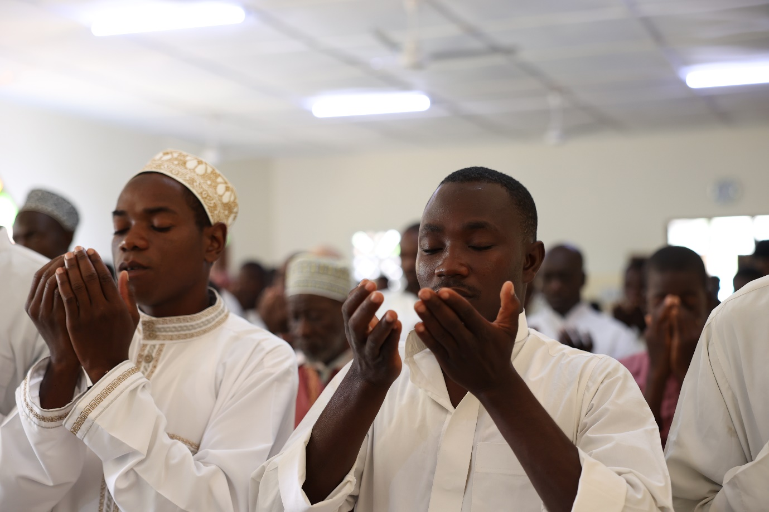

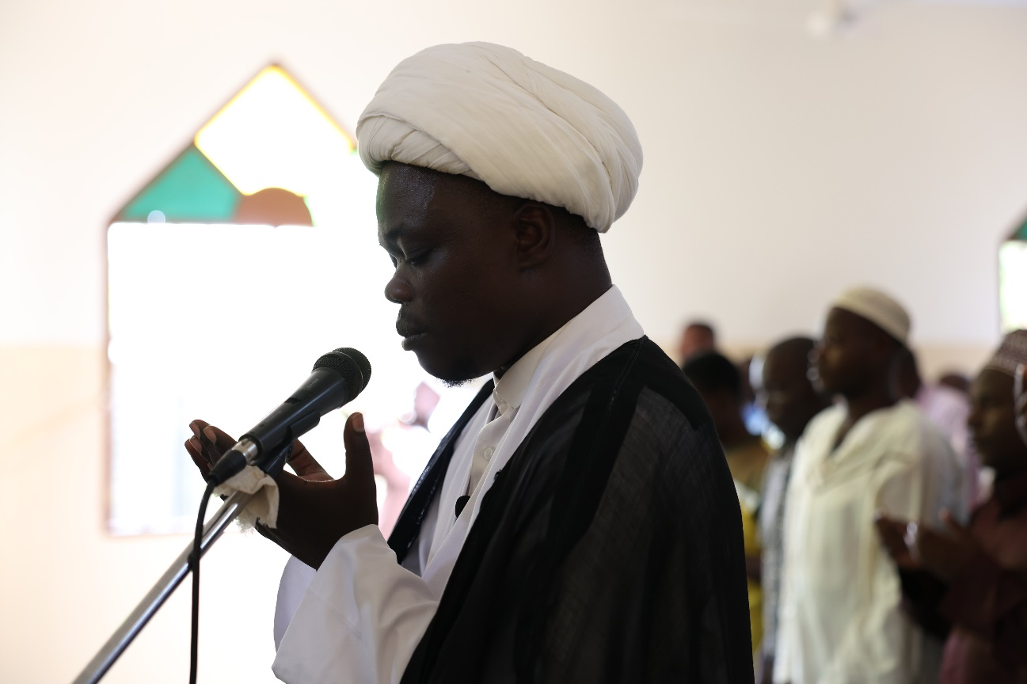

Rituals of the day included the recitation of Dua Nudba followed by the Eid prayer. Inspiring sermons highlighted the lives and characters of Prophet Ibrahim and his son Prophet Ismail. Facing trial and tribulation in life and the essence of sacrifice in Islam were the central themes.

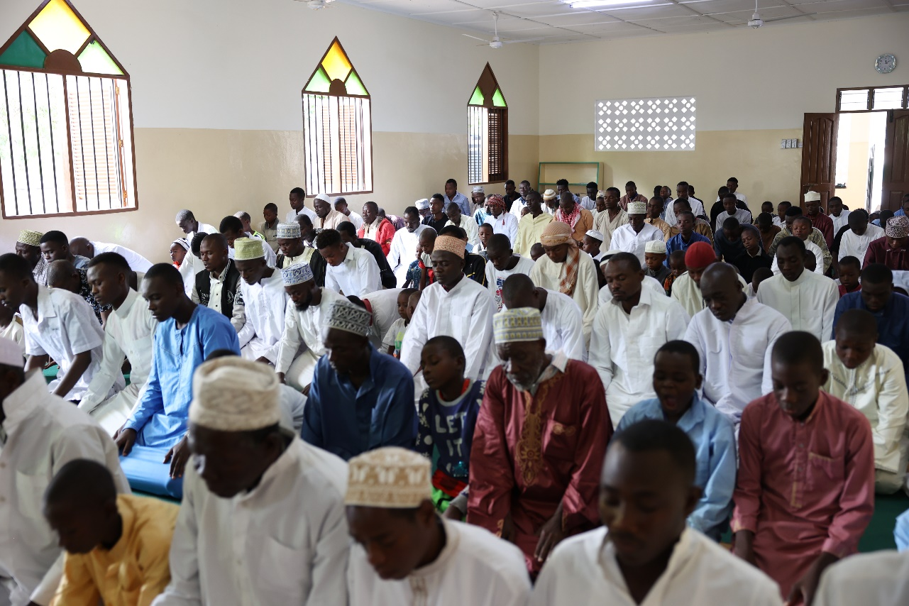

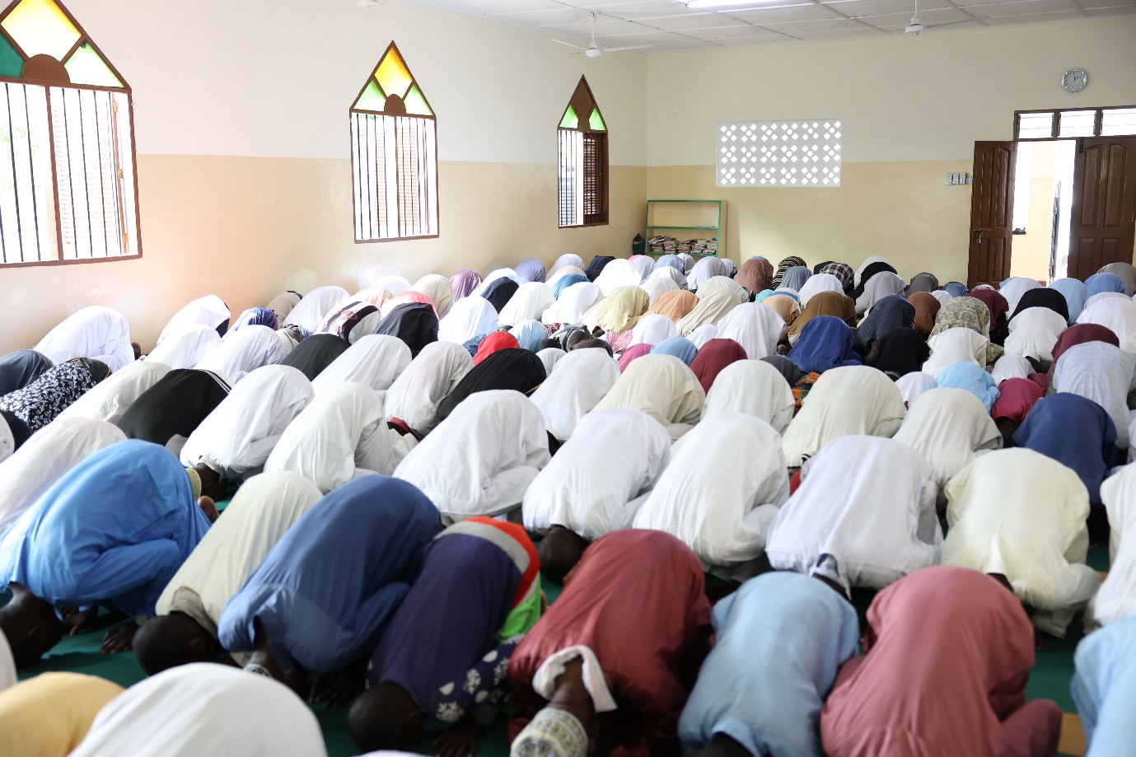

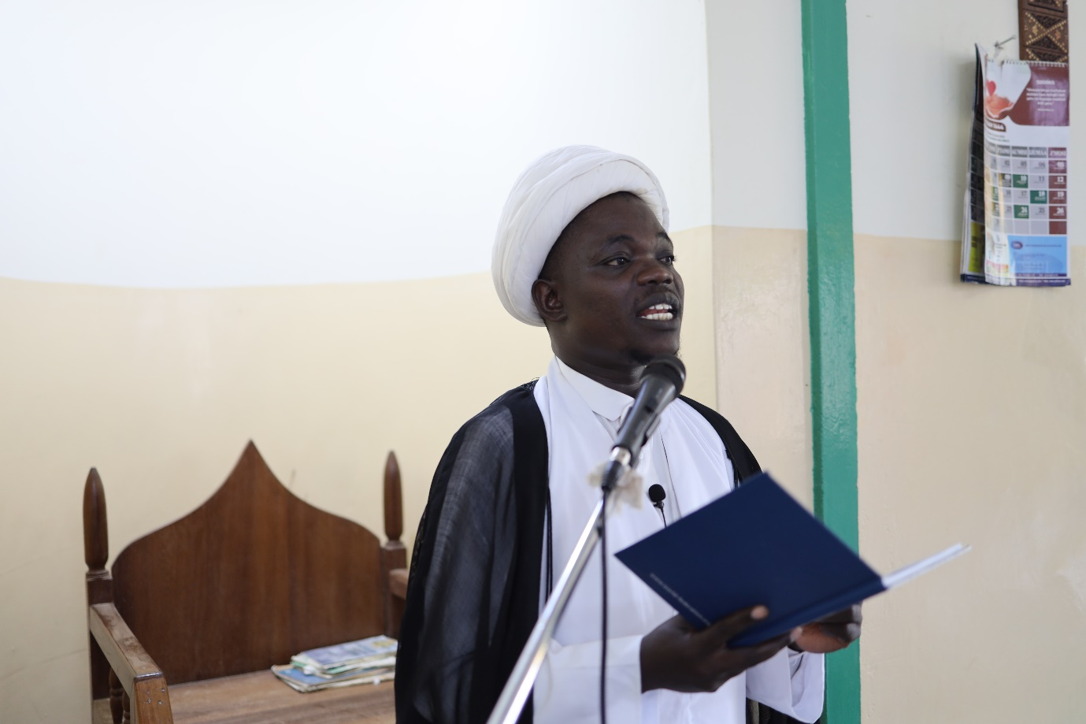

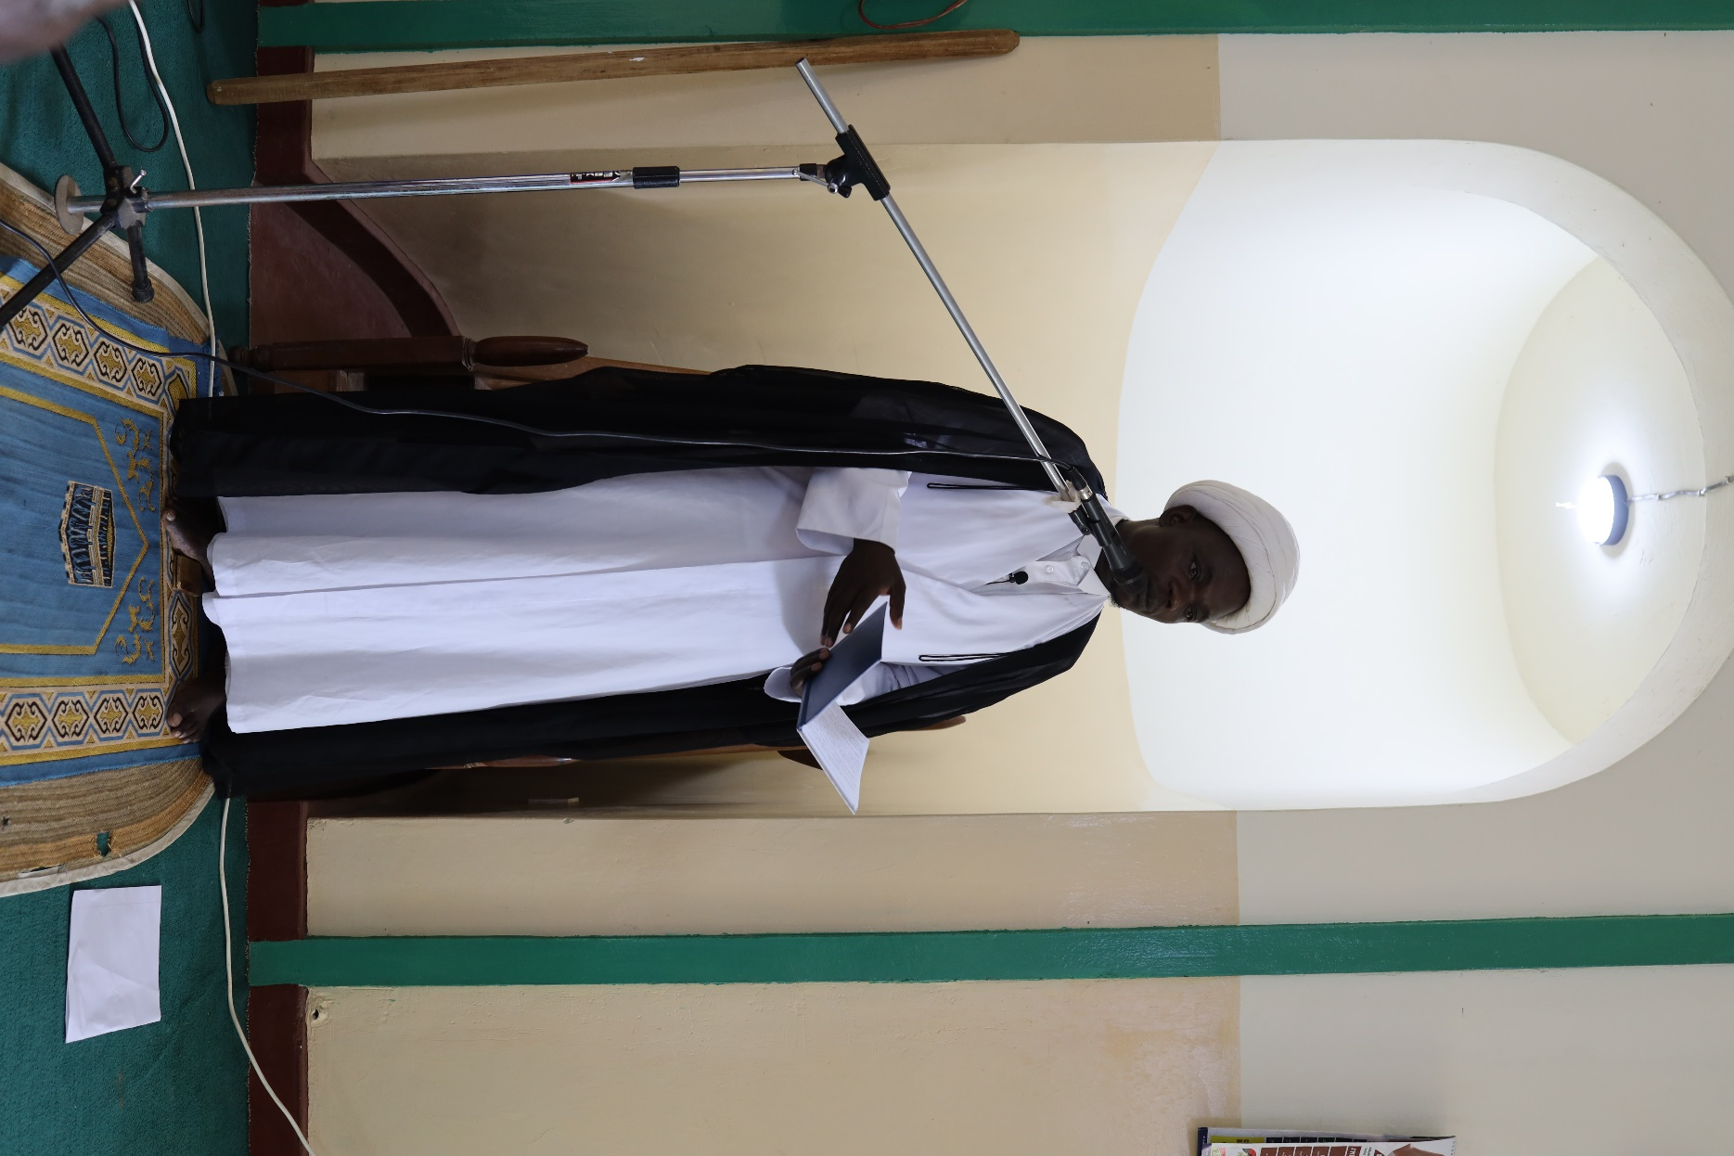

With generous support from donors and considering the nobility of offering sacrifice and distributing the meat of sacrificial animals on this auspicious day, the aforementioned initiative was undertaken at fifty-one established centres, fifteen being fully Bilal-backed locations. The remaining thirty-six were independent centres to whom we extended support. The programme was also conducted in other regions in the Country. The meat was distributed to believers in attendance as well as to neighboring families and orphanages.

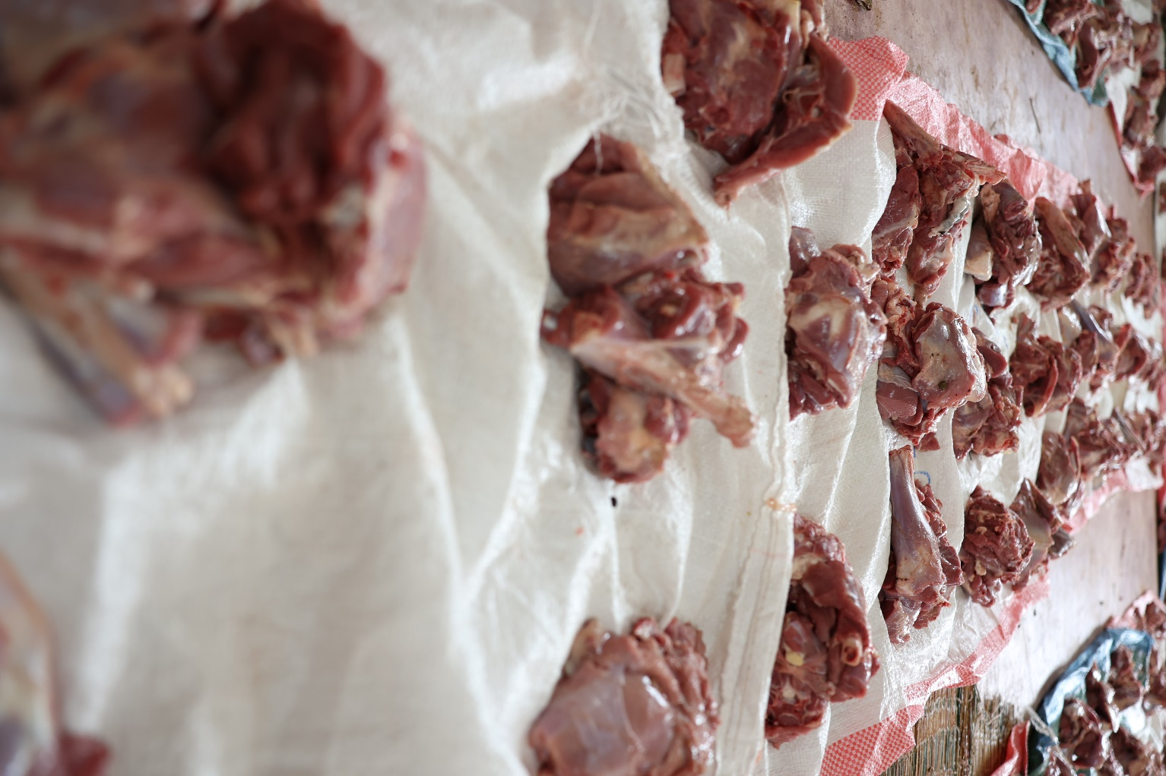

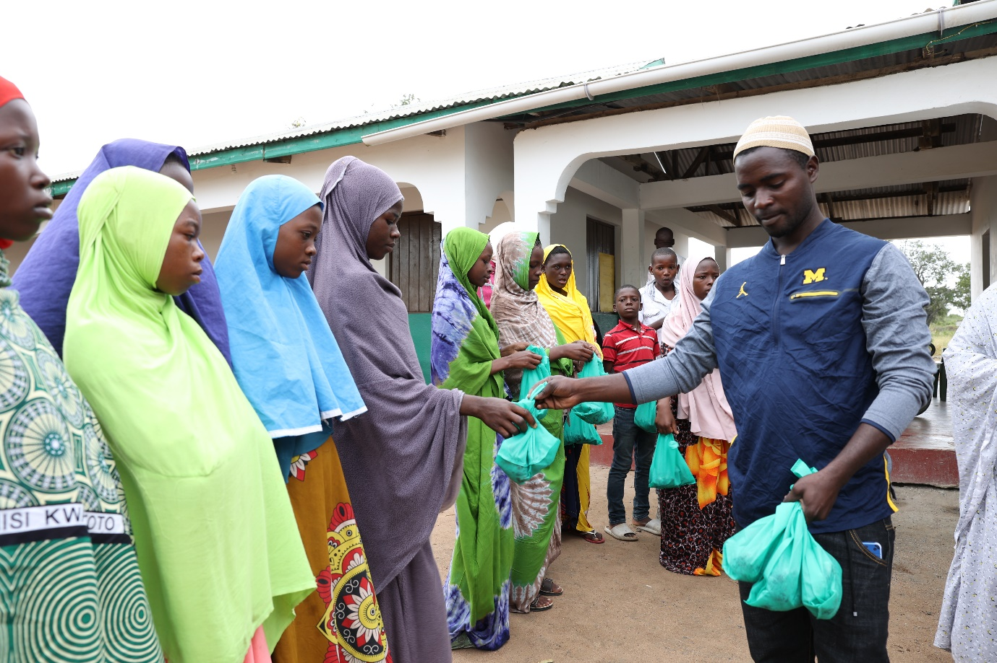

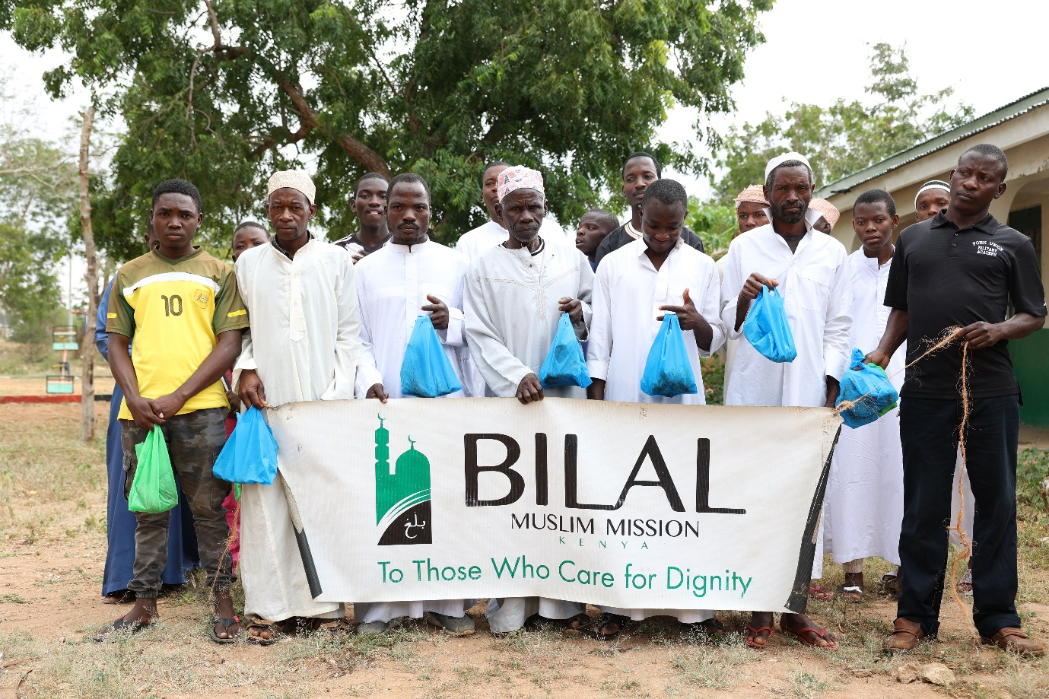

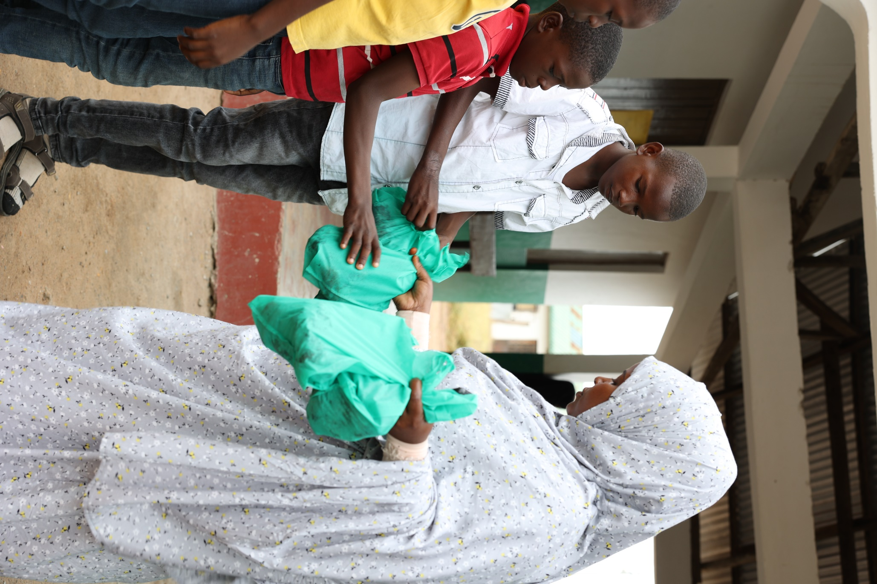

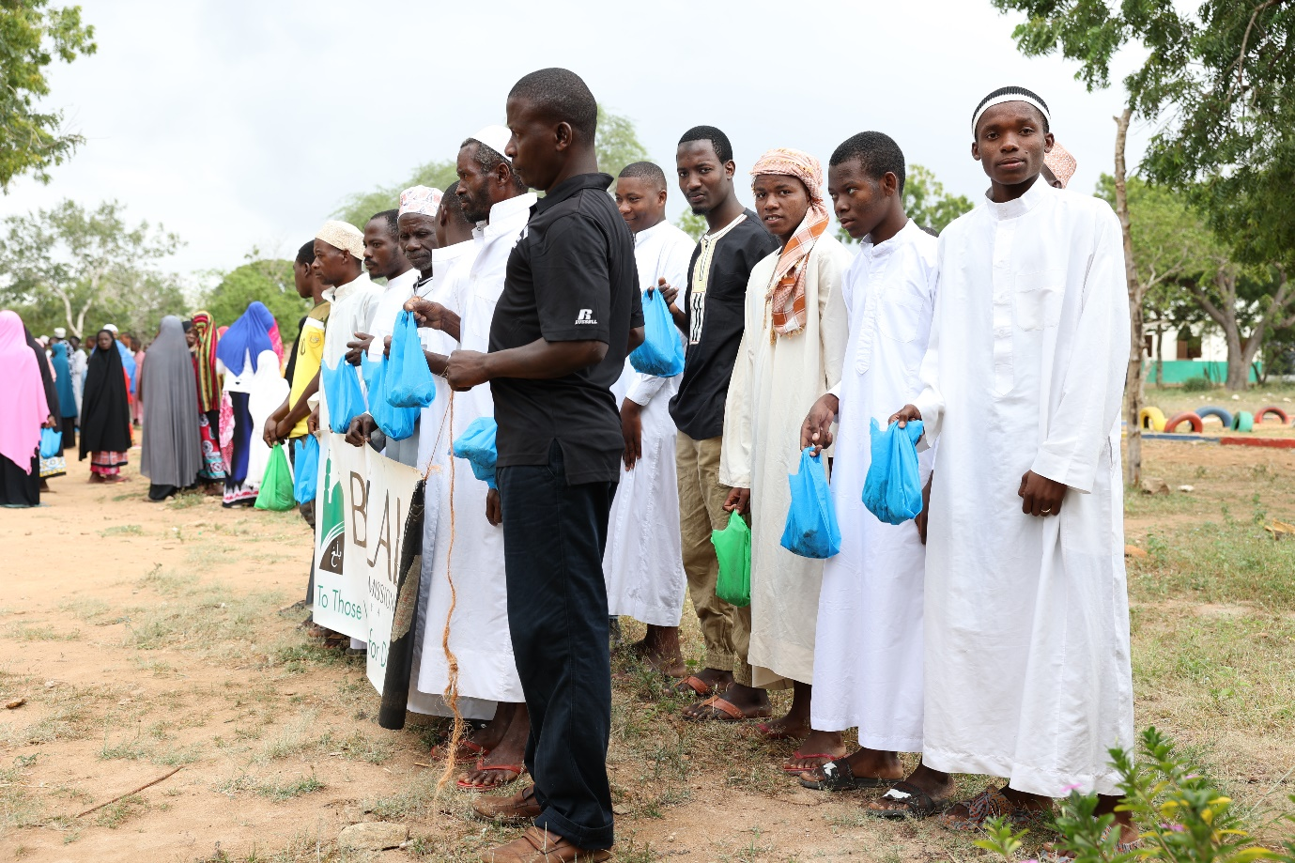

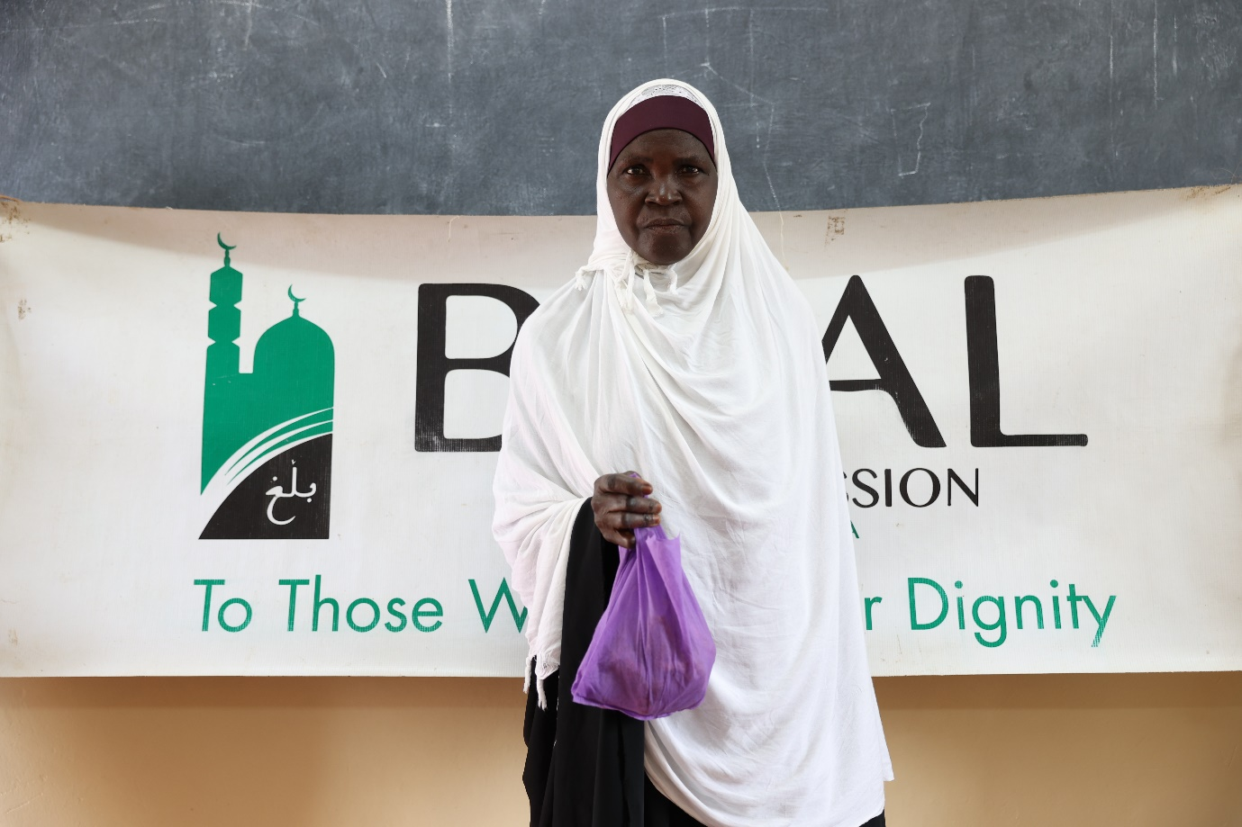

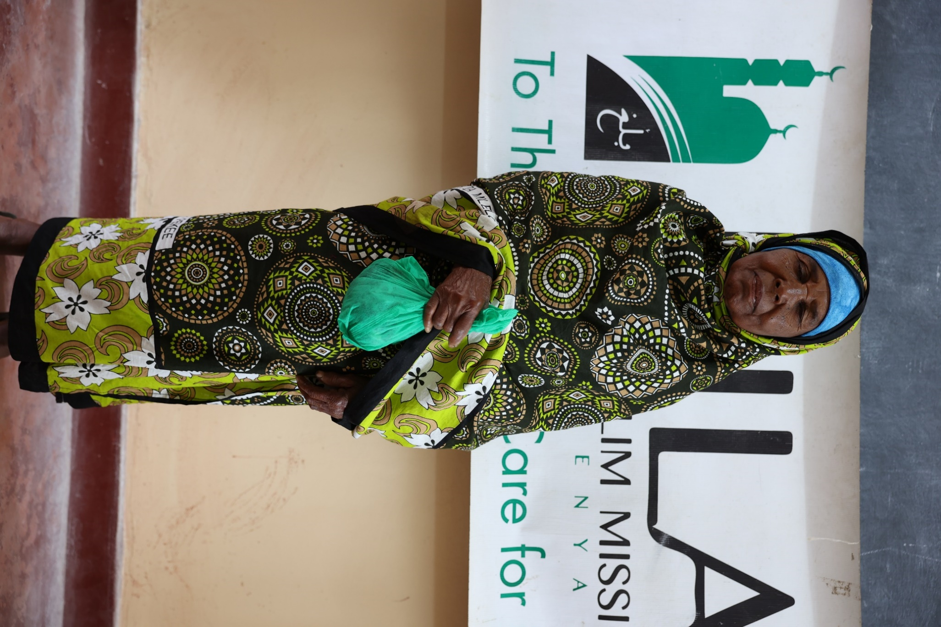

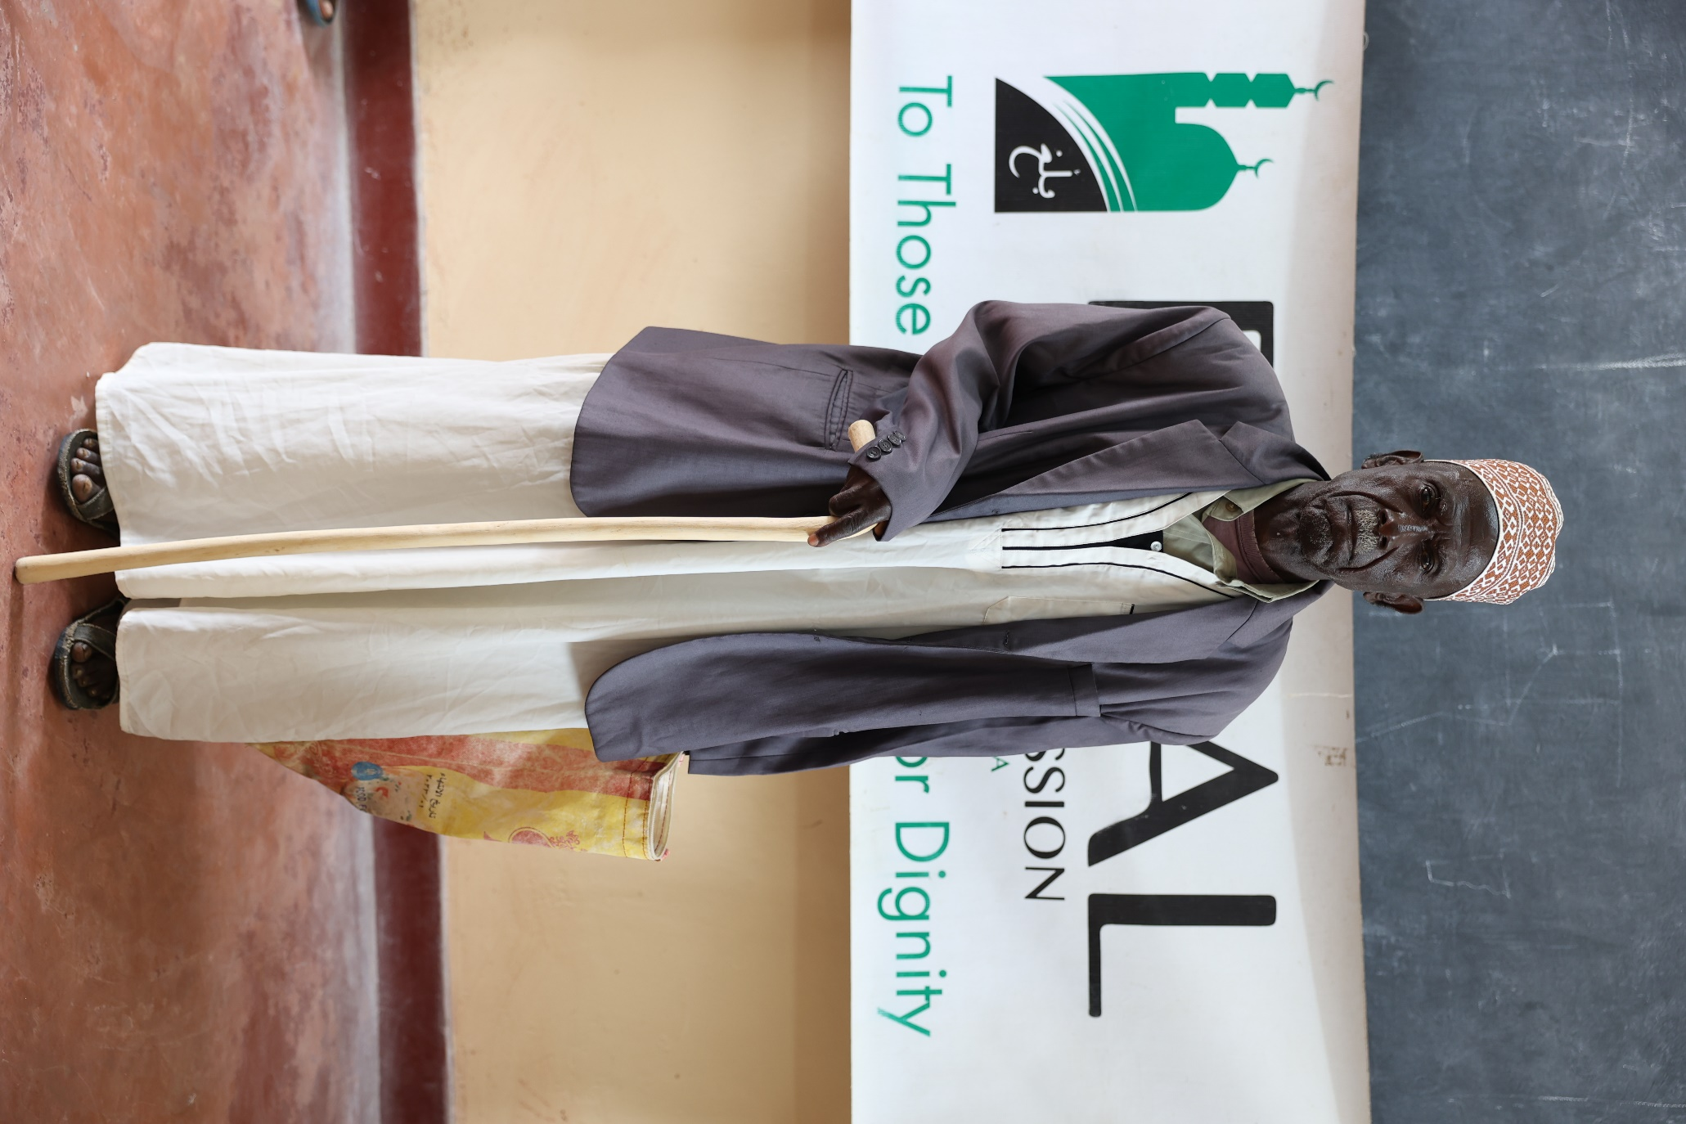

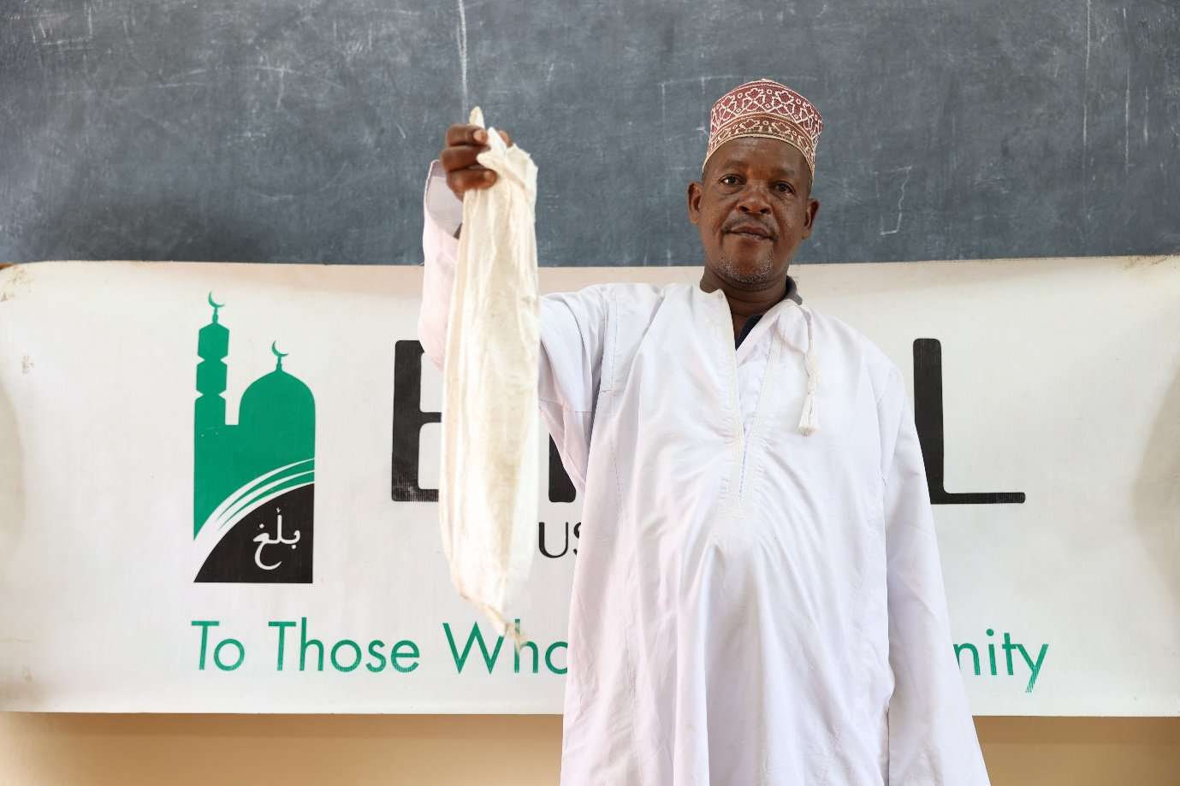

Impact

|  |  |
| --- | --- |
| Location/ Region | Number of goats distributed |
| Bilal muslim mission of Kenya centres | 450 |
| Independent centres | 296 |
| Mombasa | 35 |
| Lamu, Malindi, Kilifi and Tana River | 65 |
| Upcountry | 150 |
| Total 996 | |

Appreciation

The Bilal Muslim Mission of Kenya is appreciative of the support it has received from donors as a result of which it has been possible for numerous families to celebrate Eid ul Adha in a joyous and memorable way this year.