FEED A CHILD PROGRAMME
FEBRUARY AND MARCH 2023

Allah the most Majestic emphasizes the feeding of others in the Holy Quran. In one verse he places the command to feed those who are in need directly after the command to believe in Him. In another verse the importance of feeding others is emphasized when it is mentioned directly after the act of praying.
The Bilal Muslim Mission of Kenya extends its gratitude to its partners WF-AID and AFED for their generous and unwavering support to the feed a child programme for the beginning of the year 2023. The programme operated on the weekends at the Madrasahs from the 11th of February to the 12th of March, and at the Pre Primary Schools from Mondays to Fridays from the 9th of February to the 10th of March and there has been substantial positive impact on the wellbeing of the children at all fifteen centres.
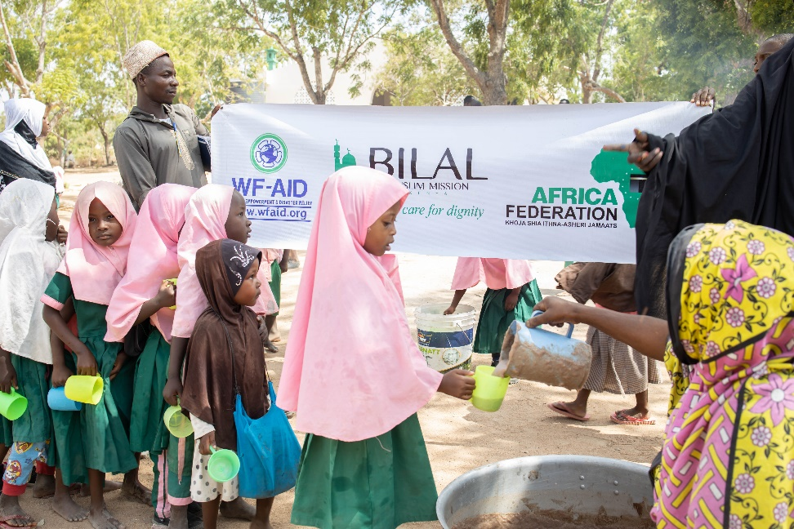
A large cup of a delicious sweet milky millet porridge was served to the students for break. Millet grains are rich in antioxidants, soluble fibre and protein. The meal is high in calcium, provides ample iron and contains the amino acid methionine which is important for joint health. This report endeavours to give you a closer look at some of the students who have benefitted, in addition to sharing some visually captured moments whilst the project was in operation.

NO. OF BENEFICIARIES FROM FEB-MARCH 2023
MADRASSAH
2594
PRE-PRIMARY
728
TOTAL
3,322

Mwanamvua Mwachunga, Shimoni
Mwanamvua makes her way to school on a hot March morning, with temperatures reaching 30 degrees Celsius, having spent the night with her family in their poorly ventilated two-bedroom home. She has six siblings, whilst the breadwinner in this household is Saumu Hassan, their widowed mother who sells Mandazi, a delicious fried bread, to make a living. Alas, the income she earns is not nearly enough as what the family require to prosper.
Alhamdulillah, nevertheless, Allah has promised relief with every difficulty. There is a wholesome mid-morning snack Mwanamvua looks forward to daily. This ensures she does not remain hungry during the late morning hours and also provides her with essential nutrients. Better grades are an added bonus and her attendance at the Ahlulbayt Madrasah has also taken a turn for the better!

Ibrahim Ndegwa, Moyeni
Ibrahim is a charming young scholar attending the Moyeni school and Ahlulbayt Madrasah. His parents are separated. He currently lives with his eighty-year-old grandmother. This young man’s mother relies on temporary work when she is able to procure it to support her family. The cup of porridge Ibrahim receives for brunch is an added incentive to attend daily. It has increased his cheerfulness, he is excelling in his studies and he absolutely loves attending madrasah.

Fisabilillah Khalid, Mackinnon Road
‘In the cause of Allah’ is the meaning of the name that this young girl has been given by her parents. Khalid Issa and his wife are small-scale farmers who have been struggling to put food on their table due to prolonged periods of drought in the region of Kenya where they reside. There are days when there is nothing to eat in their home.
Ustadh Hassan is one of the Madrasah teachers at the Jaffery Madrasah at the Mackinnon Road centre. He relates that this young pupil makes it a point to attend school and madrasah, knowing that she will be able to satiate her hunger when she receives her cup of porridge. Several other children also hail from similar familial backgrounds and the teacher writes in their case studies that they and their families ‘survive due to the power of Allah only.’

This programme, which runs in the cause of Allah swt, touches so many lives. It makes an otherwise trying day feel so much easier to get through for so many children.We pray to Allah swt to reward all those who partake in such noble causes in this world and in the hereafter and we look forward to their continued collaboration.
BMMK Team.

