LUNCH PROGRAMME 2023

PHASE TWO

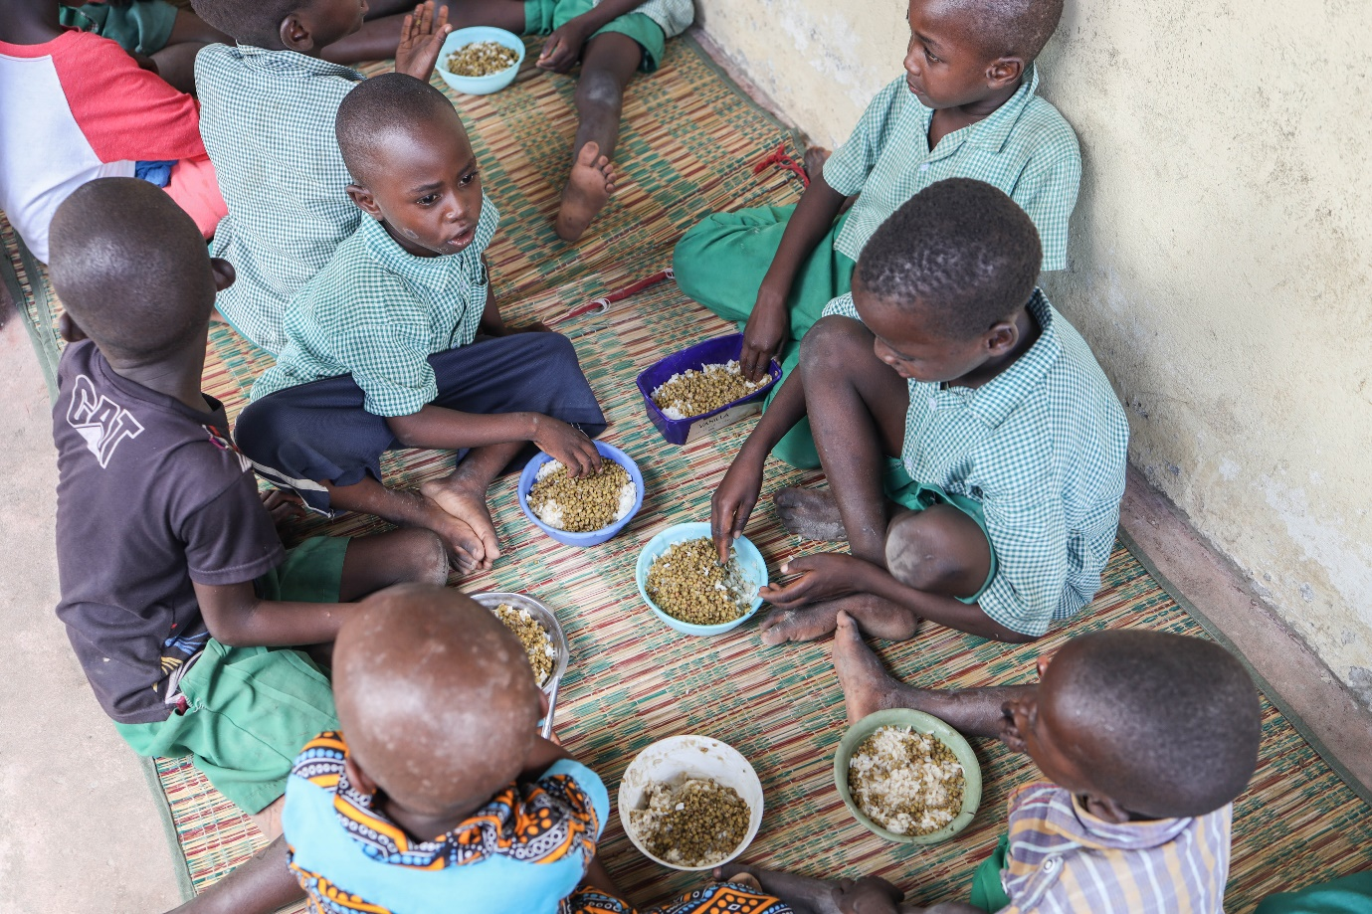





In 2023, the global food crisis continues to be driven by various converging factors. At least 153 million children are estimated to be among the global population currently facing food insecurity. School feeding remains a proven and effective method to improve food security and nutrition. These programmes are crucial nutrition and learning support nets for numerous children and also assist the wider community. Following the successful run of the initial phase of the Lunch Programme launched early this year, the Bilal Muslim Mission of Kenya partnered with generous donors once again to ensure the satisfactory completion of the second phase of the same programme. Fresh and nourishing lunches, were availed at Bilal-supported centres and Independent Madaris. Cooks were now well-experienced on the quantities to be prepared and the importance of avoiding wastage, having been properly directed during the initial phase of the programme.

**Lunch programme at Bilal-supported centres**

Eight tons each of rice, maize flour, beans and green grams were purchased and distributed in accordance to the need at different centres. The programme operated on the Weekends at the Madrassas from the 13th of May to the 2nd of July. At the Pre-Primary schools, lunches were served from the 8th of May to the 7th of June every week day.

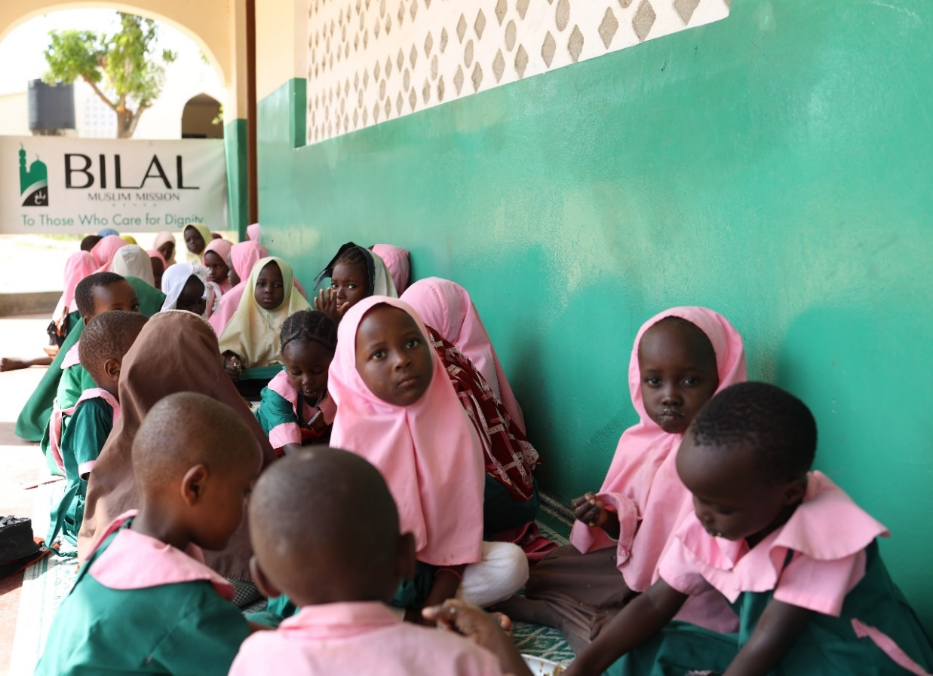

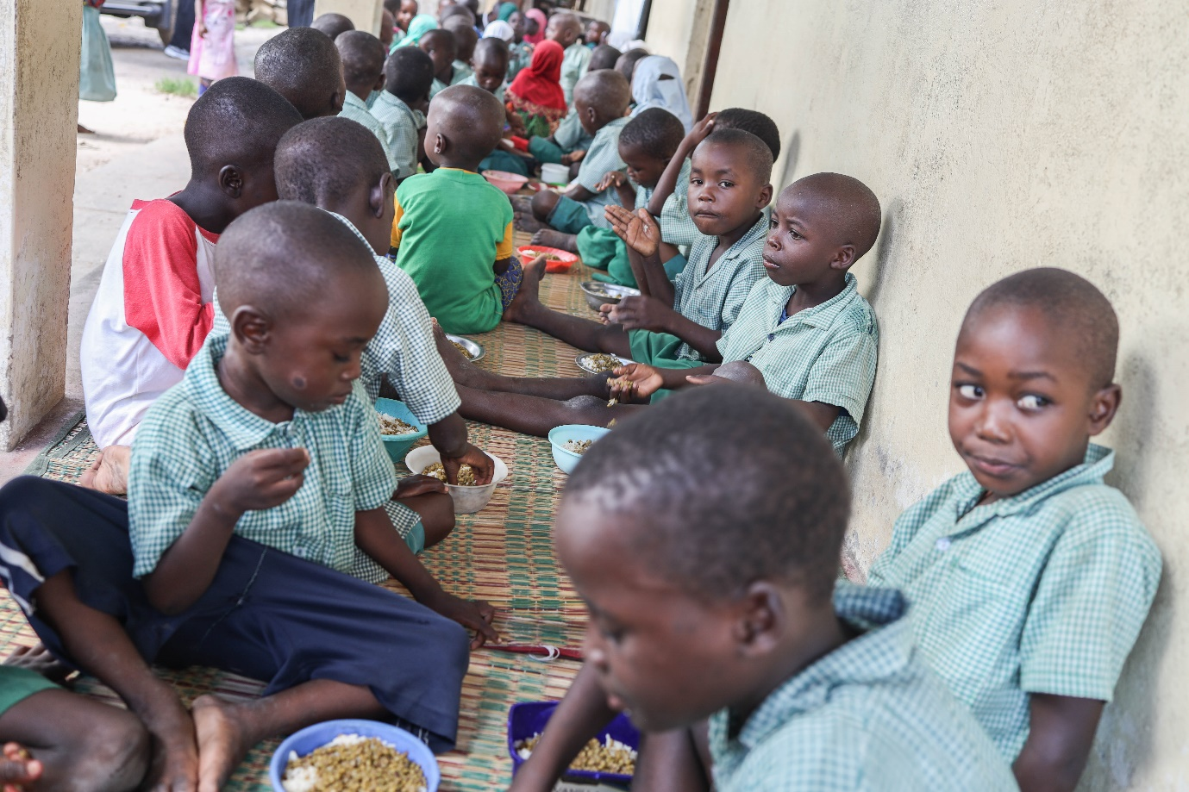

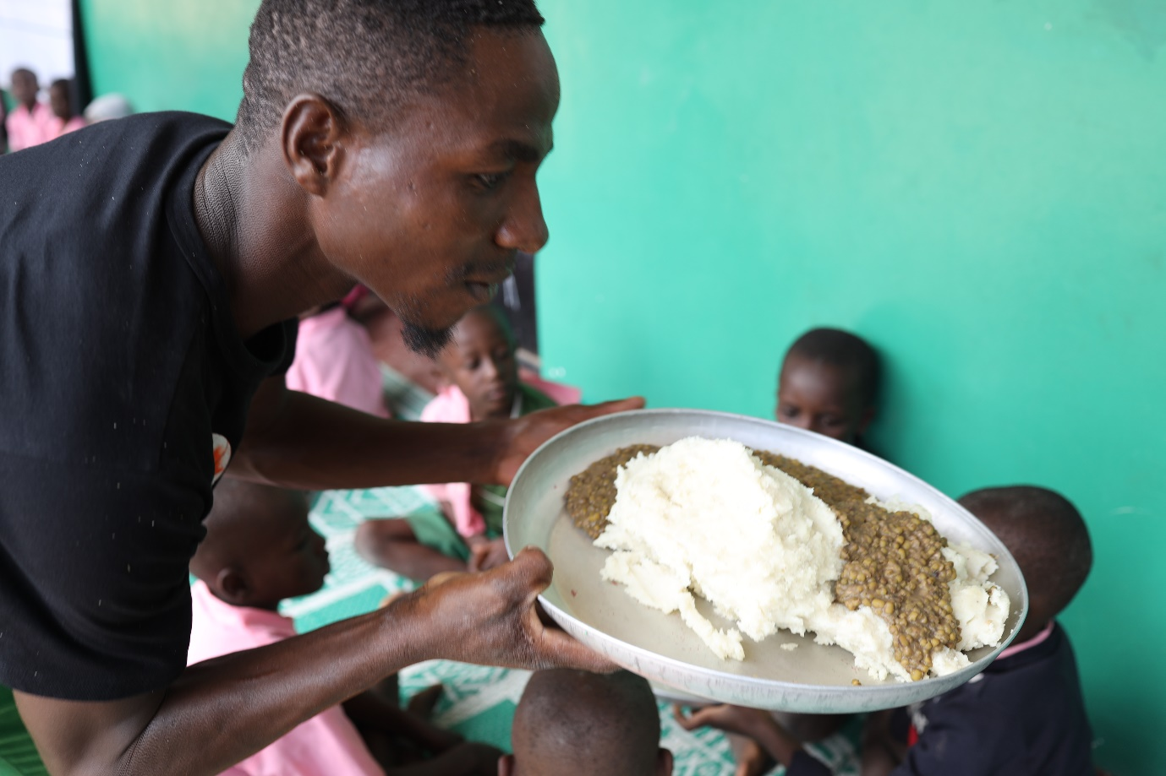

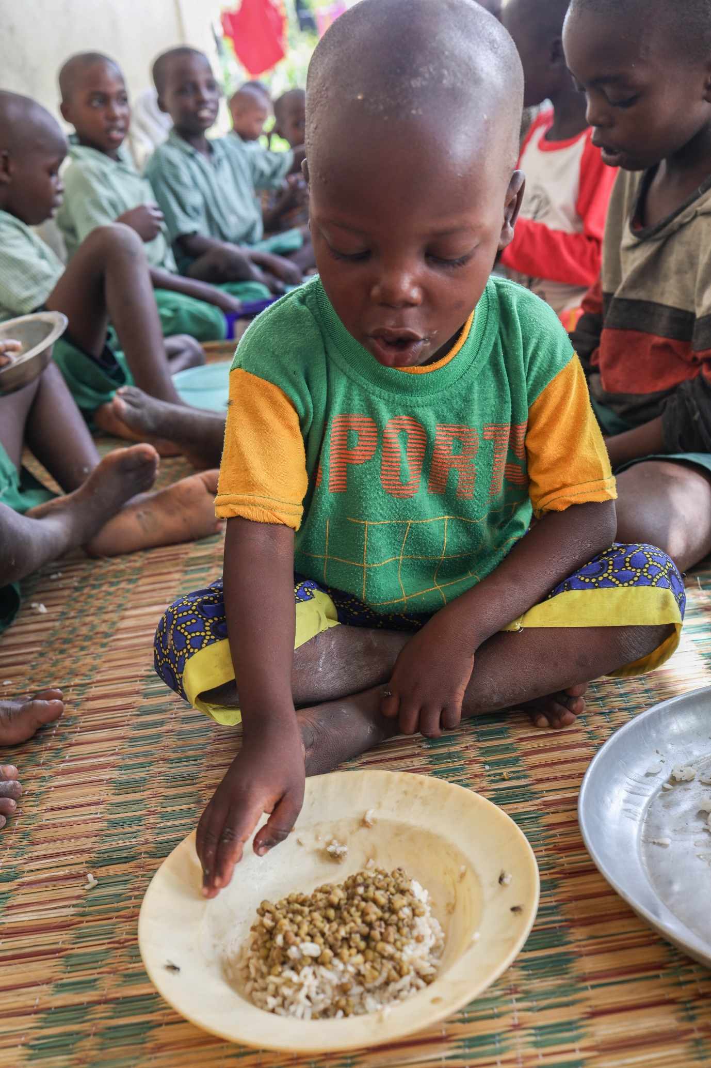

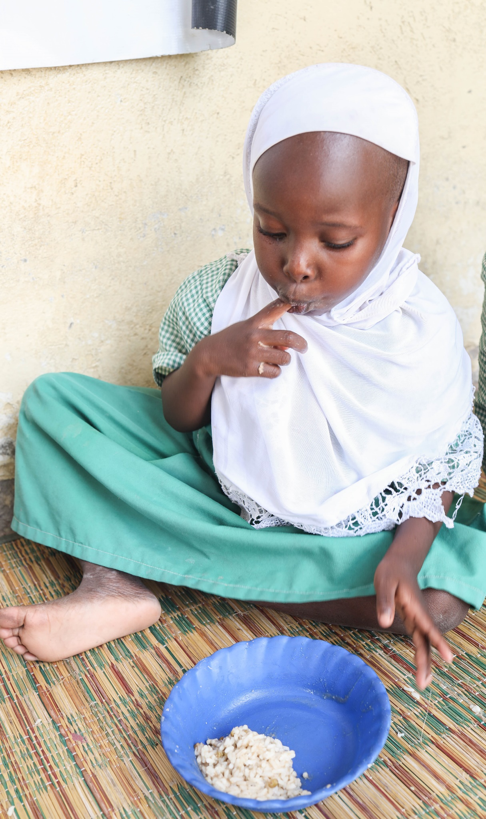

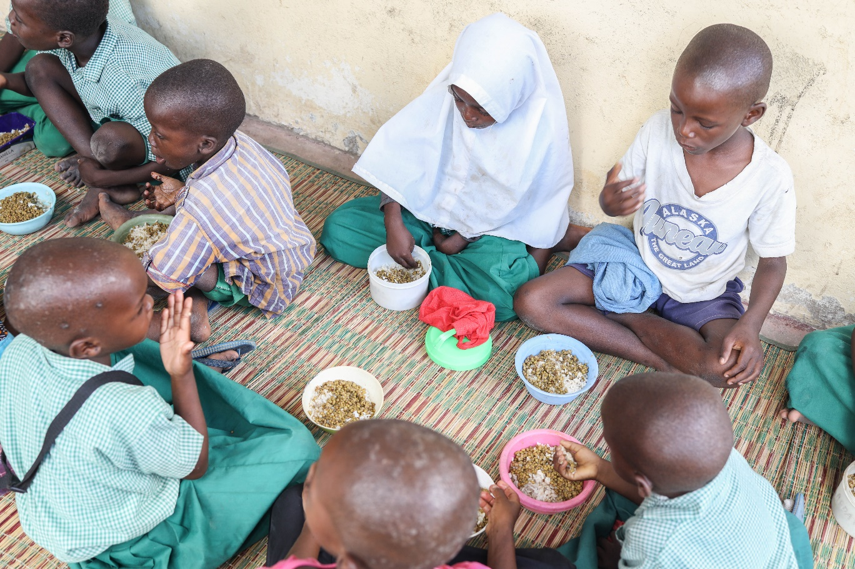

**Lunch programme at independent madaris**

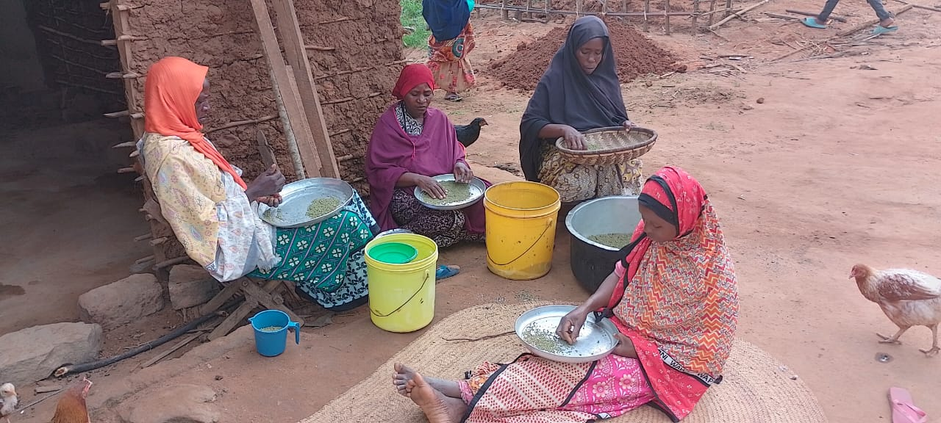At seven independent madaris, the programme was conducted from the 7th of May to the 20th of August on the weekends. Three hundred and forty learners benefitted.

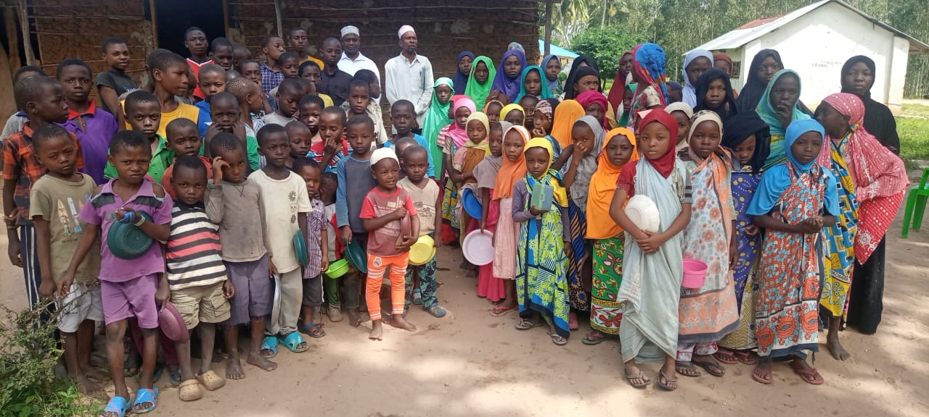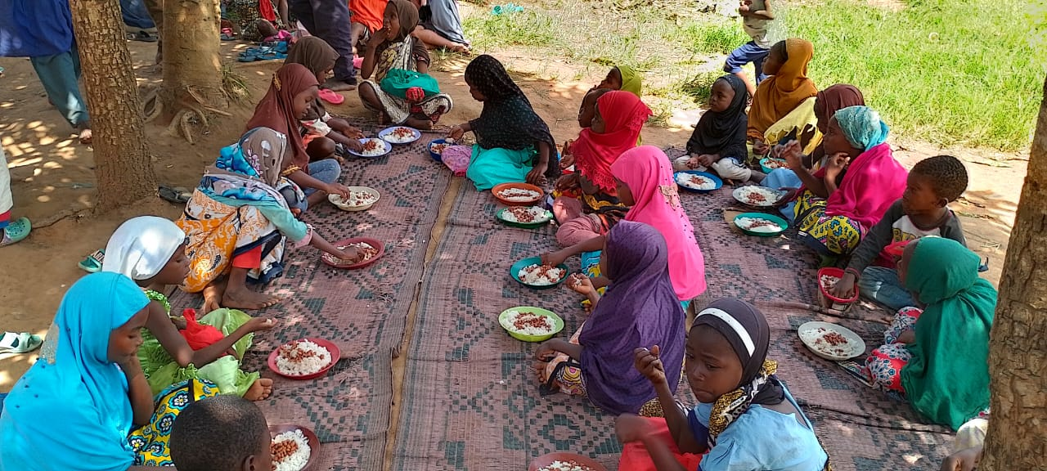

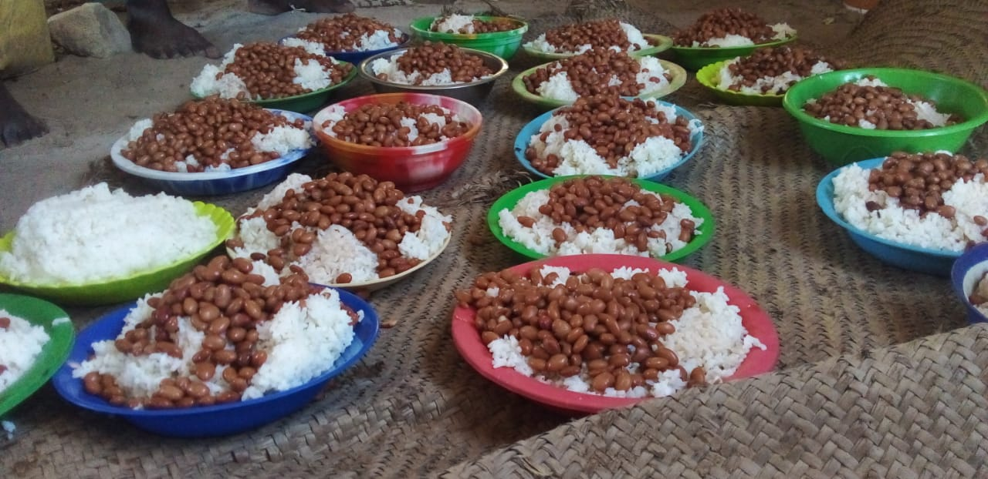

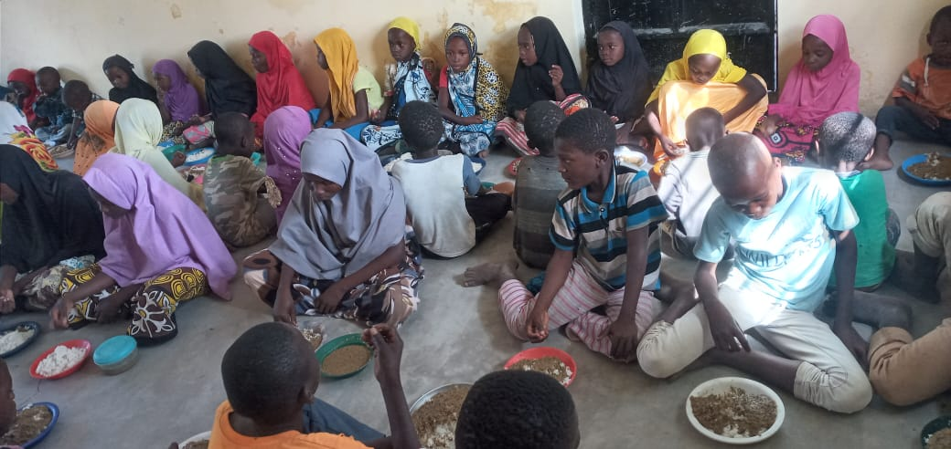

**Impact**

**Beneficiaries at Bilal-supported Centres**

|  |  |
| --- | --- |
| Pre-primary learners | 716 |
| Madrassa learners | **3049** |
| Total 3765 | |

**Beneficiaries at independent madaris**

|  |  |
| --- | --- |
| Madrassa | Number of learners |
| Jafferiya-Pengo | **30** |
| Al-Ridha Kibuyuni | **53** |
| Amirul Muminin-Zayoni | **50** |
| Hidaya Kajiweni | **62** |
| Al Farisy-Mwele | **62** |
| Zainul Abidiin- Kibarani | **38** |
| Al Hujjah Mafusi | **45** |
| total 340 | |

**Appreciation**

The Bilal Muslim Mission of Kenya is grateful for the generous financial support we received which enabled the successful completion of the second phase of the lunch programme this year.