LUNCH PROGRAMME

PILOT SCHEME 2023

**BILAL CENTRES AND INDEPENDENT CENTRES**

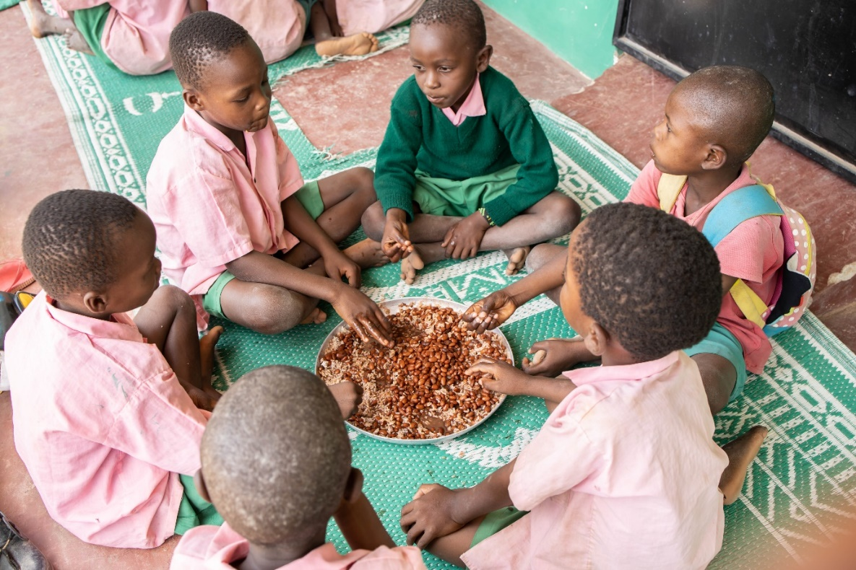





*إِنَّمَا نُطْعِمُكُمْ لِوَجْهِ اللَّهِ لَا نُرِيدُ مِنكُمْ جَزَاء وَلَا شُكُورً*

“We feed you for the sake of God alone: we desire no recompense from you, nor thanks.”

***Surah Al – Insan76:9***

The United Nations Committee on Economic, Social and Cultural Rights has declared that ‘the right to adequate food is realized when every man, woman and child, alone or in community with others, has physical and economic access at all times to adequate food or means for its procurement.’

The Bilal Muslim Mission of Kenya, with generous support from its partners, has been a stalwart advocate for a child’s right to adequate food. This year has seen the initiation of a new programme in this regard. The initial phase of the ***Lunch programme*** for the year 2023 has been very successful with the blessings of Allah swt. There has been substantial positive impact observed on the wellbeing of the numerous children that have benefitted.

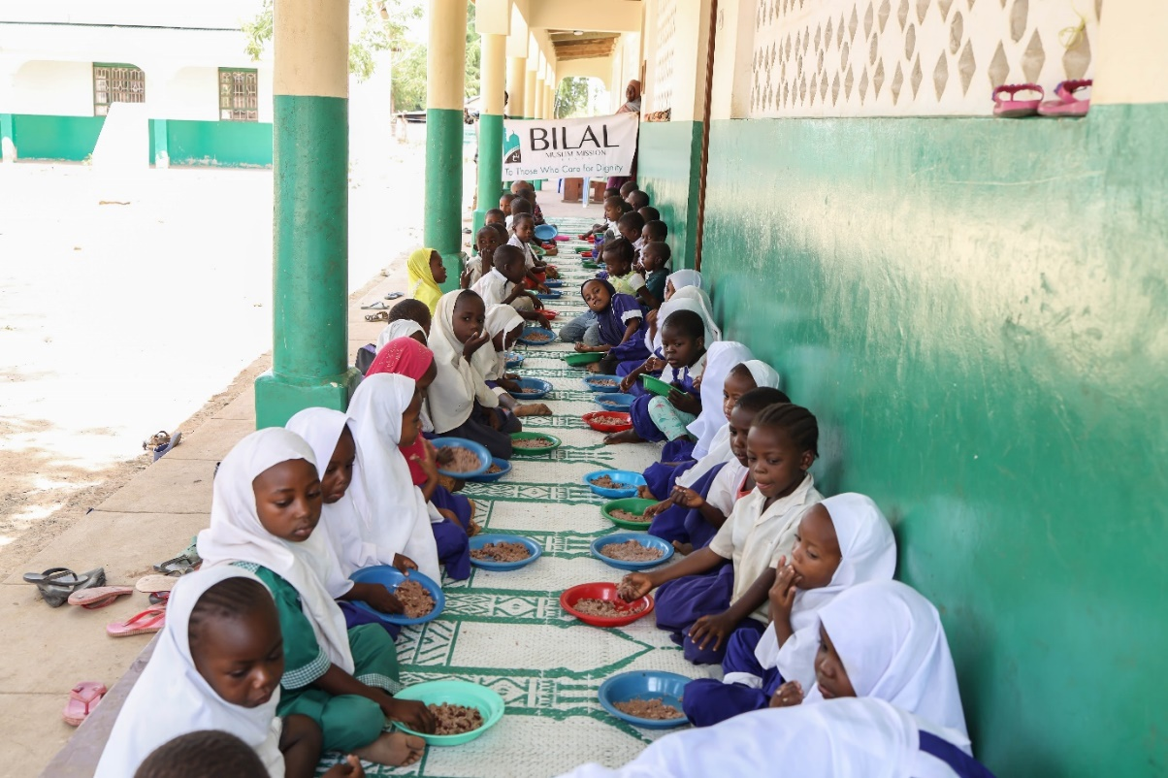

**BILAL CENTRES**

The programme operated on the Weekends at the Madaris from the 11th of February to the 12th of March. At the pre-primary schools, lunches were served from the 23rd of January to the 3rd of March from Mondays to Fridays.

Nutritious, well balanced and fresh lunches were prepared daily, in correlation with the number of children in attendance on the day. Cooks were guided and well-advised on quantities to be prepared and the importance of avoiding wastage.

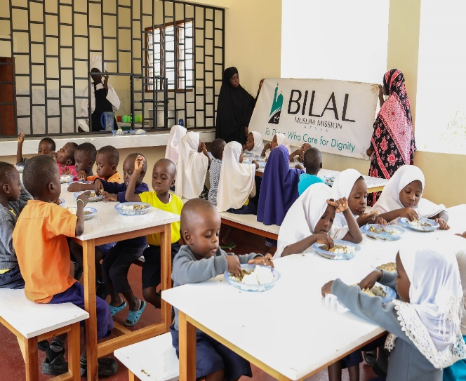 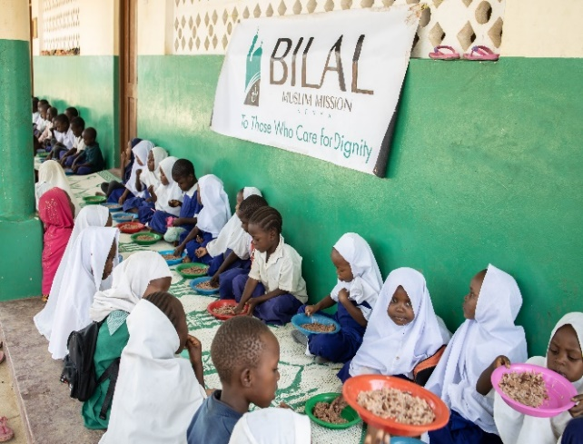

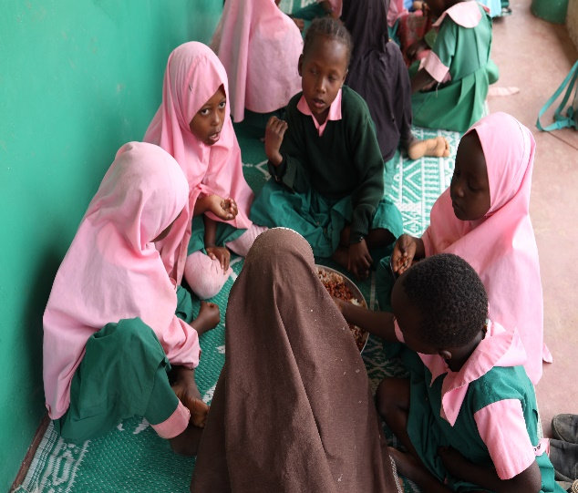 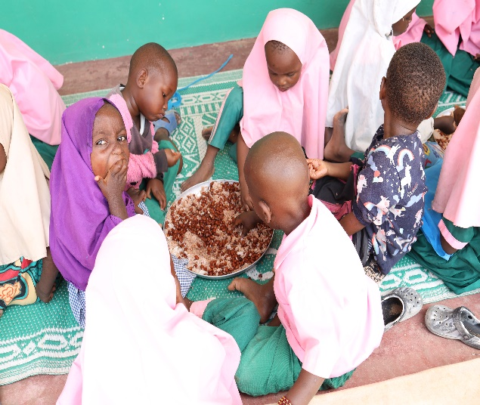

**BENEFICIARIES OF LUNCH PROGRAMME – PHASE ONE 2023**

|  |  |
| --- | --- |
| Madaris | 2519 |
| Pre-primary | 683 |
| Total | 3202 |

**INDEPENDENT CENTRES**

The project was launched on the 4th of February 2023 at the Madaris at seven independent centres. The respective local communities were appreciative of this initiative and showed their support in various ways where possible. This included the provision of a cook, clean water and firewood.

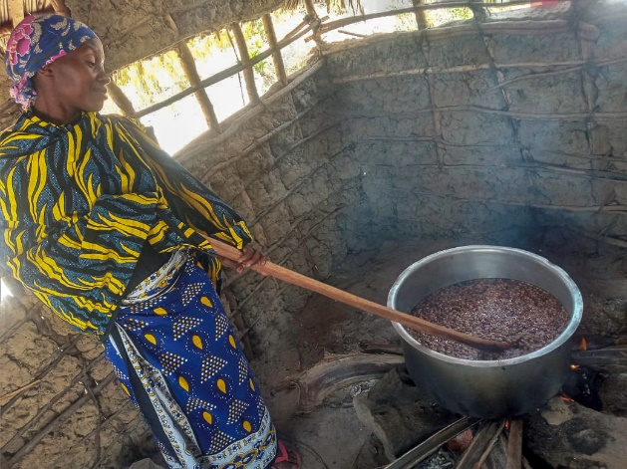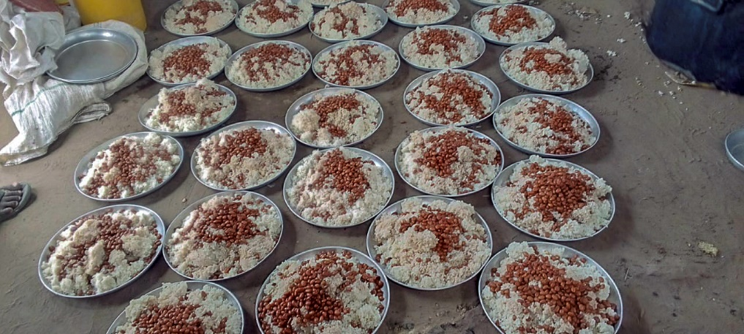

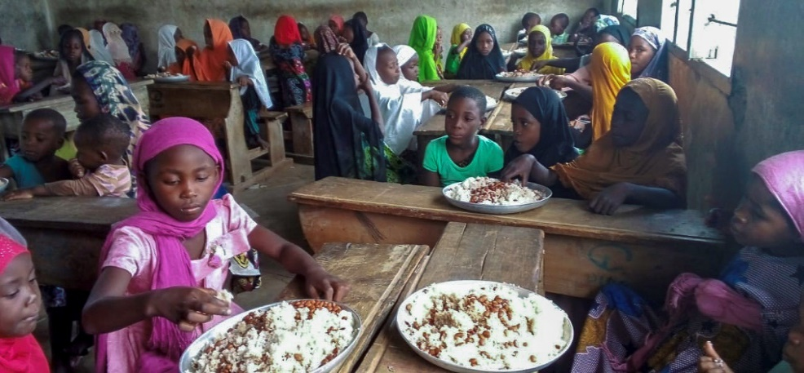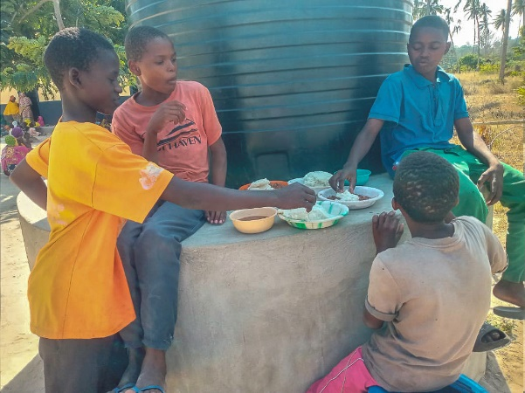

BENEFICIARIES AT INDEPENDENT MADARIS

|  |  |  |
| --- | --- | --- |
| NO | CENTRE | LEARNERS |
|  | Jafferiya-Pengo | 75 |
|  | Al Ridha-Kibuyuni | 86 |
|  | Amirul Muuminin-Zayoni | 115 |
|  | Hidaya-Kajiweni | 181 |
|  | Al Farisy-Mwele | 120 |
|  | Zainul Abidiin-Kibarani | 86 |
|  | Al Hujjah-Mafusi | 45 |
| TOTAL | | 708 |

**IMPACT**

* A sense of relief for so many parents struggling to provide even a single meal a day for their child at home
* Happier satiated learners
* Improved academic performance
* Improved attendance
* Healthier children

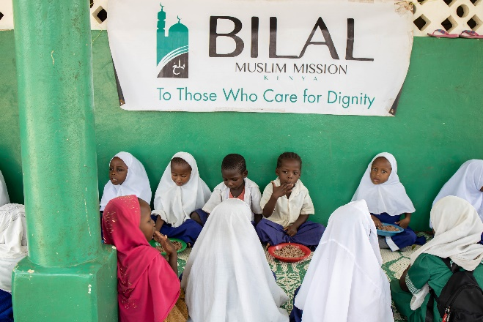

**BILAL KENYA THANKS THE DONORS WHO SUPPORTED THIS INITIATIVE GENEROUSLY**