**MUHARRAM**

**2023**

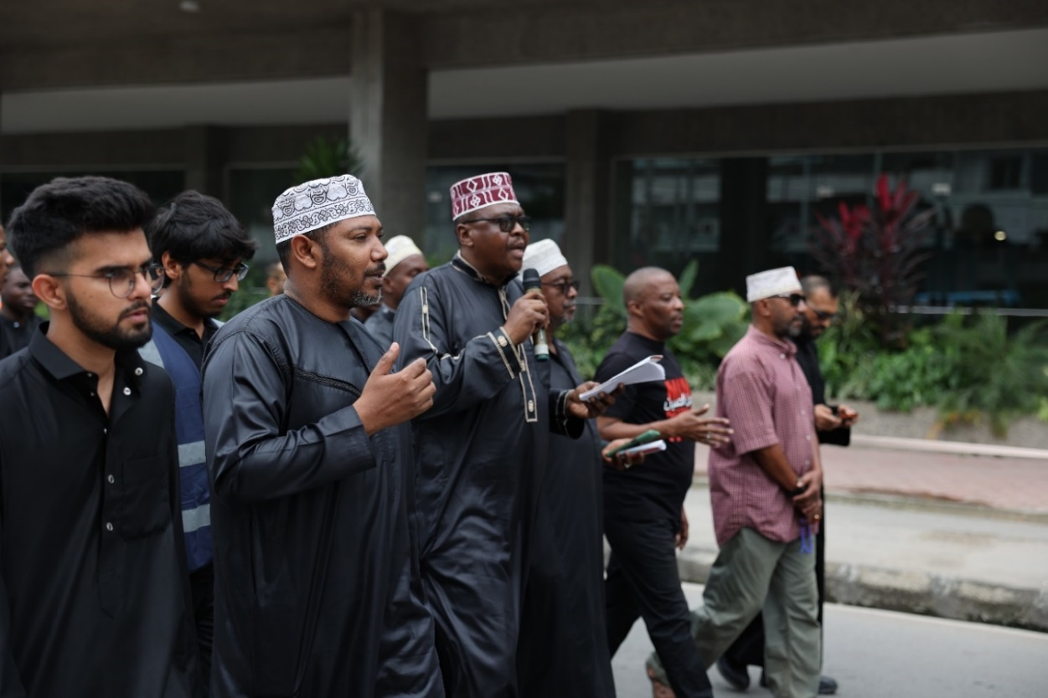





The ark of salvation springs into motion, floating on an ocean of mourners gathered from the very corners of the earth. Muharram is here. @majpoetry

This year the season of grief and reform began on the 20th of July 2023. This report primarily highlights:

* The majaalis held at the Bilal Hall in Mombasa.
* The Ashura Day procession held in Mombasa.
* The majaalis held at the fifteen Bilal-supported centres in the country.
* Purchase and distribution of food and drink items served at the majaalis.

**The central theme of the Majaalis held at the Bilal Hall in Mombasa**

The theme this year was **‘Muhanga wa karbala ukombozi kutokana na utumwa.’** It means that the Sacrifices made in Karbala freed us from slavery.

This stems from the famous line of Imam Husayn (A) **‘A person like me can never pay allegiance to a person like him’** and from the encouragement the Imam had given to those that wanted to kill him in Kerbala to be free in their thinking. Imam Husayn is Abal Ahrar, **Father of the free**. He inspired freedom in his companions and family. Freedom from physical, emotional, spiritual and mental slavery.

The lectures held at the Bilal Hall this year aimed at inspiring the same sense of freedom in us, his devoted followers.

**Ladies Majaalis at the Bilal Hall in Mombasa**

Ladies majaalis were held for nine days in the mornings from approximately 11am to 12pm. The first majlis was held on Wednesday the 19th of July. Average attendance was one hundred and thirty ladies. The inclusivity of these sessions was noteworthy, with attendees hailing from various ethnic backgrounds and different Islamic sects.

Madrasatuz Zahra was responsible for the poetry and maatam recitals. Masha Allah these were very well recited and invoked feelings of grief and sympathy in the attendees.

The speaker who delivered the majaalis for the first five days was Sister Nuru Hassan. She travelled daily from Chengoni to Mombasa to attend these sessions. A second speaker gave four equally inspiring lectures beginning on the 24th of July. In her first lecture, Sister Aisha Hiha covered the important historical sermons that undermined the tyrant Yazeed and his authority.

[Sister Aisha's Lecture](https://www.youtube.com/watch?v=1EJ_2KxWC7k)

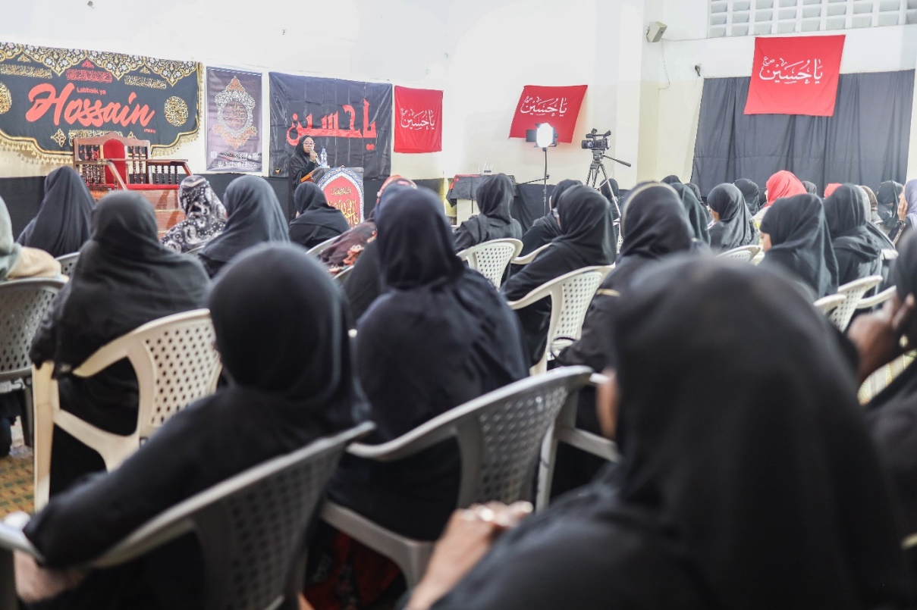

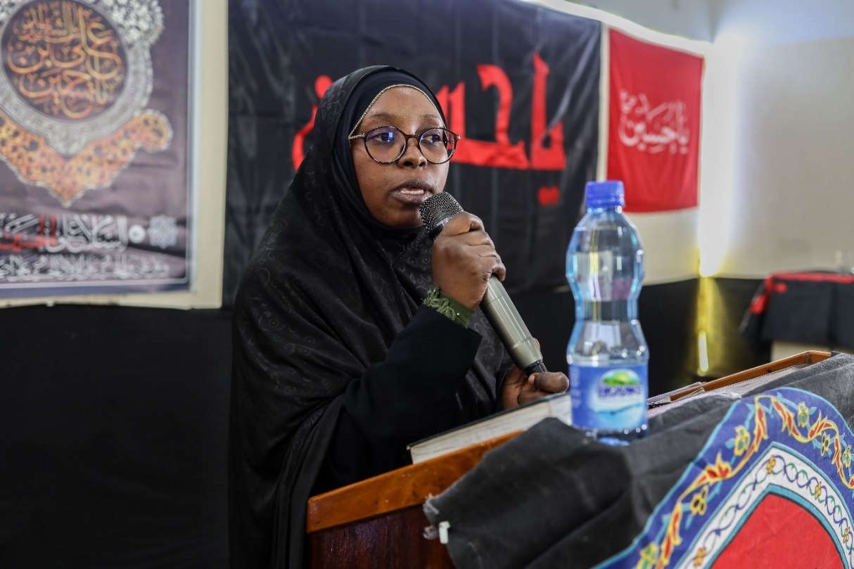

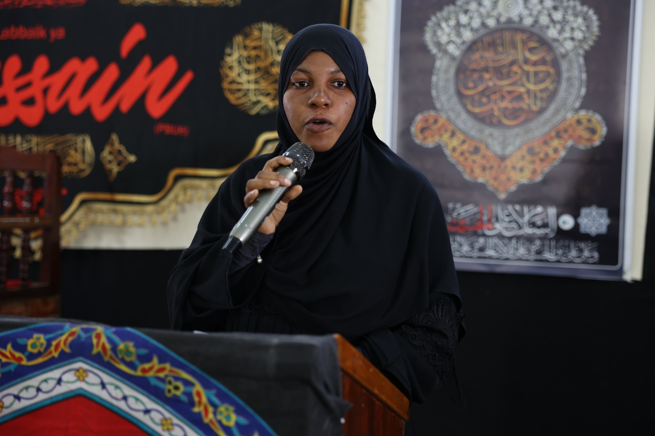

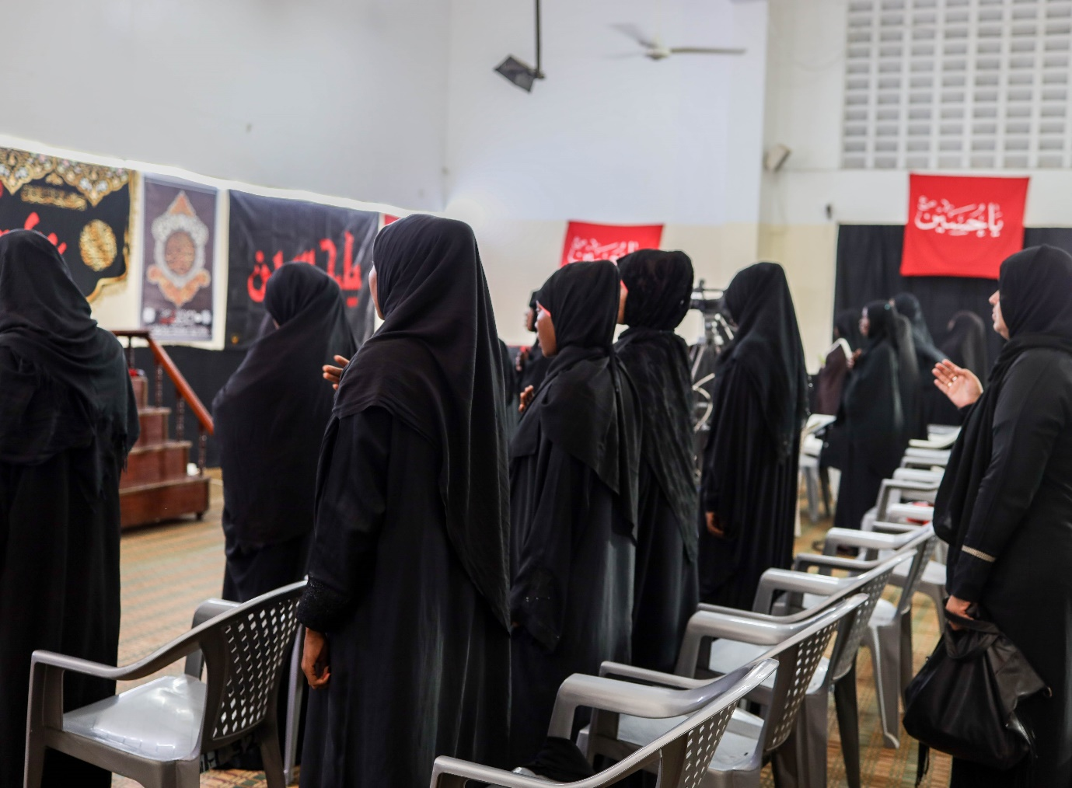

**Gents Majaalis at the Bilal Hall in Mombasa**

Majaalis for the gents were held on the same days as those for the ladies, between 5 pm and 6pm in the evenings. Average attendance was one hundred and seventy people.

Madrassa Zainul Abeidin took charge of the maatam and poetry recitals and these were beautifully delivered.

Sheikh Muhammad Dumila addressed the attendees for the first five days and Sheikh Hassan Rocky gave the remaining four lectures.

Sheikh Hassan’s fourth lecture provided an in-depth analysis of why we pray to Allah, may his glory be glorified, to remove his mercy from the killers of Imam Husayn(A). He substantiated his arguments in detail by examining several qur’anic verses in this regard. Sheikh emphasized that there can be no sitting on the fence, no grey area regarding this issue. Click on the link below to watch this intriguing discourse.

[Sheikh Hassan's Lecture](https://www.youtube.com/watch?v=YI89HOcqSK0)

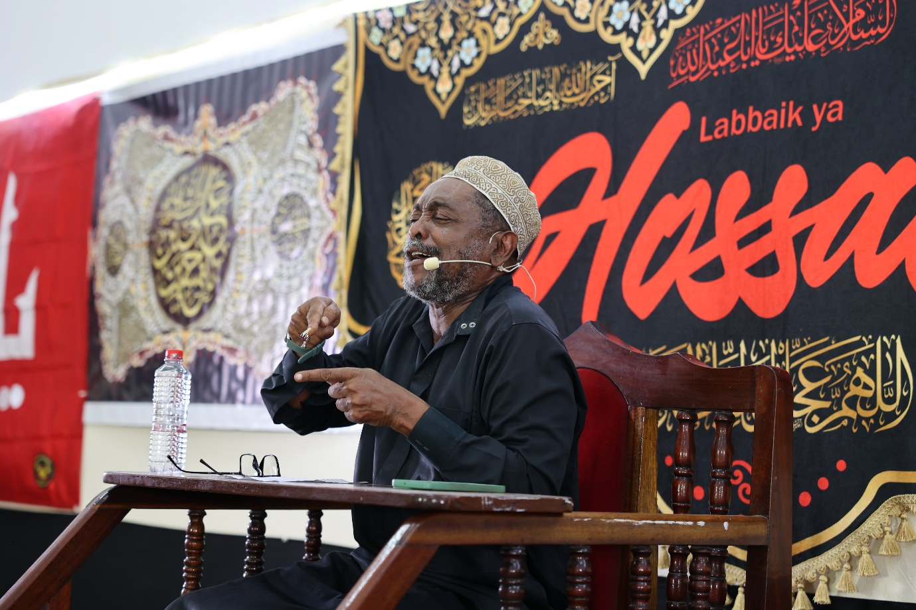

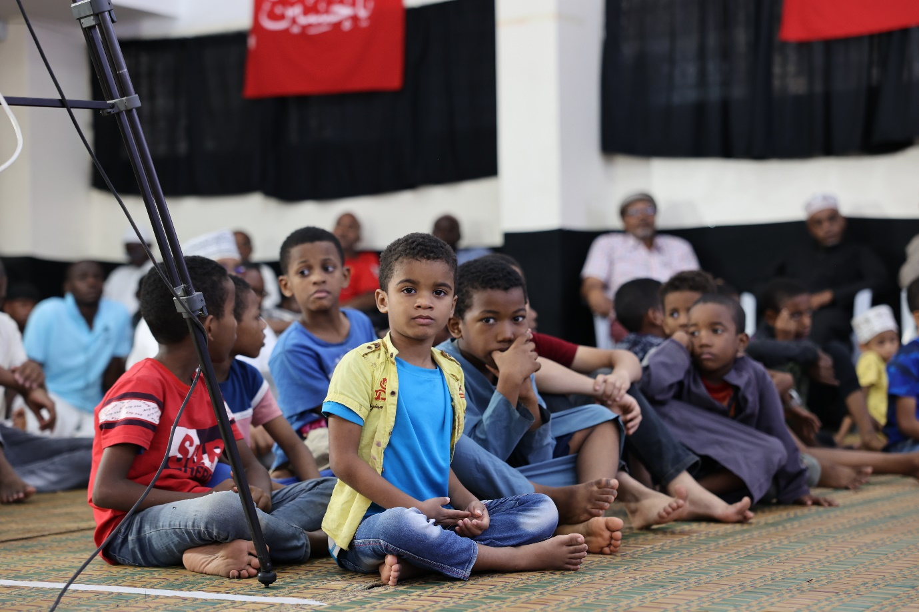

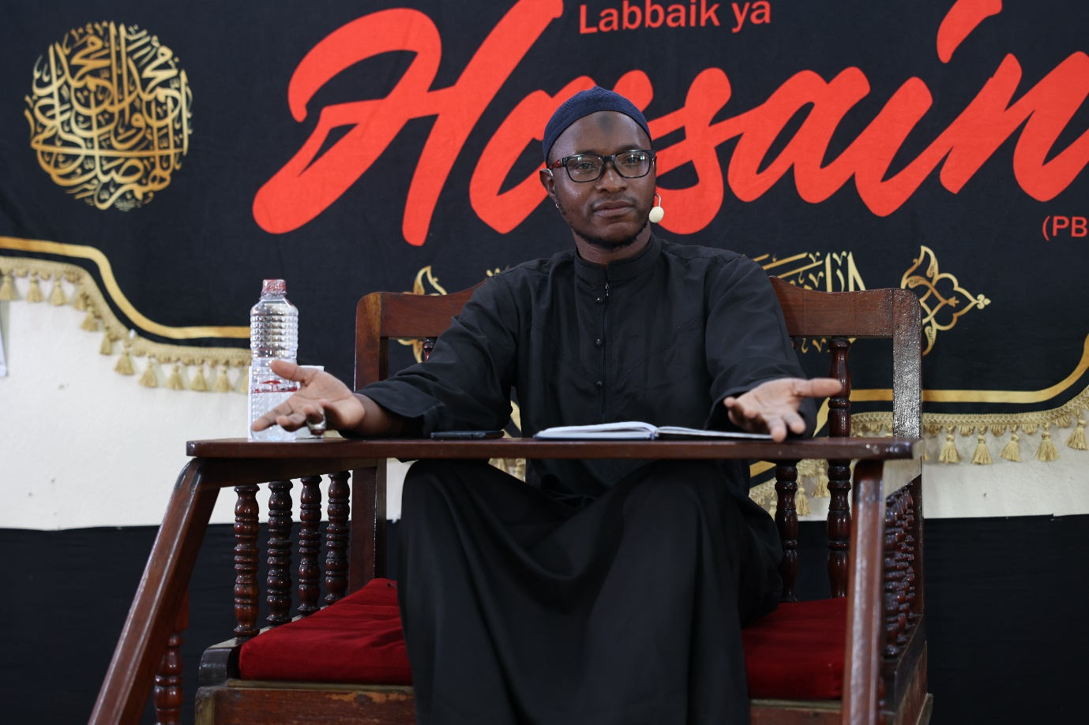

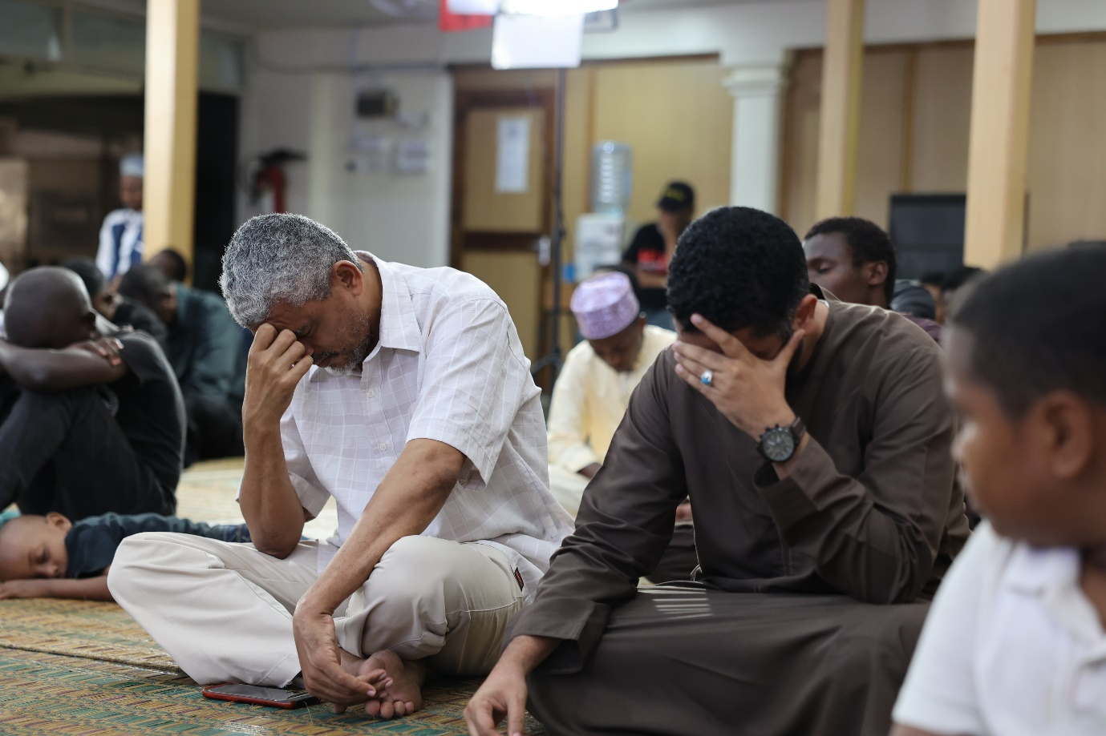

**Combined majlis at the Bilal Hall in Mombasa**

On Friday the 28th of July a Majlis for both ladies and gents was held at the Bilal Hall in Mombasa between 3pm and 5pm to commemorate and mourn over the events of the Day of Ashura. Three hundred and fifty people attended, with the schedule being similar to the majaalis held earlier.

The highlight of the programme was the address of Sheikh Juma Shughuli. He recited the tragedies that befell the courageous group of Allah on that day from the Maqtal and covered the martyrdom of AliAsgher (A) Abbas (A) and Imam Husayn (A) himself. He recited some part of the Imam’s sermon in its original Arabic form. The Imam had made final attempts at convincing the enemy to become free men!

The sheikh also recited some heartfelt and emotional poetry on Aliasgher (A) that was extremely touching and brought to life once again the savagery that was perpetrated on that fateful day on the plains of Karbala.

[Maqtal recitation](https://www.youtube.com/watch?v=L3nhWU0IgOA)

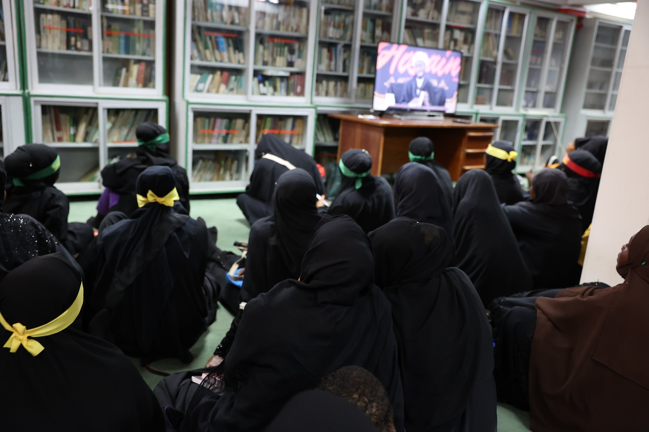

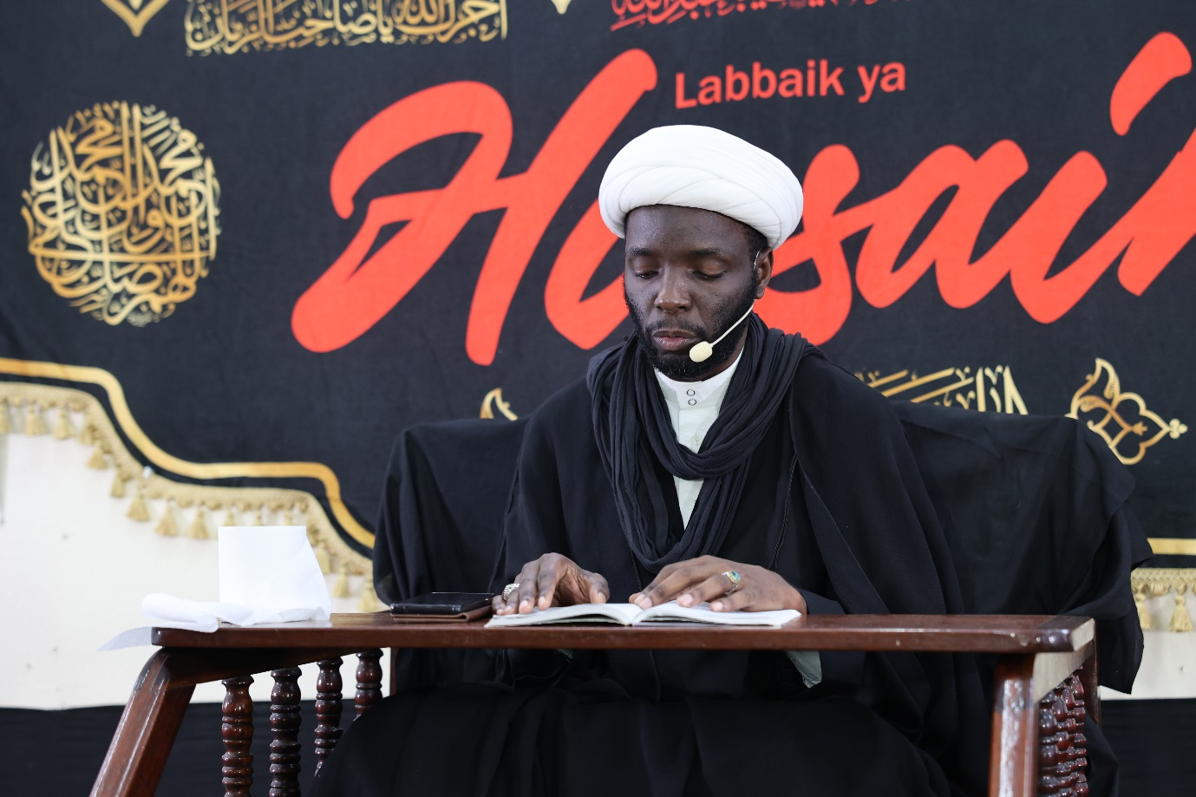

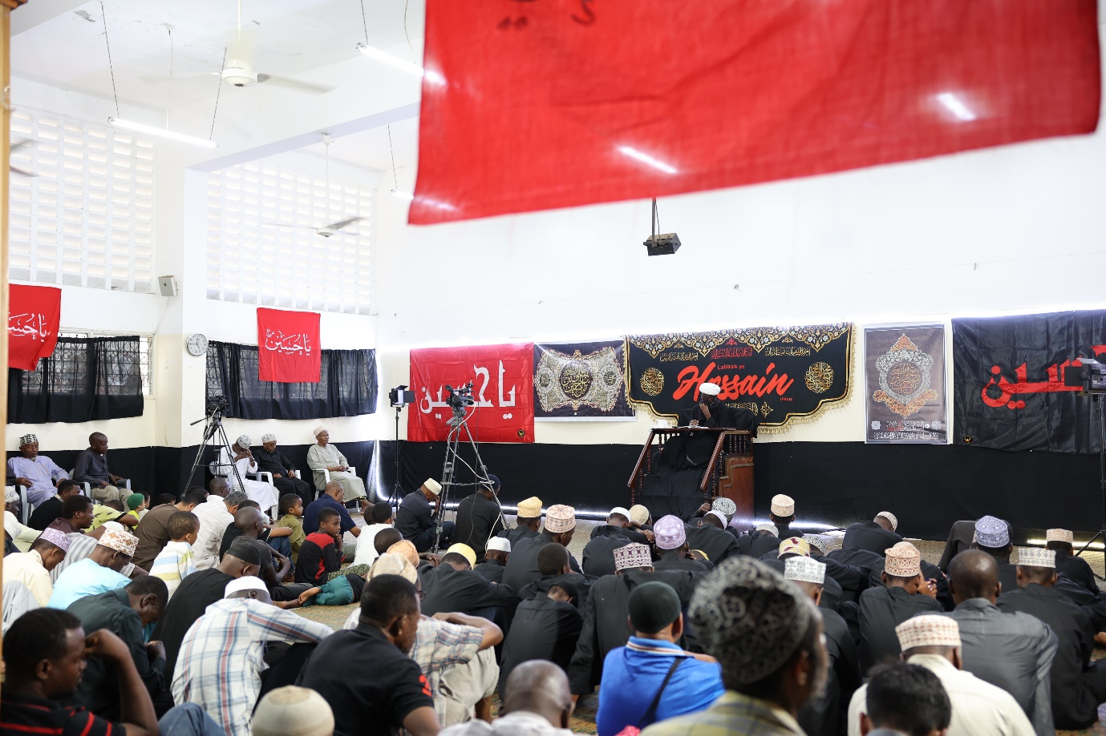

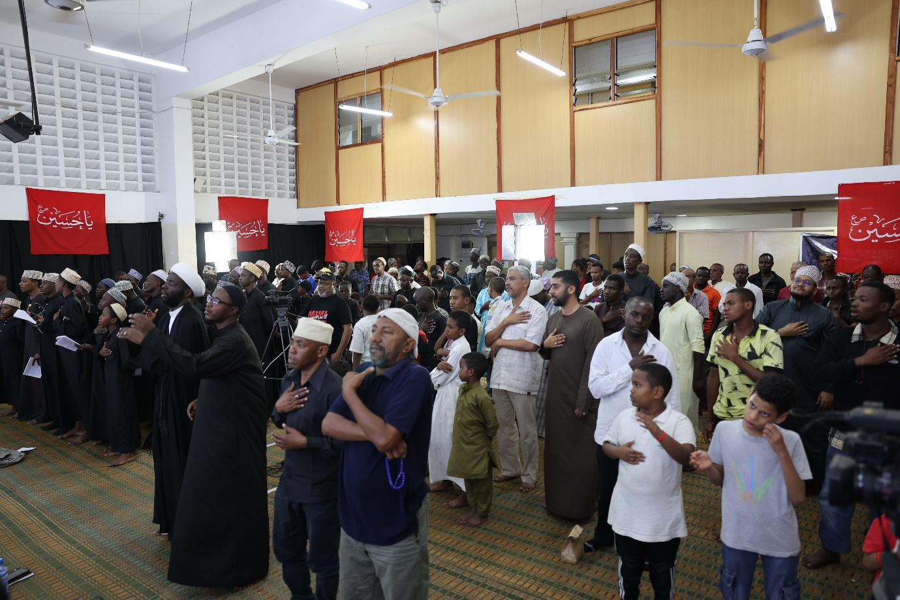

**Ashura Day supplications at the Bilal Hall in Mombasa**

On the Day of Ashura, supplications and prayers specific to the day were conducted at the Bilal Hall by Sheikh Aidarus Athman, Sheikh Athman Akbar and Ustaad Nassor.

**Ashura Day procession in Mombasa – Saturday 29th July**

A large procession was organized on the morning of Ashura day in collaboration with the management of the Khoja Shia Ithna Asheri community. Mourners and lovers of Imam Husayn(A) and believers in his cause from diverse Shia Ithna Asheri communities came out in large numbers to show their solidarity.

The procession began walking at about 10.30 am from the Jaffery Islamic Centre and ended at the Khoja Shia Ithna Asheri Cemetery before Dhuhr prayers. It was a very well-organized event and the turn out was impressive.

Short sermons and recitations were broadcast via the public address system. Sheikh Dumila and Sheikh Ali Bahero represented the Bilal Muslim Mission of Kenya aptly as they delivered their speeches on the importance of commemorating this day and who Imam Husayn(A) was. Informative pamphlets printed by Bilal Kenya were distributed to onlookers and other knowledge seekers during the event.

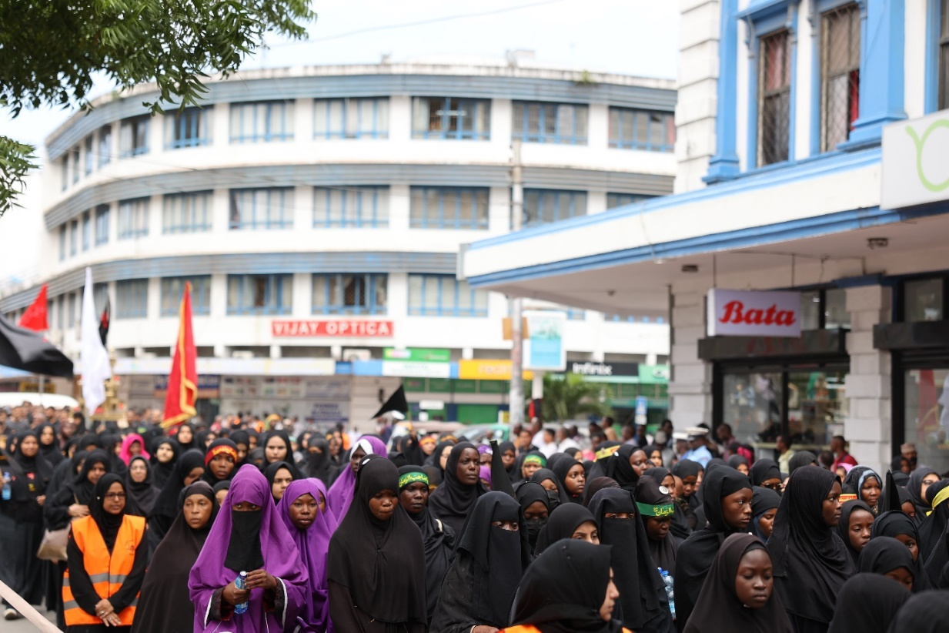

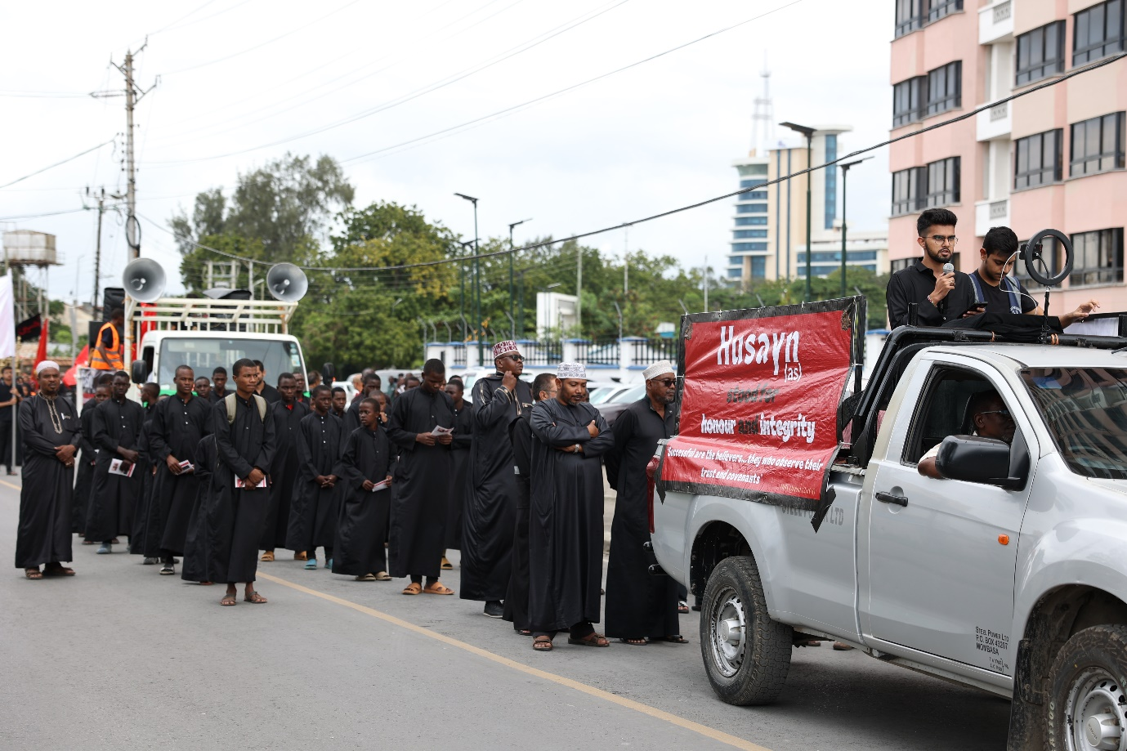

**Global reach**

Each of the majaalis conducted at the Bilal Hall in Mombasa as well as the Ashura Day procession were live streamed on all our digital media platforms and were therefore available for participation and viewing to a global audience. Photography at the procession was also managed by the Bilal Kenya Media Team.

**Majaalis held at other Bilal-supported centres in the country**

Alhamdulillah, the message of Imam Husayn (A) has spread far and wide and gatherings to remember him and revive the true teachings of Islam were held in varied settings. A generous donation enabled the purchase and distribution of food and drink items that were served to attendees as refreshments and meals after the majaalis. Additionally, Most centres across the country organized Ashura day processions in their respective towns and villages in collaboration with other shia centres in their localities.

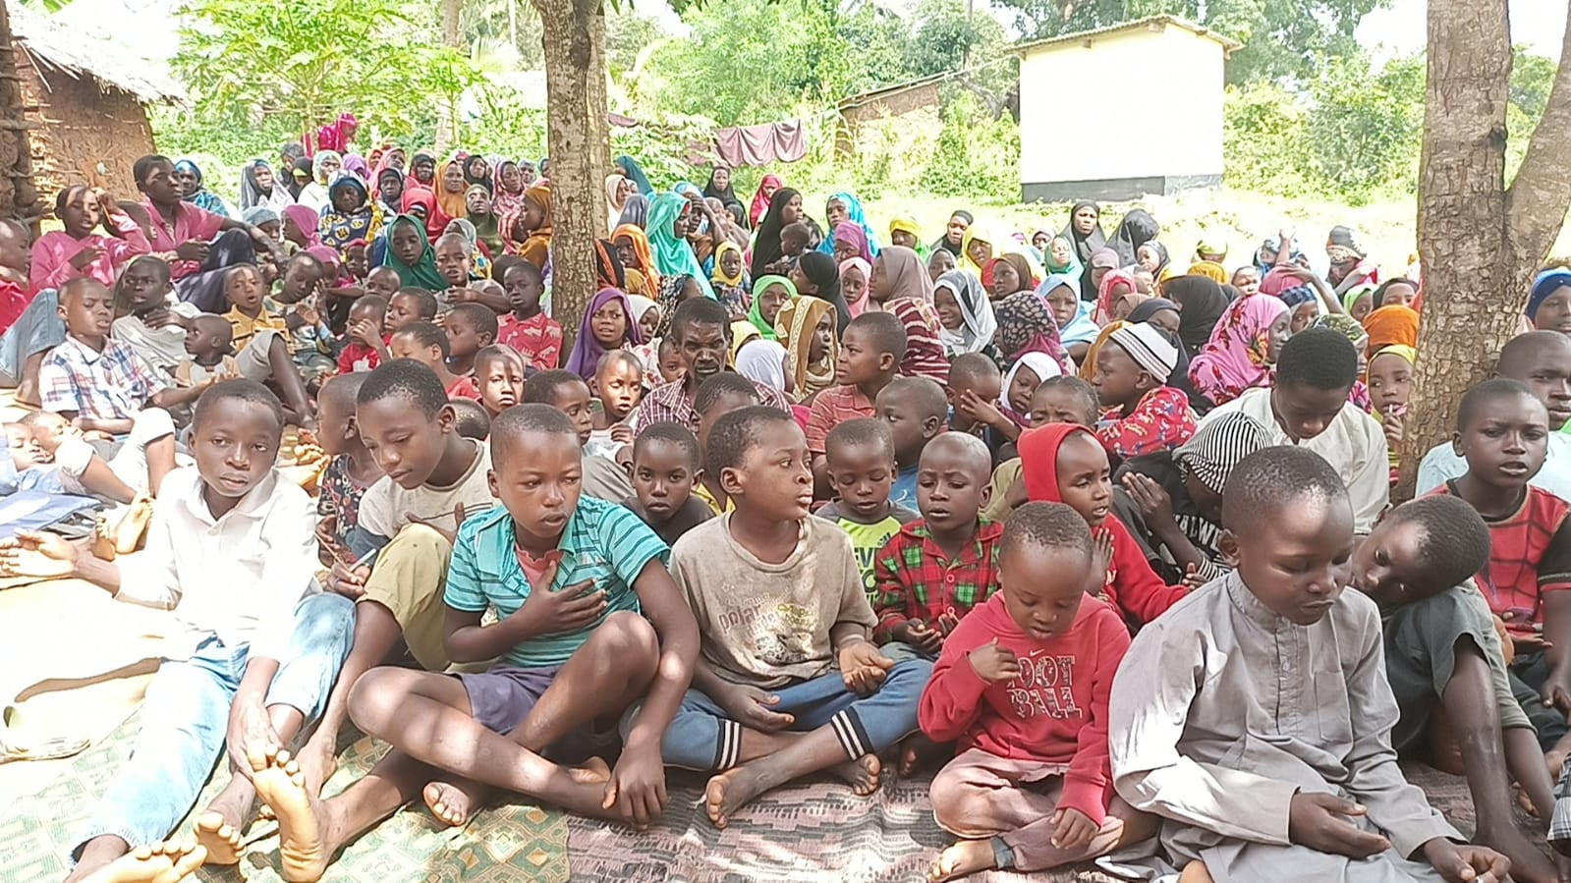

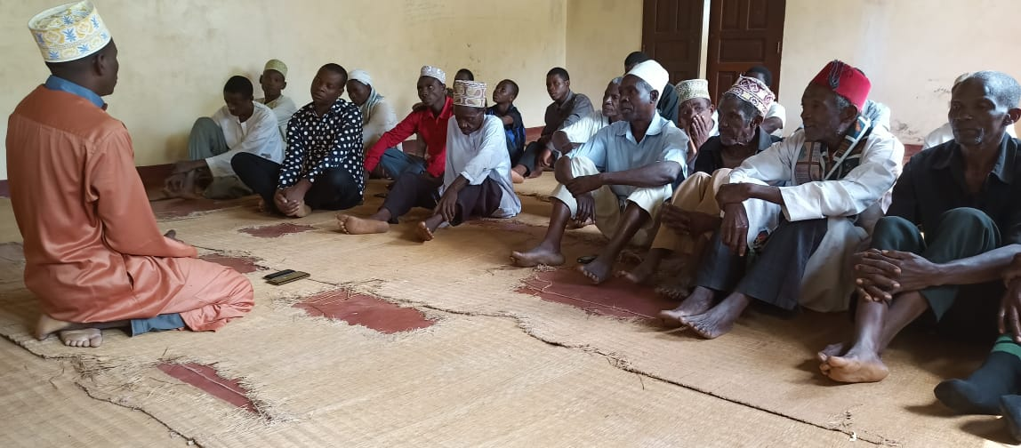

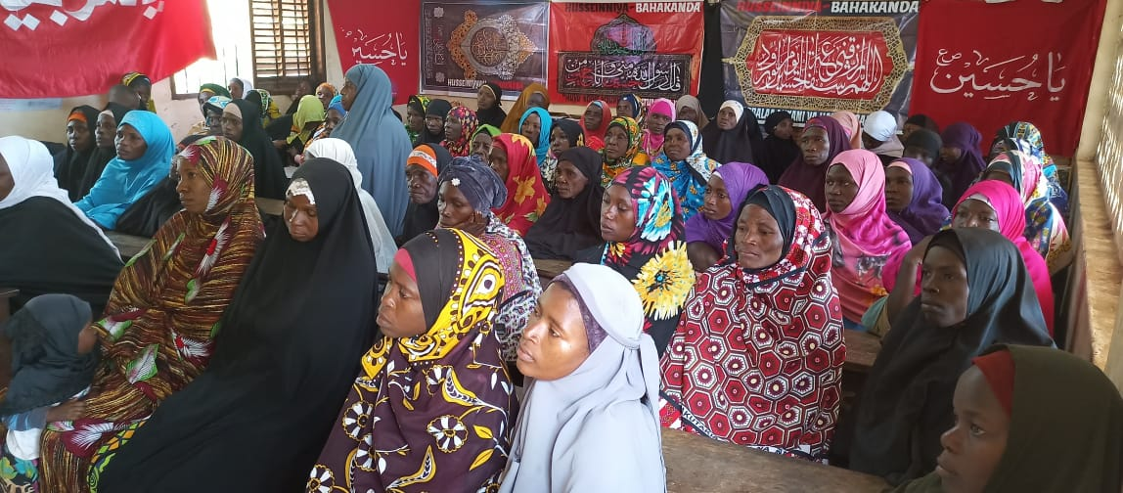

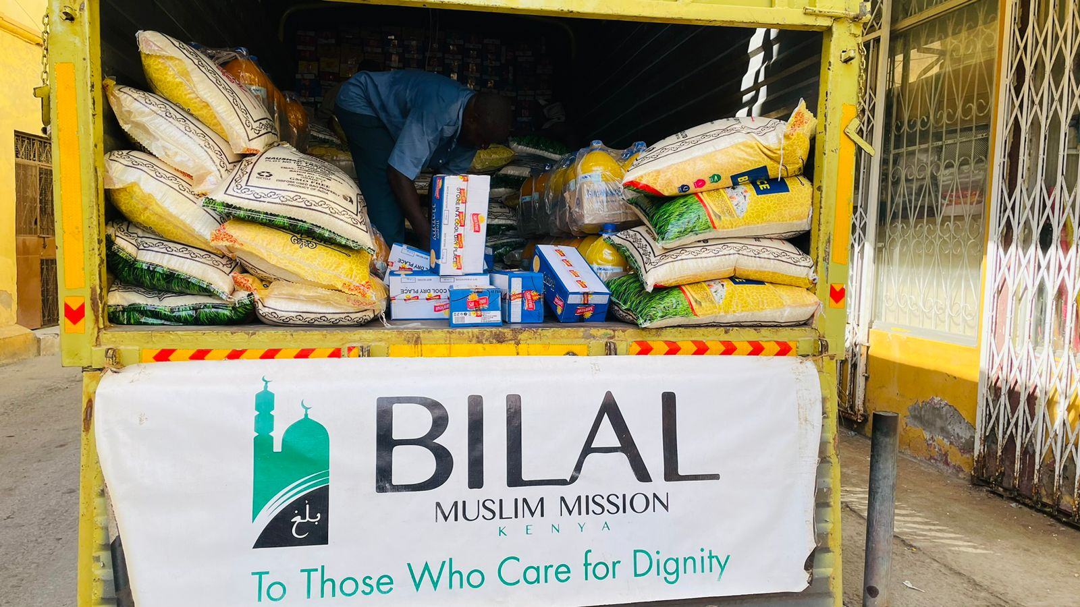

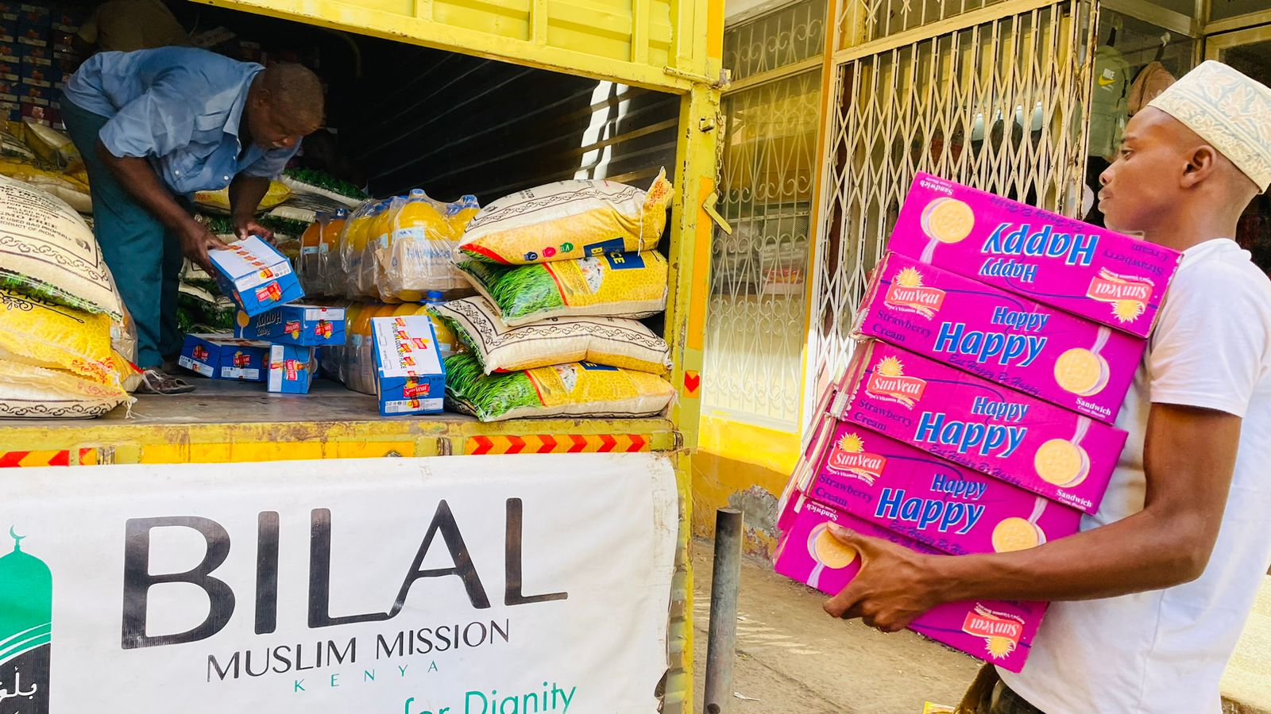

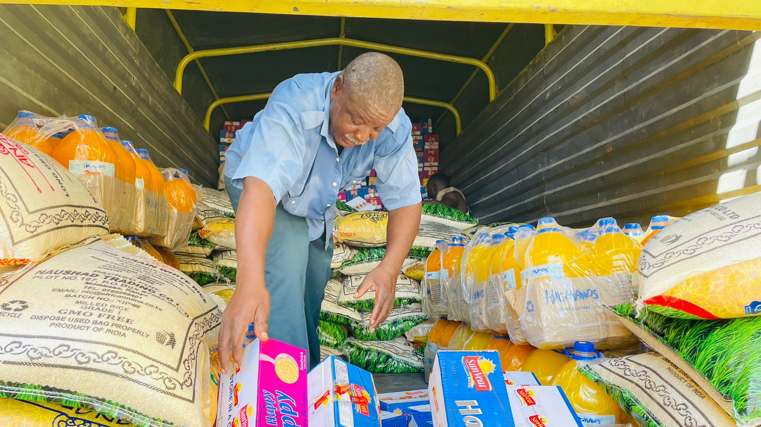

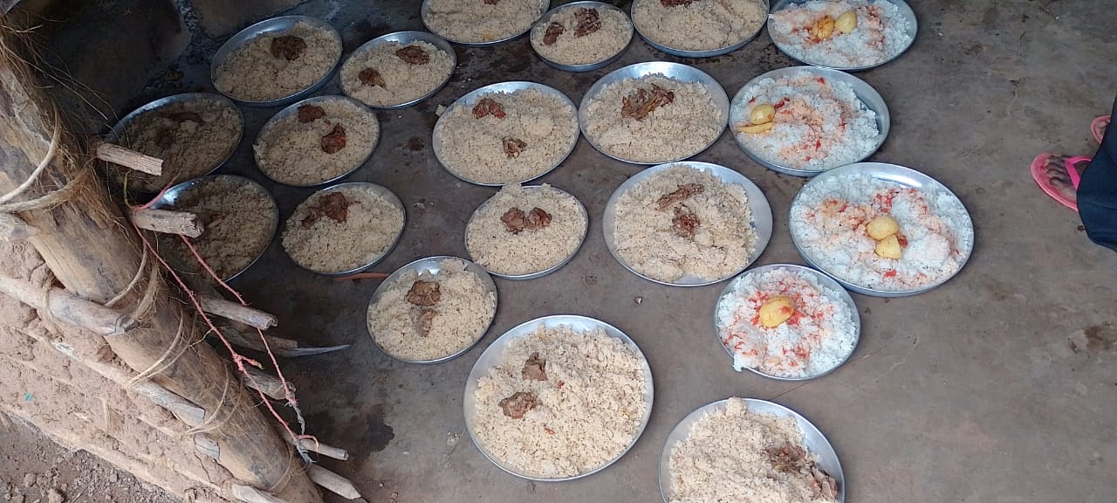

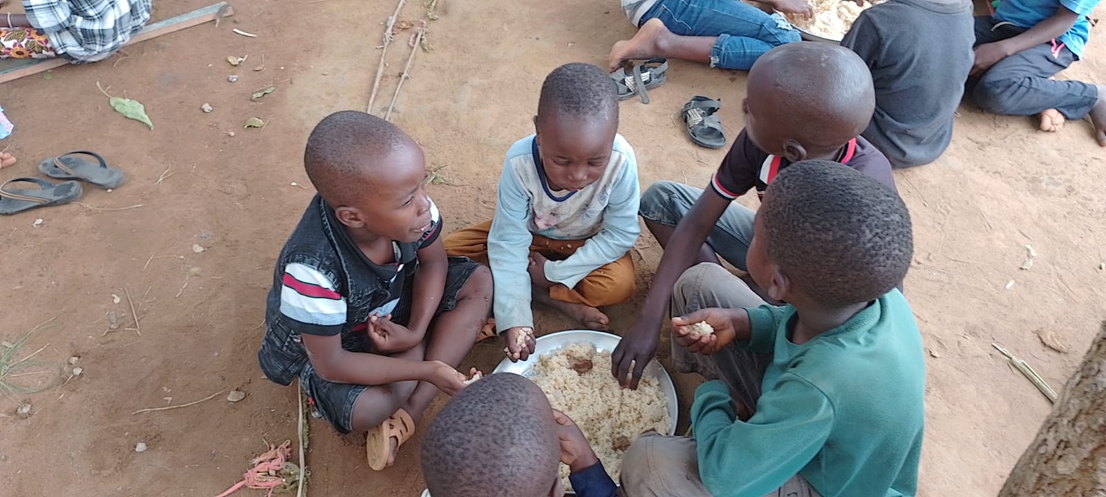

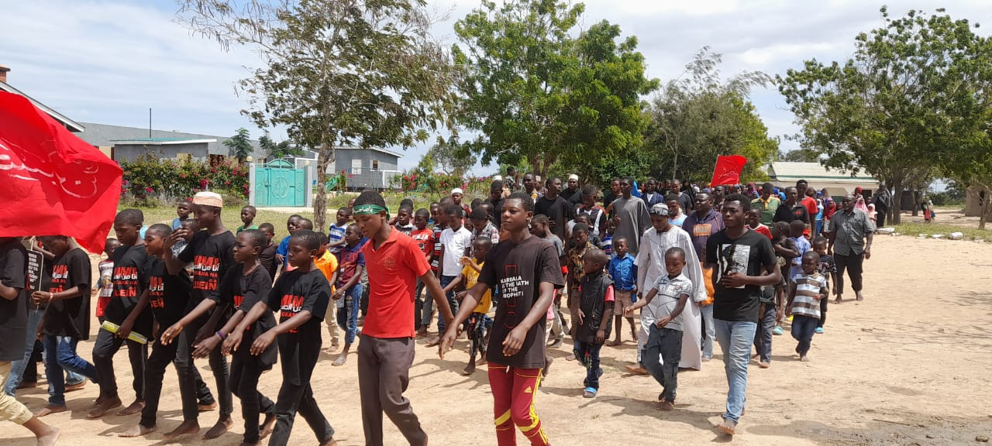

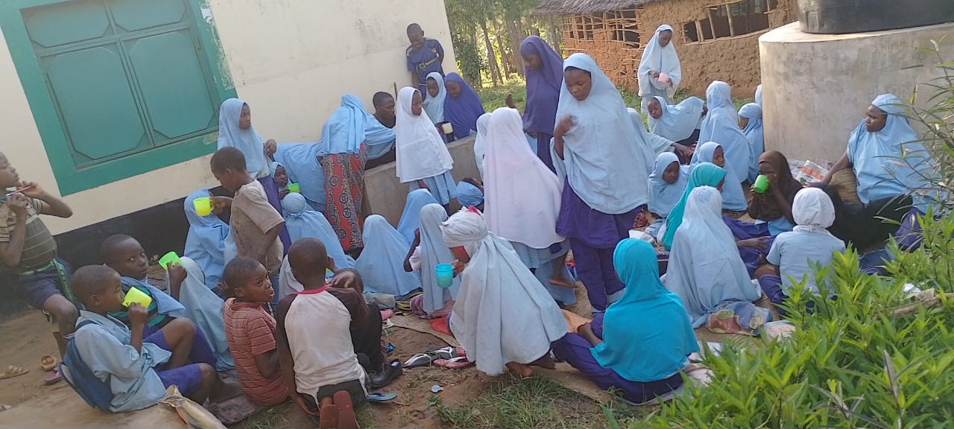

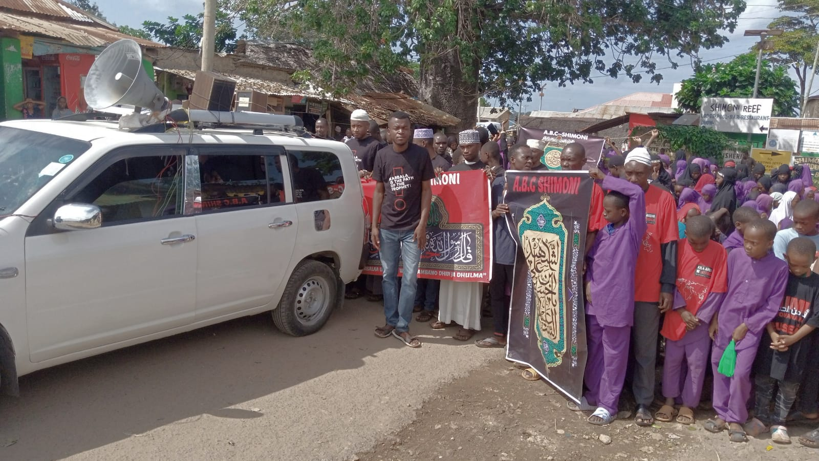

**Note of thanks**

The Bilal Muslim Mission of Kenya appreciates the generous financial support we received which enabled us to honour the memory of Imam Husayn(A) and his noble supporters at Karbala with the reverence they deserve.

We also wish to acknowledge all those who volunteered and/or participated in various ways to ensure the Muharram programmes were conducted successfully.