**HOLY MONTH OF RAMADHAN**

**PROGRAMMES**

**2023**

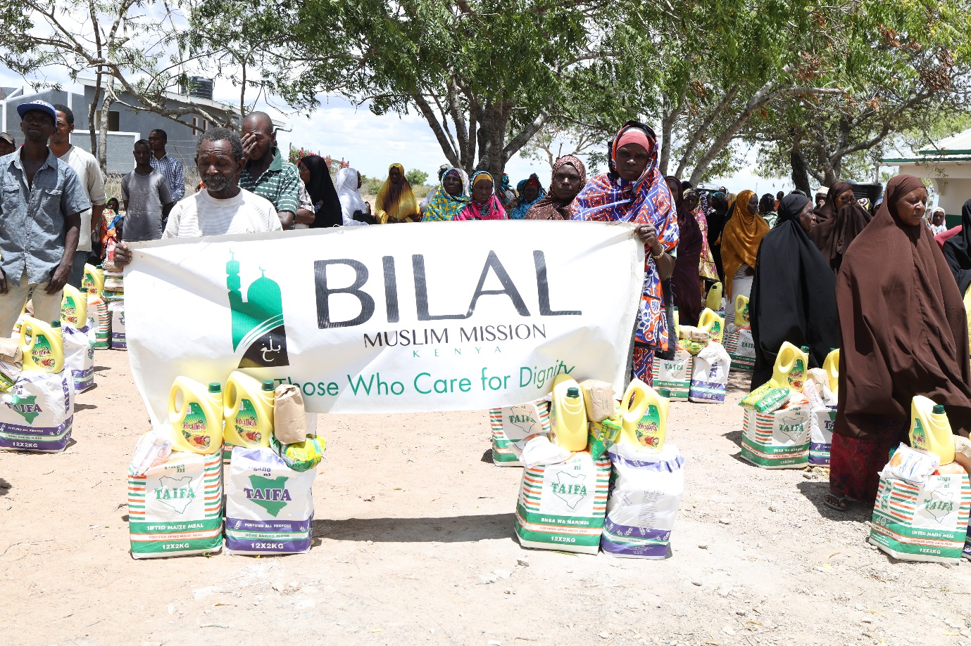

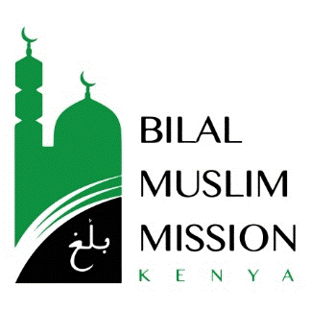



The Bilal Muslim Mission of Kenya works dedicatedly in the cause of Allah throughout the year. With the arrival of the Holy month of Ramadhan, efforts are intensified in keeping with the traditions of our beloved Immaculate Prophet, Muhammad Mustafa (may Allah honour him and grant him peace) and his purified progeny.

In the sermon the holy prophet gave to welcome this pristine month, in which we have been invited to the banquet of Allah the most glorified, he reminded people of the immense blessings and mercy with which the month was approaching them. His sermon had clear indicators about giving charity and showing sympathy to the less fortunate by the provision of iftaar to fasting believers.

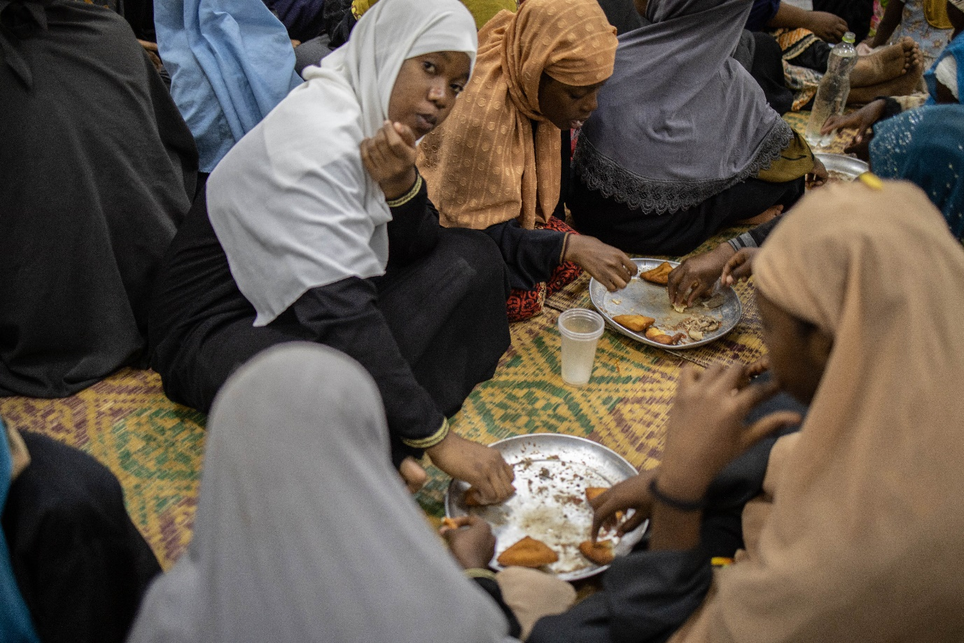

Additionally, he emphasized that of prime importance in the month of Ramadhan was the repentance of our sins and the lightening of their burdens from our backs. In this regard he advised his followers to lengthen their supplications and prostrations and beseech the Almighty sincerely.

On day eight of the holy month, we supplicate ‘O Allah, on this day, let me have mercy on the orphans and feed the hungry and spread peace and keep company with the noble-minded, O the shelter of the hopeful! ‘

In light of the sacred words of the prophet and the emphasis Islam lays on the propagation of the divine message, Bilal Kenya was able to accomplish various programmes with the blessings of Allah the best of providers and with generous support from donors.

* Family food parcels
* Iftaars at various institutions
* Daily streaming of Lectures
* Islamic Law lessons
* Quranic commentary lessons
* Fitra distribution
* Eid – al – Fitr gifts

Family food parcels

Just as in previous years, various non-perishable food items commonly utilized in preparing iftaar were purchased, packaged and distributed to families at all fifteen centres managed by Bilal Kenya. Furthermore, the mission extended its support to twenty-two independent centres in the coastal region and food parcels were distributed therein. Food packages were also provided at other centres located in upcountry as well as in Malindi and Lamu.

Each parcel comprised the following

* Maize flour – 12 kilograms
* Wheat flour – 12 kilograms
* Cooking oil – 3 litres
* Rice – 2 kilograms
* Sugar – 2 kilograms
* Salt – 2 kilograms

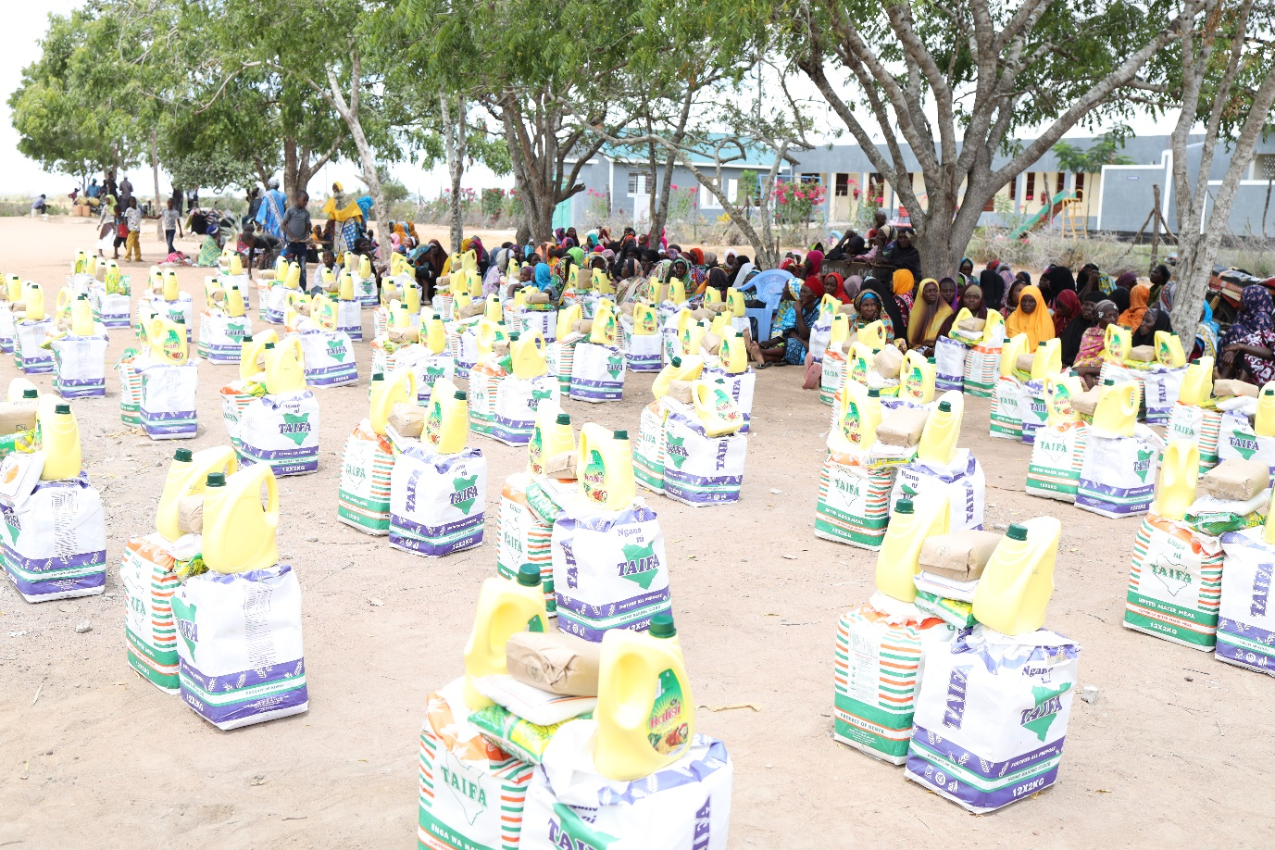

A total of 216.56 tons of food were distributed by way of this initiative. The table below summarizes the positive impact felt in various regions of the country.

|  |  |
| --- | --- |
| Location / Region | Number of beneficiary families |
| BMMK centres | **3,929** |
| Independent centres | **1,863** |
| Mombasa | **610** |
| Malindi | **48** |
| Lamu | **145** |
| Upcountry | **600** |
| Total | **7,195** |

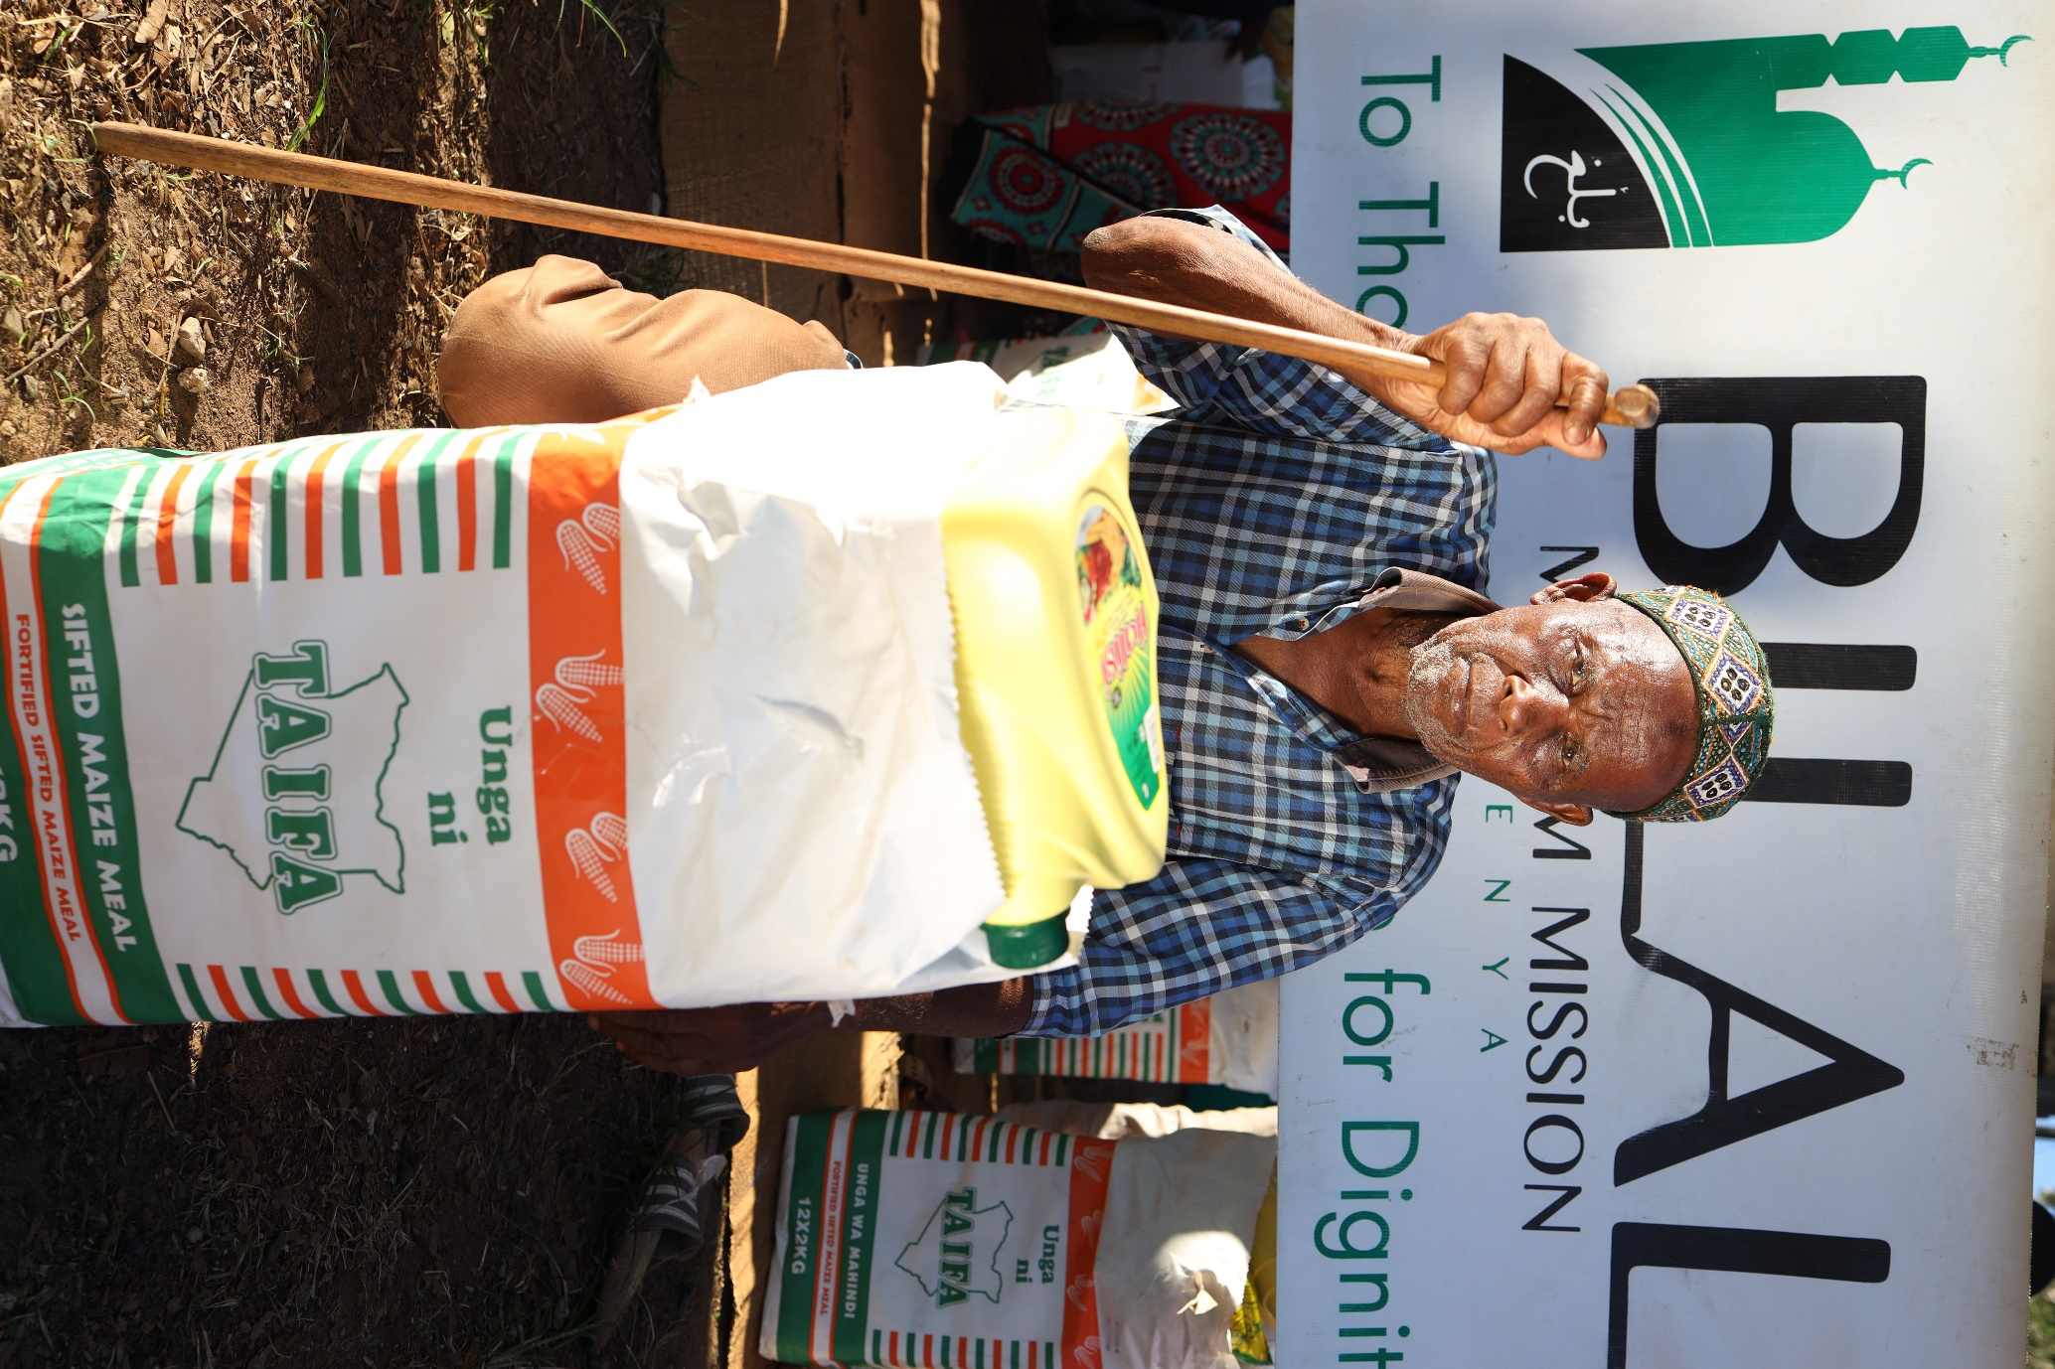

IFTAARS

Bilal Kenya planned for an Iftaar meal to be served within the mosques at all fifteen centres managed by us. Additionally, arrangements were made for Iftaar to be enjoyed at twenty-six independent centres, four prisons and seven secondary schools. 29.2 tonnes of supplies were distributed for these meals.

Iftaar provisions contained

* Wheat Flour ❖ Yeast
* Sugar ❖ Tea Leaves
* Cooking oil ❖ Dates
* Rice

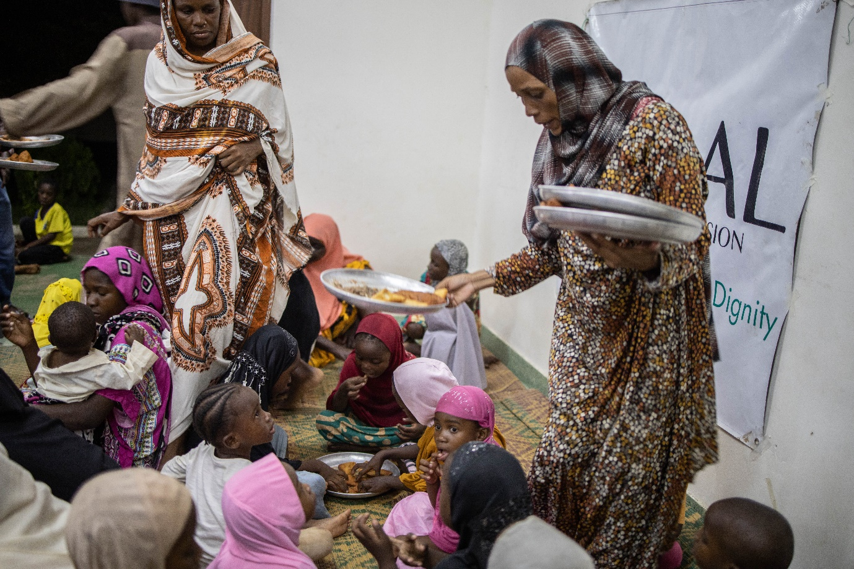

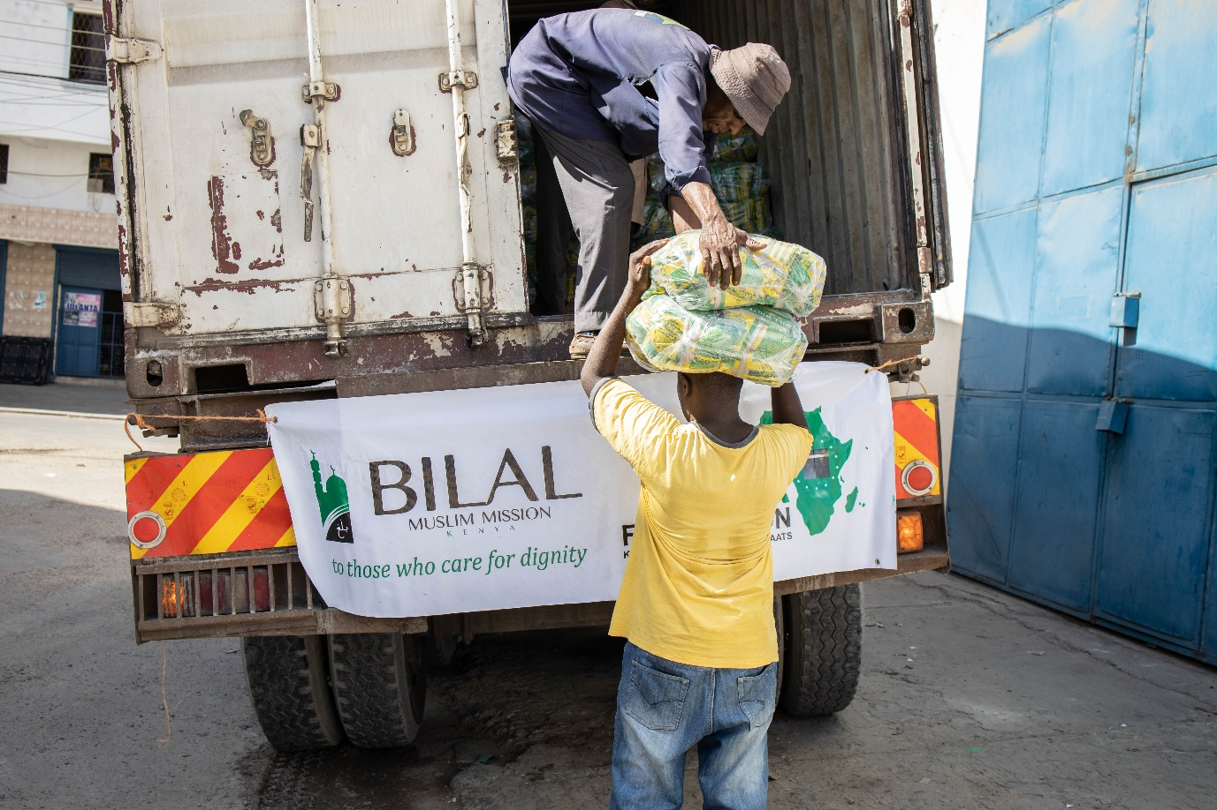

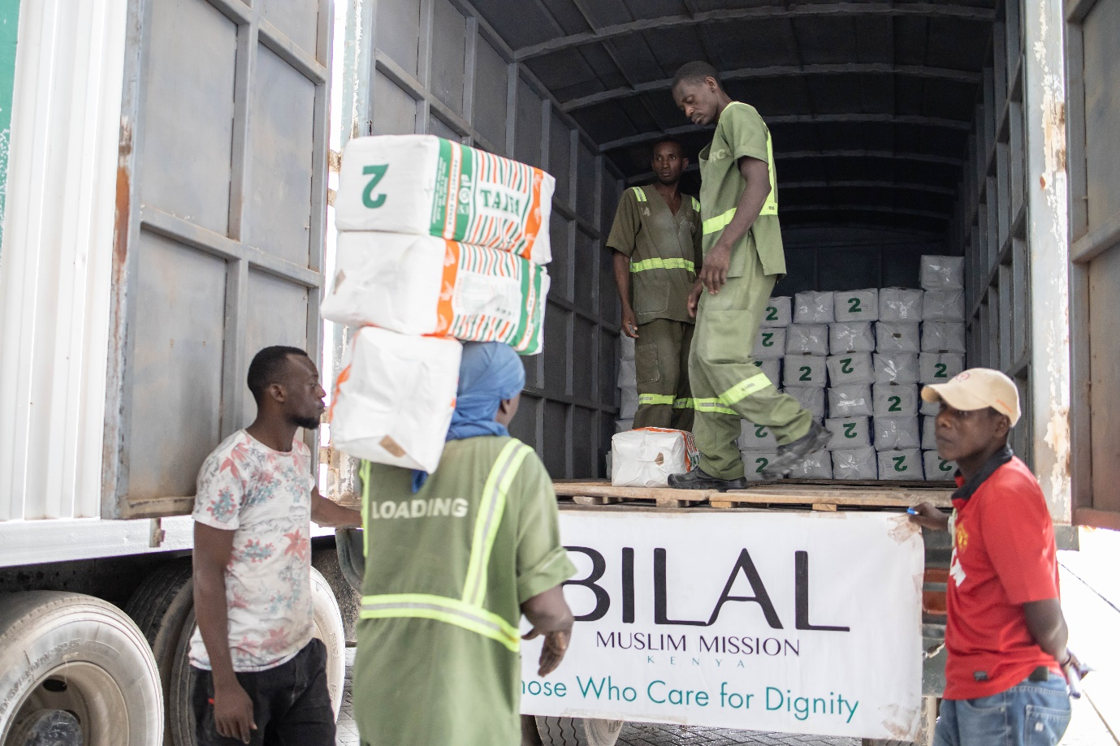

ONLINE PROGRAMMES IN KISWAHILI

**LECTURES**

From the first to the fifteenth night of Ramadhan, **Sheikh Ali Samojah** delivered excellent lectures in Kiswahili whereby he enlightened audiences further regarding

* Fiqh rulings on Fasting
* Ramadhan Amaals
* Lady Khadija (S.A)
* 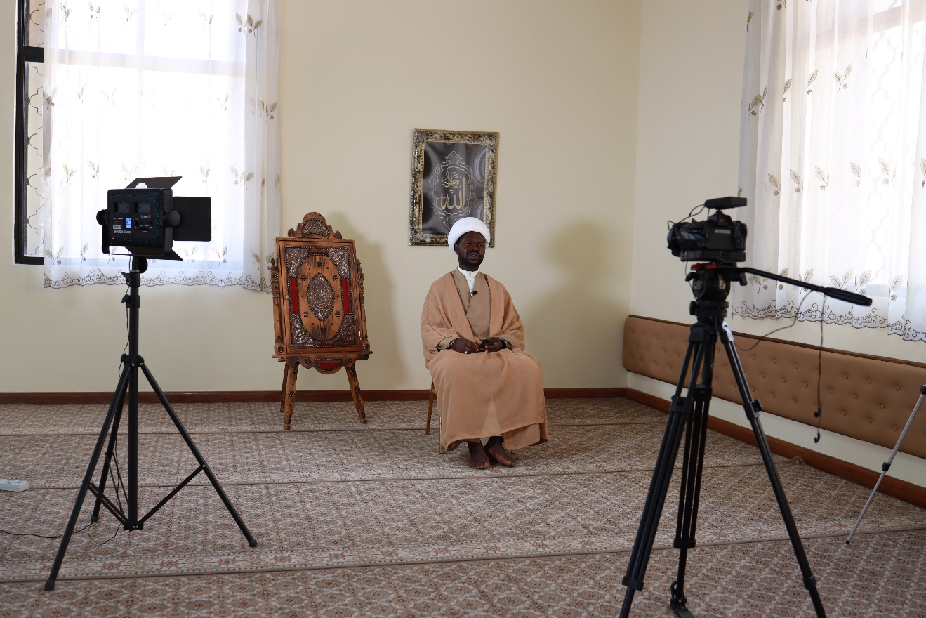Imam Hassan-al-Mujtaba (A.S)

The lecture on Imam Hassan (A.S) can be easily accessed to by clicking on the link below:

<https://www.youtube.com/watch?v=B3nIjSK9CyU&t=563s>

For the next fifteen nights, **Doctor Sheikh AbdulRazaq Ameer** addressed listeners. He conveyed important messages surrounding the historical battle of Badr. Thereafter, up to the end of Ramadhan he focused on the Lion of Allah, the supporter of the Holy Prophet and the hero of Islam, Ameer-ul-Momineen Ali ibn Abu Talib (A.S). On the 24th night, a speech titled **Who is Ali?** was given and can be watched using the link below

<https://www.youtube.com/watch?v=2uQuqJW1O-w>

Lectures were streamed daily during the holy month on all of the available Bilal Kenya digital platforms. Viewers could choose to connect on [Facebook](https://www.facebook.com/BilalMuslimMissionofKenya/), [YouTube](https://www.youtube.com/user/bilalkenya) or [Twitter](https://twitter.com/bilalkenya?lang=en).

**LESSONS ON QURANIC COMMENTARY AND ISLAMIC LAW**

Valuable lessons were held at **Masjid Hassanain** **(Bahman )** between 1pm and 2pm daily.

* Quranic Commentary – This was taught by **Sheikh Muhammad Dumila** from Monday to Thursday every week. Click on the link below to listen to one of these lessons.

<https://www.youtube.com/watch?v=DU1L9YDp3Ww&t=1716s>

* Islamic Law – specifically, lessons focusing on fasting were taught by **Sheikh** **Juma Shughuli** on the weekends. The link below is for the lesson that was delivered on the tenth of Ramadhan.

<https://www.youtube.com/watch?v=xy4s4aYIXK0>

These lessons had an in-person audience and were also streamed live on all Bilal Kenya Digital platforms.

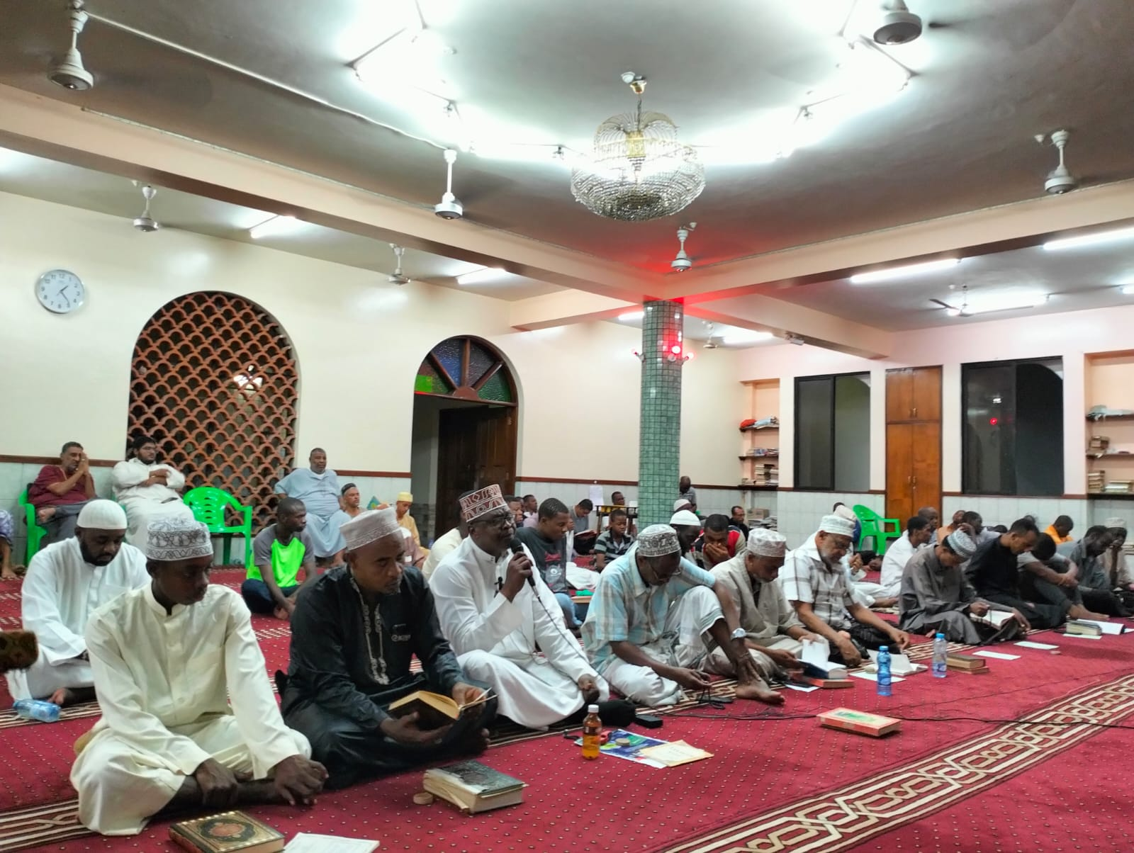

**LAYLATUL QADR NIGHTS**

The sanctified Laylatul Qadr nights were observed at all Bilal- supported centres with the reverence they deserved. The media department captured and live streamed the programmes conducted at the following centres

* 19th night – **Ali Ridha centre, Mtongwe.** The night of the cowardly attack on the commander of the faithful as he prostrated.
* 21st night - **Al Mahdi centre, Samburu.** Together with the commemoration of the martyrdom of Imam Ali (A.S).
* 23rd night – **Masjid Hassanain (Bahman), Mombasa.** The most meritorious of the three nights.

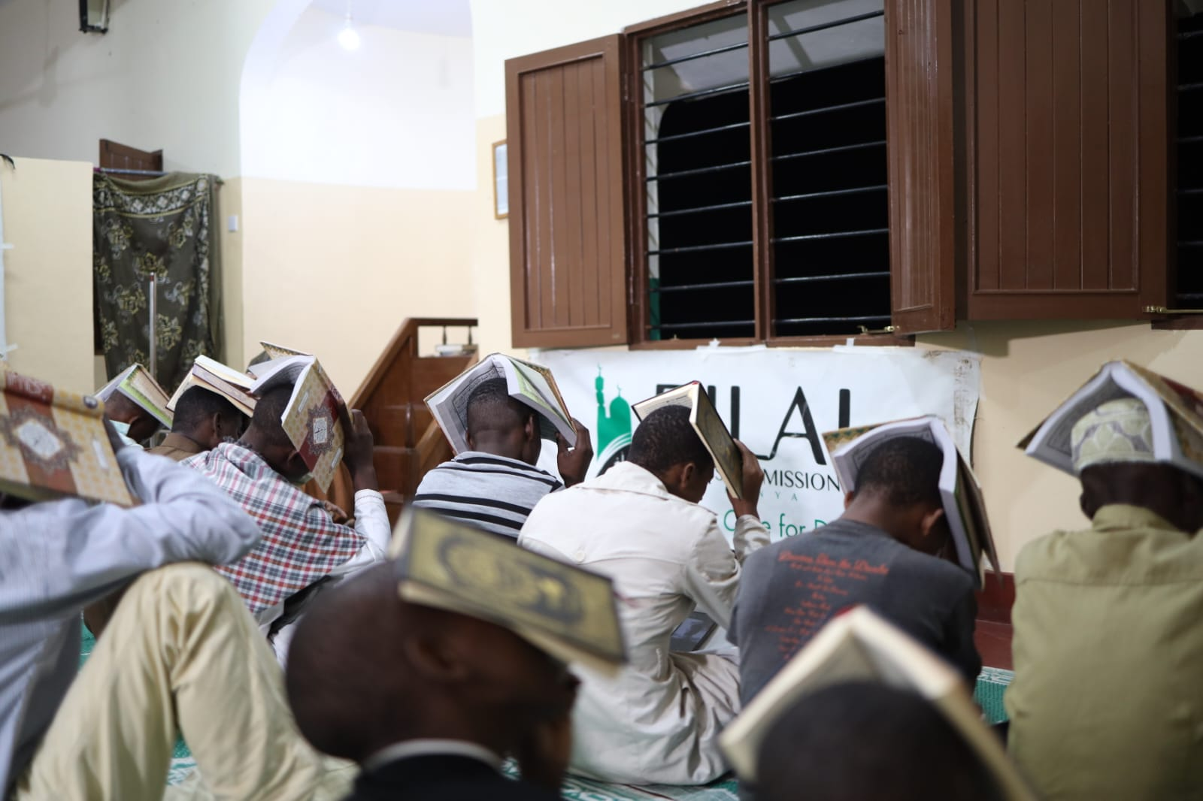

EID – AL – FITR

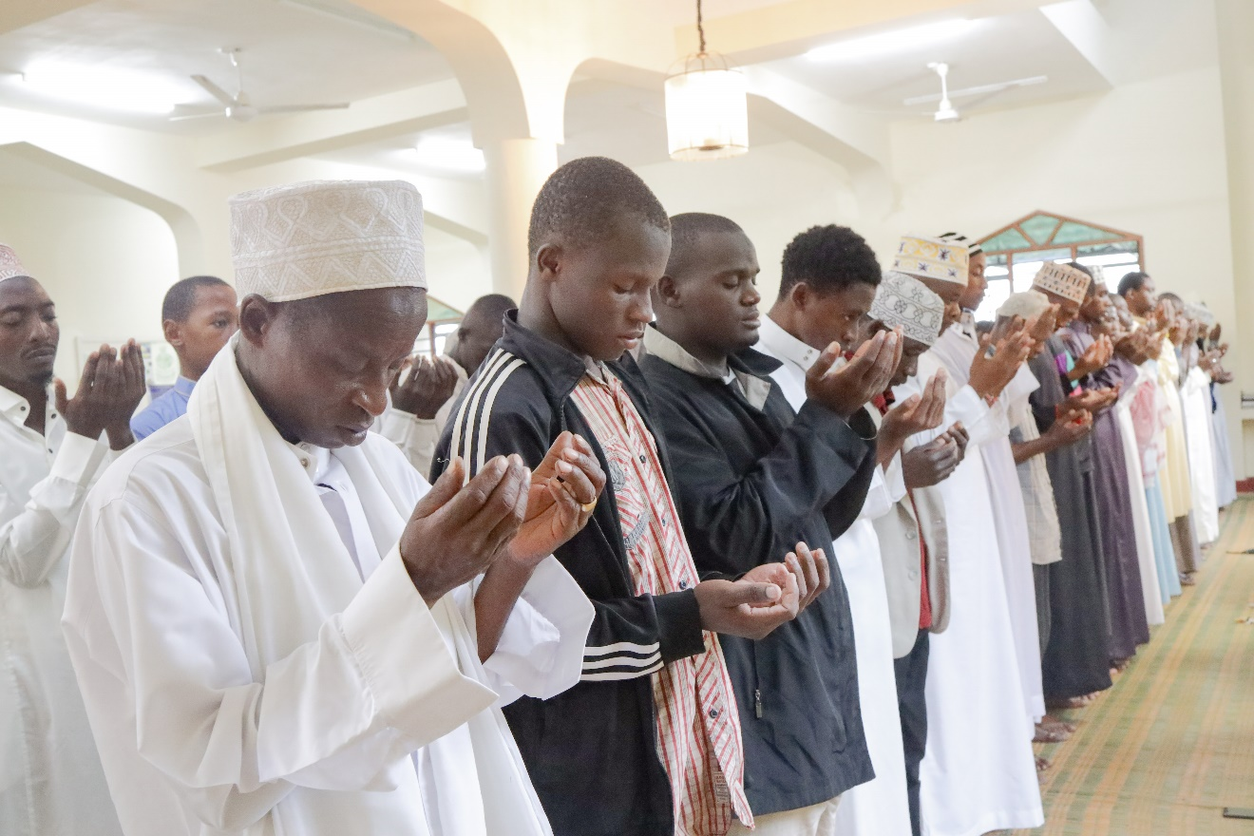Eid –al –Fitr is a joyous time at which Bilal Kenya appreciated various preachers and staff across Kenya for their dedicated and tireless services towards propagation. Orphans and specially-abled individuals were also remembered and gifted.

**EID GIFT DISTRIBUTION**

|  |  |
| --- | --- |
| **Bilal Kenya Centres**  **(New set of outfits)** | **385 orphans**  **109 specially-abled individuals** |
| **Matuga and Malindi**  **(Cash gifts)** | **68 orphans** |
| **Various regions across the country**  **(Cash gifts)** | **312 centre staff and preachers** |

Additionally, three hundred and seventy-seven (377) individuals received cash gifts on account of the Fitra distribution. Among them were deserving widows and preachers, specially-abled people and the Elderly.

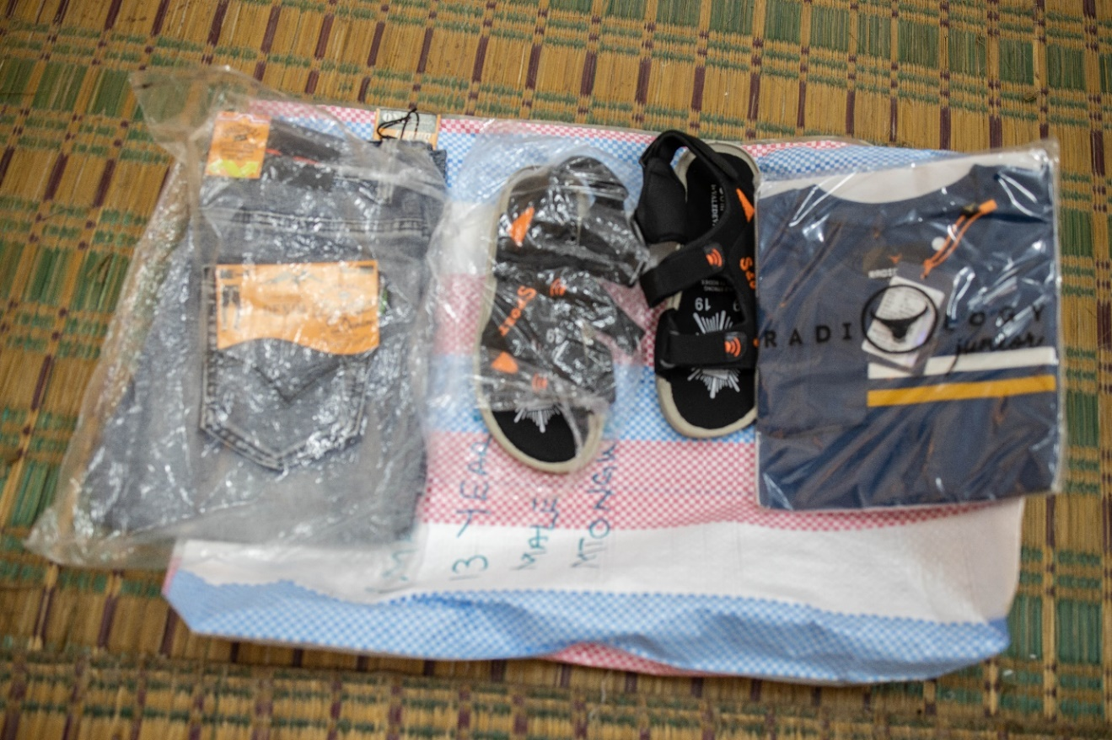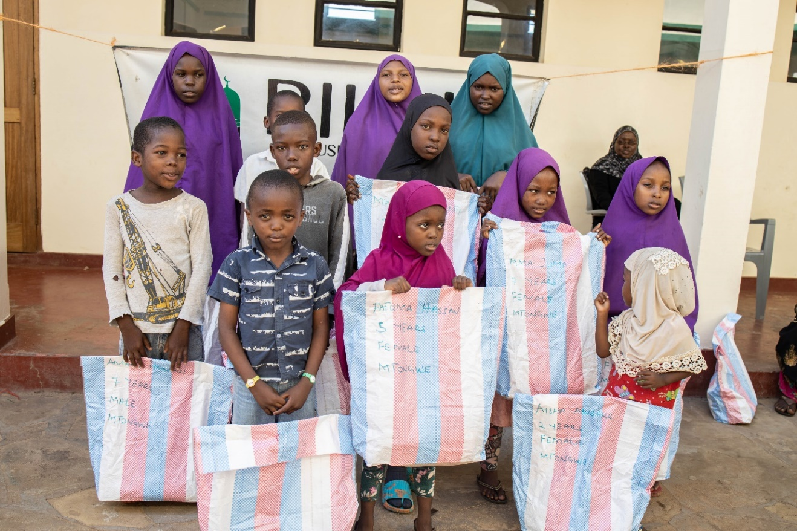

APPRECIATION

We are thankful to Allah, may his glory be glorified, with whose blessings the Ramadhan projects were undertaken. The Bilal Muslim Mission of Kenya appreciates all the generous donors for the support provided to us during this month of giving and mercy. We also wish to acknowledge all staff and volunteers who worked passionately to ensure the smooth running and completion of the various programmes.

It was a great bounty that we were able to witness the holy month of fasting this year and embark on the noble initiatives highlighted in this report. We beseech the Almighty to be able to witness the next Ramadhan when the earth has been filled with Justice by his vicegerent, Imam Muhammad Mahdi (A.S). Ameen.