STUDENT SEMINAR

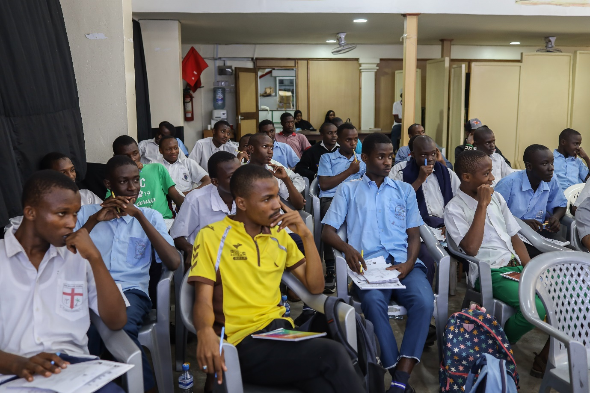22nd August 2023





The student seminar is a vibrant event held annually at the Bilal Hall in Mombasa. 71 students were in attendance this year; their studies are sponsored through the Zainabiyya child sponsorship scheme and the Mission’s other partners. Attendees comprised 59 students from secondary school level and 12 students in tertiary studies. The tertiary learners comprised students in vocational training and those in colleges and universities.

The day’s programme incorporated

* Registration of attendees
* Short motivational and interactive talks
* Madrassa assessment
* Lunch

**Registration**

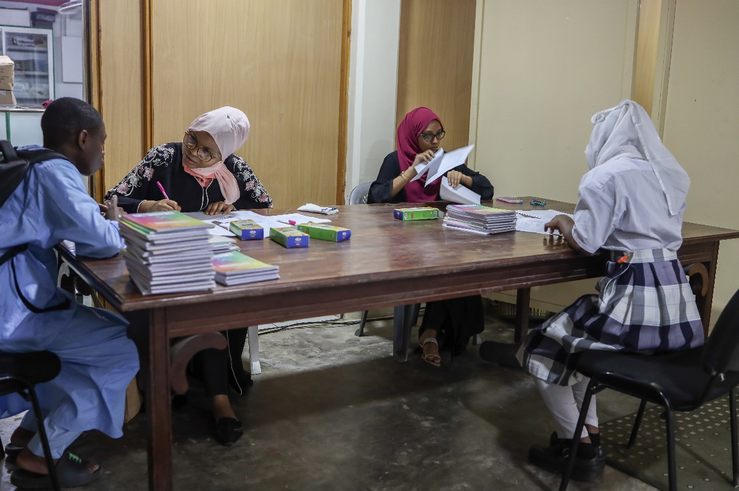

**Bilal Muslim Mission of Kenya Staff conducting the registration process. Attendees were also provided a notebook and pen to use during the seminar.**

**Interactive Talks**

**Speakers**

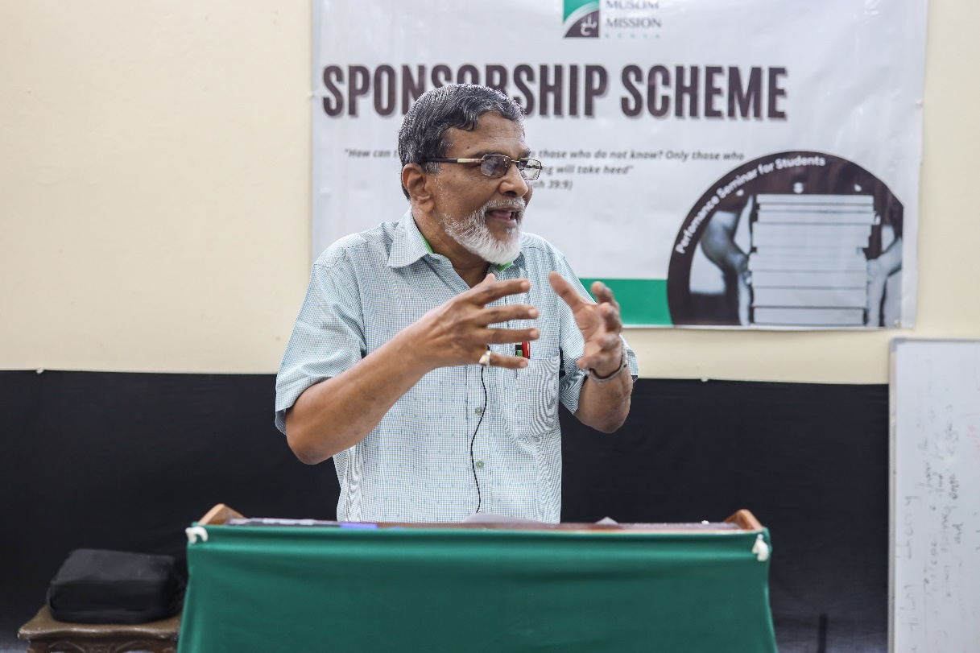

**Mr Ahmedali – Project Manager at Bilal Kenya**

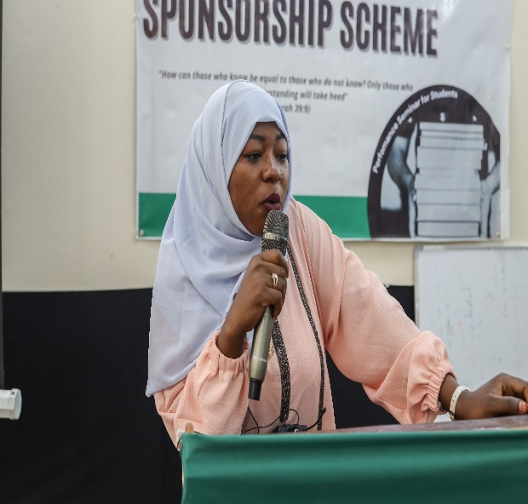

**Sister Saida Mueni – Alumni Brother Yusuf Abwanzo – Alumni**

**Central themes**

* The responsibility that comes with having a shia muslim identity. Religious morals and values.
* The importance of picking the right role models for oneself. How to become a good role model for others.
* The importance of secular education. Subject selection and exam preparation. Achieving one’s dream career.
* Lifelong Islamic learning.
* Giving back to the community and the value of scholarships.
* Having confidence in your identity.

**Madrassa Assessment**

Learners who attend our madrassas underwent an assessment by Bilal Kenya Zone Supervisors. It aimed to ascertain their proficiency in Quran reading and other subjects taught there.

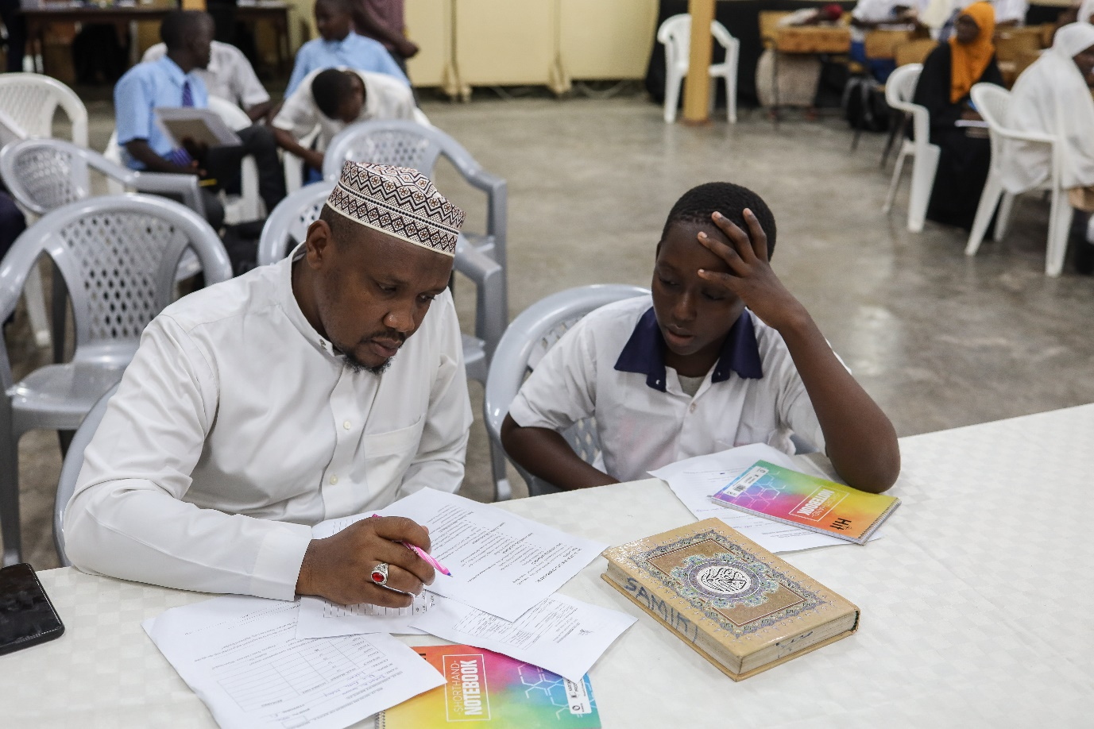

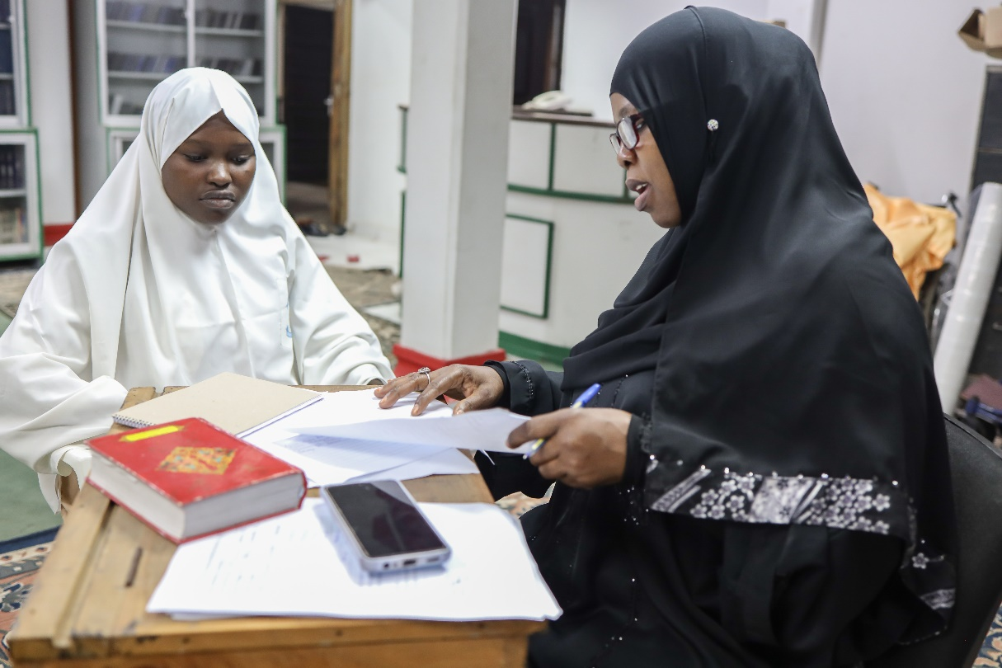

**Lunch Time!**

A wholesome lunch complete with fruit and drinks was enjoyed by the deserving Students.

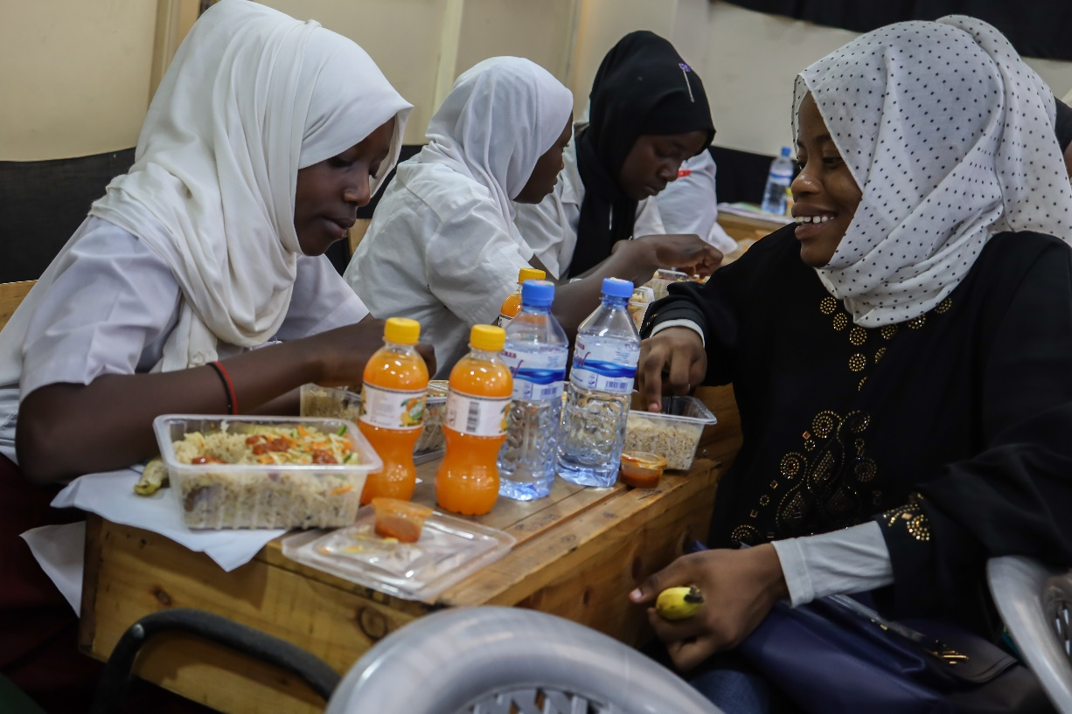

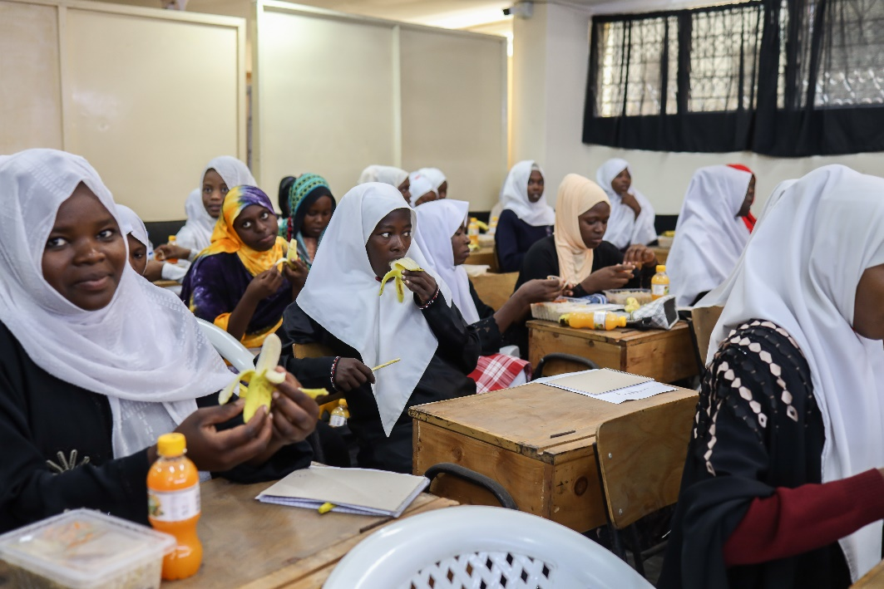

# **Social interaction, Feedback and future plans**

Open Discussions between the seminar facilitators and the students and within the students themselves encouraged healthy debate and discussion that led to constructive positive feedback from various stakeholders on the way forward for future seminars as well as the enhancement of opportunities for the Learners in the near future.

