**EDUCATIONAL TECHNOLOGY IN EARLY CHILDHOOD LEARNING**

**TABLET DISTRIBUTION**

MARCH 2023

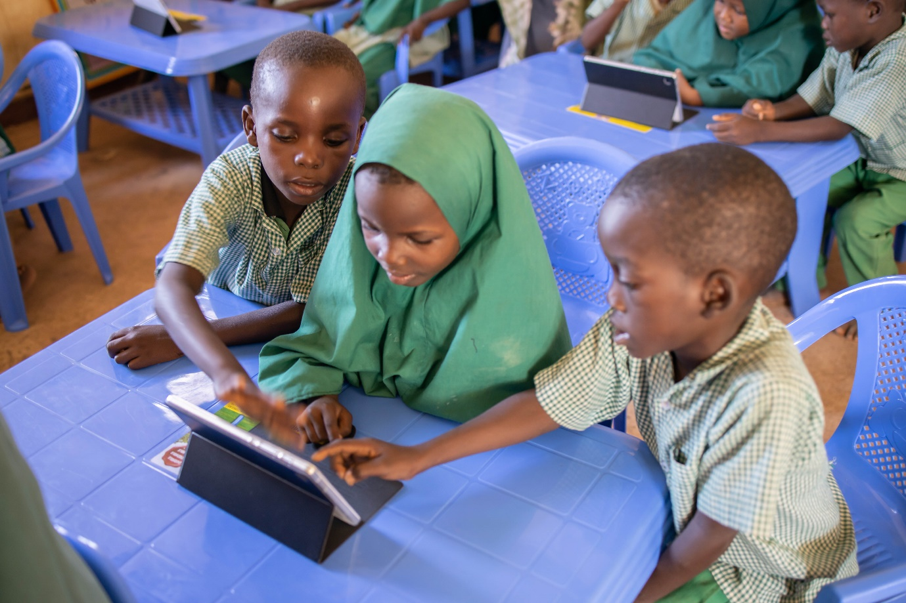





Detailed Studies demonstrate that when educational technology and interactive media is used in ways that enhance non technological teaching materials and methods the result is a highly productive learning environment in which specific learning goals are successfully achieved.

The intentional integration of technology in classrooms in which there are strong relationships between teachers and students and where teaching practices are attuned to the children as unique individuals creates an environment where learners are enabled to reach goals that are both challenging and achievable.

The Bilal Muslim Mission of Kenya began supplying the Pre-primary schools at the centres it manages with Tablets. The pilot project was launched on the 25th of January 2021. The pre-primary classes at the Jaffery centre at Mackinnon Road were the recipients of the first four tablets. Teachers and Students were provided with the necessary training and support in order to gain maximum advantage from the availability of this educational technology.

Since then, all fourteen pre-primary schools being managed by the mission have been supplied with Tablets. The most recent run of this initiative took place in November 2022 after the donation of a generous financial sum enabled the purchase of **fifty tablets**. The fifty units were distributed amongst fourteen centres according to a previously determined criterion.

The acquisition of these additional fifty Tablets brought the total number of units being utilized at the centres to **one hundred and twenty-one.** In some centres a team of children shares one tablet and although this is not an ideal situation, they have gained lessons in sharing and teamwork.

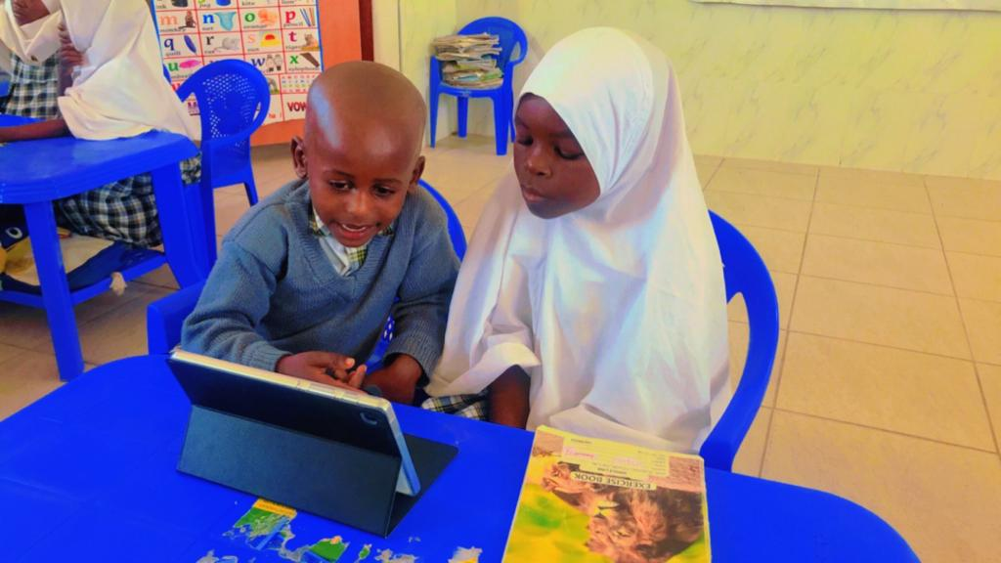

Students supplement their studies using the tablets at Al-Hujjah centre, Chengoni

BENEFITS OF TECHNOLOGY IN EARLY CHILDHOOD LEARNING

* Equips young children with confidence and functional skills to thrive in diverse future learning environments
* Learning becomes a multisensory and interactive experience
* Young children enjoy learning from animated and narrated content
* Interaction with technology supports the development of fine motor skills and helps children improve their precision and dexterity
* Hand-eye co-ordination is strengthened
* Cause-and-effect interactions in educational games and applications can improve a child’s reaction time to different stimuli as well as their peripheral vision and their ability to multitask
* Educational software helps children with letter recognition, expanding their vocabulary and learning words in a different language.
* Recording and playback technology can aid in pronounciation

|  |  |  |  |
| --- | --- | --- | --- |
| **CENTRE NAME** | **LOCATION** | **NO. OF STUDENTS** | **TOTAL TABLETS AT EACH CENTRE AS AT MARCH 2023** |
|
|
| AHLULBAYT | SHIMONI | 71 | 10 |
| AHLUL KISA | KICHAKAMKWAJU | 49 | 8 |
| AL MAHDI | BURANI | 67 | 10 |
| HUSAYNI | BAHAKANDA | 70 | 10 |
| AHLUL BAYT | MOYENI | 83 | 10 |
| AL MAHDI | SAMBURU | 73 | 10 |
| AL HUJJAH | CHENGONI | 57 | 10 |
| AL BAQIR | MWASAFU | 32 | 8 |
| AN NABI | NZAVONI | 17 | 5 |
| RAHMA | KILUNGU | 19 | 5 |
| JAFFERY | MASONGALENI | 12 | 5 |
| JAFFERY | MACKINNON ROAD | 52 | 10 |
| AMANI | DEMBWA | 74 | 10 |
| AL MUJTABA | MIAMBA | 68 | 10 |
| **TOTAL** | | 744 | 121 |

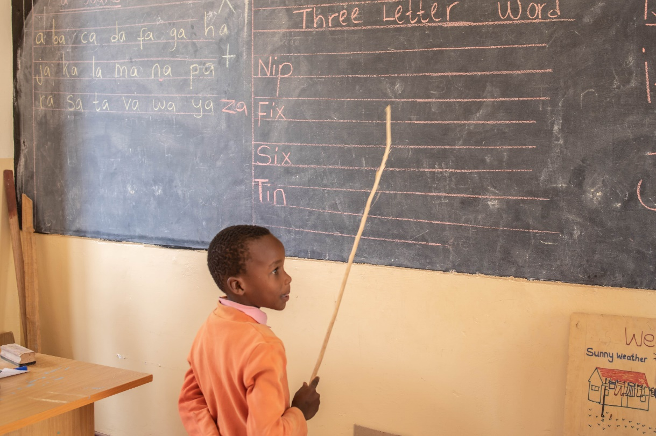

3-letter words using the blackboard at al-mahdi, Samburu

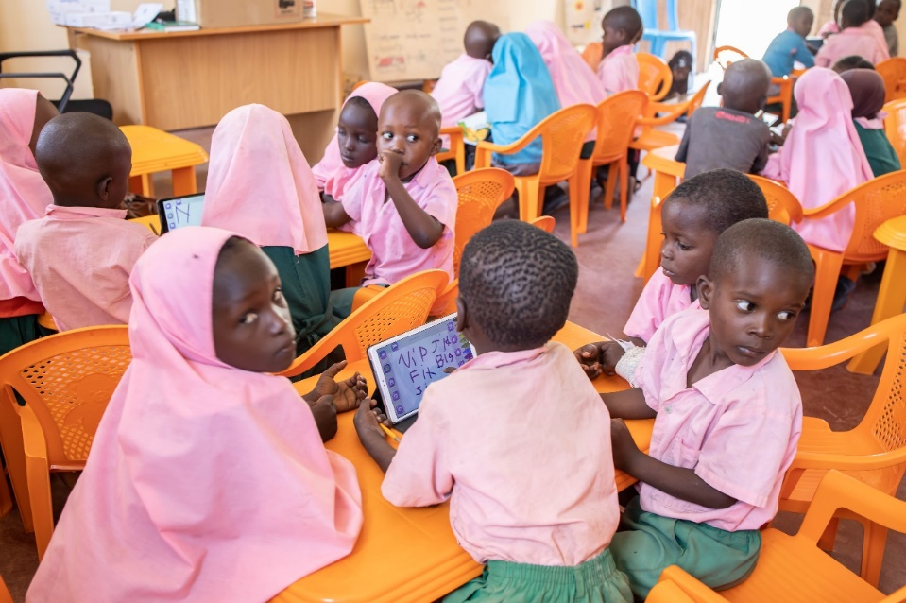

Enforcing the concept of 3-letter words using tablets at al-mahdi, Samburu

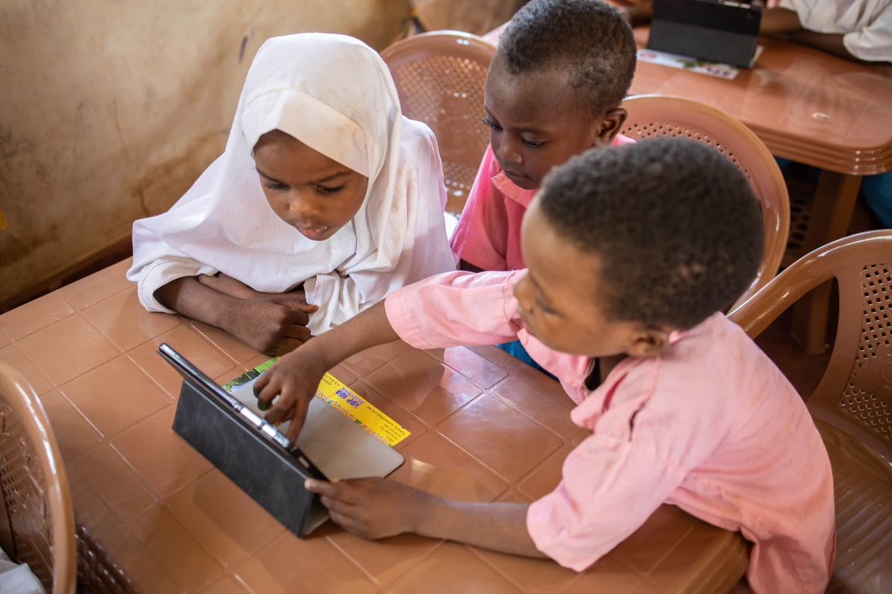

Students sharing limited resources at Ahlul Kisa, Kichaka Mkwaju

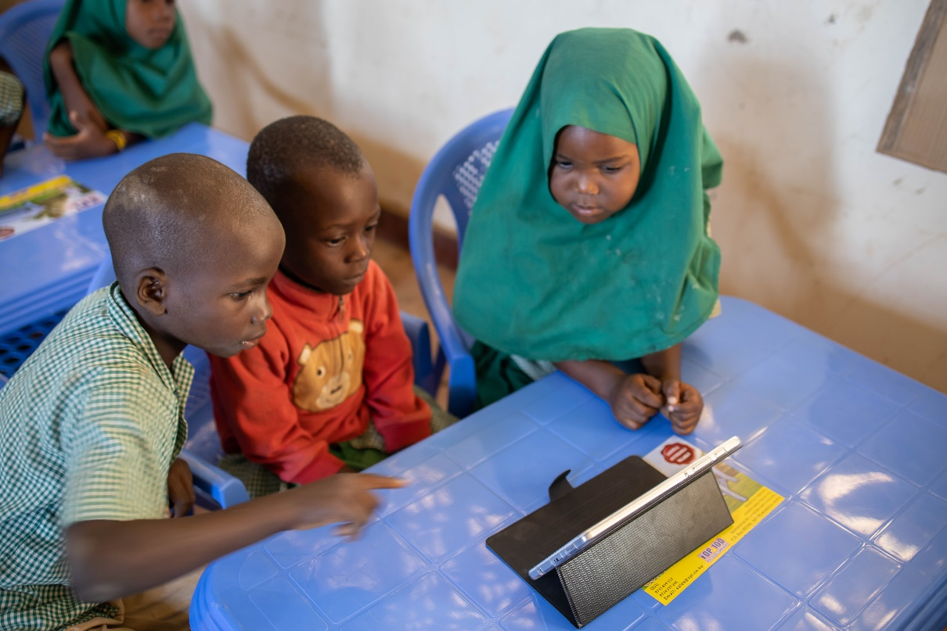

Educational Technology in use at the Ahlulbayt centre, Moyeni

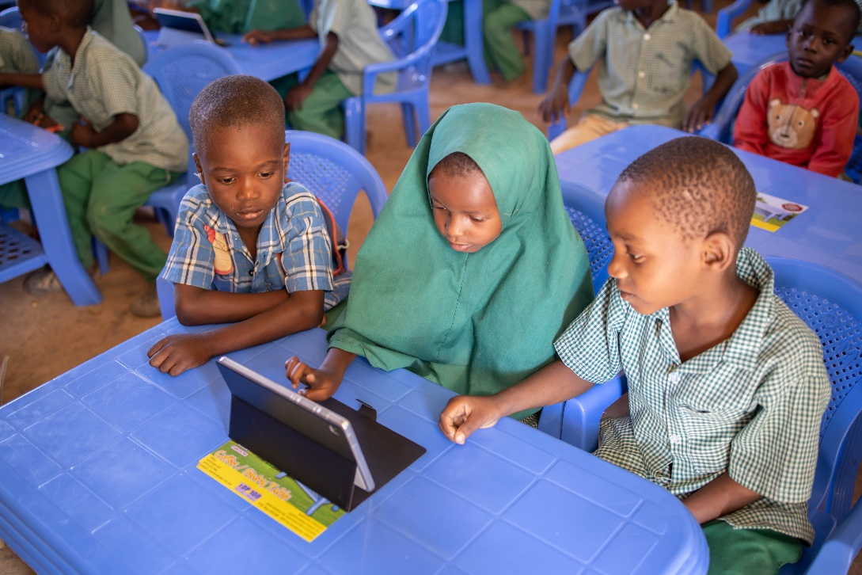

Learners interacting while using tablets at Ahlul Bayt Centre, Moyeni

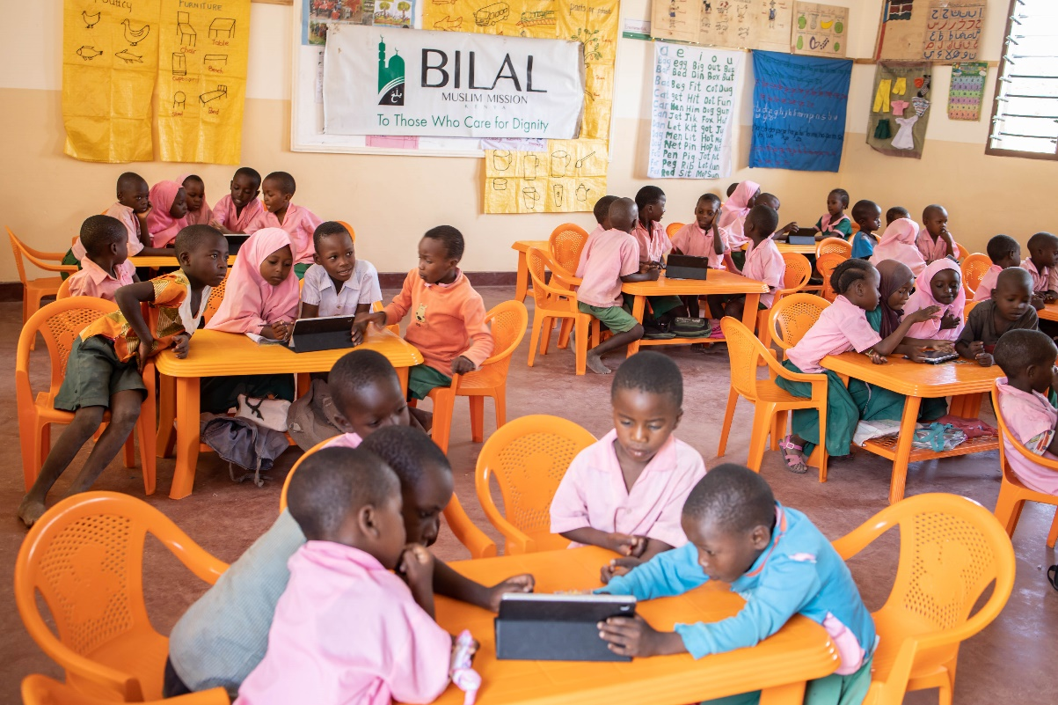

Learners are well accustomed to using the tabs at Al-Mahdi centre, Samburu

**Bilal Kenya appreciates the generous support it received from the donor which enabled the purchase and distribution of the additional fifty tablets in March 2023.**